**Derivation and characterization of oligodendrocytes from patients with neurodevelopmental disorders**

*Thesis submitted to*

*National Institute of Mental Health and Neuro Sciences*

*For the award of*

**Doctor of Philosophy (Ph.D.) in Psychiatry**

**Biju Viswanath**

July 2019



**Department of Psychiatry**

National Institute of Mental Health and Neuro Sciences

(An Institute of National Importance)

BANGALORE 560 029



National Institute of Mental Health and Neuro Sciences

(An Institute of National Importance)

Bangalore – 560029

**Department of Psychiatry**

**____________________________________________________________________**

***CERTIFICATE***

This is to certify that the thesis titled “**Derivation and characterization of oligodendrocytes from patients with neurodevelopmental disorders**” submitted in fulfilment of the requirement for the award of the degree of Doctor of Philosophy (Ph.D.) in Psychiatry submitted to National Institute of Mental Health and Neuro Sciences (NIMHANS), An Institute of National Importance, Bangalore, 560029 is a record of *bonafide* original research work carried out by **Dr.** **Biju Viswanath**, under our guidance and supervision and that, no part of this has been submitted for award of any other degree or diploma or fellowships or other similar titles to any institute or university.

**Dr. Siddharthan Chandran**

Joint-guide

Professor of Neurology, University of Edinburgh & Collaborative Science Chair, Centre for Brain Development and Repair, Institute for stem cell science and regenerative medicine (InStem), Bangalore

**Dr. Sumantra Chattarji**

Joint-guide

Professor, National Centre for Biological Sciences (NCBS) &

Director, Centre for Brain Development and Repair, Institute for stem cell science and regenerative medicine (InStem), Bangalore

**Dr. Sanjeev Jain**

Joint-guide

Professor of Psychiatry

National Institute of Mental Health and Neuro Sciences (NIMHANS), Bangalore

**Dr. Mathew Varghese**

Guide

Professor of Psychiatry

National Institute of Mental Health and Neuro Sciences (NIMHANS), Bangalore

Professor & Head

Department of Psychiatry NIMHANS

**DECLARATION**

I, **Dr. Biju Viswanath** hereby declare that the thesis titled **Derivation and characterization of oligodendrocytes from patients with neurodevelopmental disorders**” was carried out by me under the guidance of **Prof. Mathew Varghese**, Professor, Department of Psychiatry, at National Institute of Mental Health and Neurosciences (NIMHANS), Bangalore, and co-guidance of **Profs. Sanjeev Jain, Sumantra Chattarji** (Centre for Brain Development and Repair, Institute for stem cell science and regenerative medicine, (InStem), Bangalore)and **Siddharthan Chandran** (University of Edinburgh, UK).

The thesis has been submitted to the NIMHANS for the award of the degree of Doctor of Philosophy in Psychiatry, and has not been submitted anywhere in full or part thereof for the award of any other degree or diploma.

Date: 06 July 2019 Signature of the Candidate

Place: Bangalore

**Acknowledgements**

I take this opportunity to express my gratitude to all people who have helped and stood by me during the 5 long years of my doctoral research.

My guide Prof. Mathew Varghese, has helped me immensely through critical and timely suggestions, and providing permission and time for the additional work that my doctoral research required, especially during his tenure as Head of the Department of Psychiatry.

Prof. Sanjeev Jain, my co-guide, was my gateway to transition from clinical research to molecular genetics and basic science research. In addition to being a great teacher and mentor, he provided me with ample venues to meet and discuss with people involved in these areas of research and was also an important link to the National Centre for Biological Sciences (NCBS) where much of my doctoral research work was carried out.

I owe much to my co-guides, Prof. Sumantra Chattarji of the Centre for Brain Development and Repair (CBDR), Institute for stem cell science and regenerative medicine, (InStem) at NCBS and Prof. Siddharthan Chandran, University of Edinburgh, UK, for the faith that they placed in me in spite of my lack of experience in the basic science research field. They have provided me with the opportunity to learn state of the art, cutting edge research being conducted at their labs, in addition to providing me with venues for honing my skills through discussions with other doctoral students and researchers at the lab facility.

I would like to additionally thank Prof. Siddharthan Chandran for providing the stem cell lines from his lab for me to work on, in my doctoral research, and for the opportunity to visit his facility at Edinburgh for hands on learning of the various techniques involved in this research. This thesis work would not have materialised without him as my primary mentor for stem cell work.

My heartfelt thanks to my colleagues in the CBDR stem cell team, Rakhi Pal, Bharath Reddy, Durga Jeyalakshmi, Vidya, Krishna Kumar, Shreya, Reena, and Vijayalaxmi Nalawadi. They all been pillars of support for my research plans and experiments. I would not have been able to manage my time across institutes without them. They have also been great sources of academic, research, and emotional support at various points.

Prof. Peter Kind and Prof. David Wyllie of the University of Edinburgh, have been generous with requisite intellectual inputs for my PhD research. I thank them for the same.

I thank Prof. Prabha S. Chandra and Prof. Pratima Murthy who were the Heads of the Department of Psychiatry during my PhD course. They have provided invaluable support and encouragement.

Special thanks to Prof. Satish Chandra and Prof. B.N. Gangadhar, who during their tenures as Directors of NIMHANS provided me with resource support and permission for the research.

I also thank Prof. Satyajit Mayor, Director of NCBS, for his generous support and provision of research and accommodation facilities at NCBS during this period.

My gratitude to the Central Imaging and Flow Cytometry facility at NCBS, for permitting me to make use of their resources during my study.

My gratitude to the team members of Shona and Ravi lab, especially Preeti Kute for helping me out during various experiments.

Immeasurable thanks to Dr. Meera Purushottam, Senior Scientific Officer, and Dr. Nitish Machewad, my Senior Resident for their unending support and helping me with my responsibilities at the Molecular Genetics Lab and clinical work at the hospital in NIMHANS, so that I could devote sufficient time to my doctoral research.

I also owe a great deal to Prof. Mitradas Panicker, NCBS for motivating me to continue on my path as a researcher despite the difficulties.

I sincerely thank my wife, Ami and son, Ayush for being there, unconditionally. I do not know how they have managed to not complain in spite of me spending so much time in the laboratories. I am indebted to them for this sacrifice.

|  |  |  |  |
| --- | --- | --- | --- |
| **Contents** | | **Page** | |
| **1. Introduction** | | **10** | |
| **2. Review of Literature** | | **12** | |
| 2.1. Neurodevelopmental disorders | | 12 | |
| 2.2. Genetics of neurodevelopmental disorders | | 13 | |
| 2.3. Fragile X – the syndrome and the protein | | 14 | |
| 2.4. Use of cell lines in studying Fragile X syndrome | | 16 | |
| 2.5. Indirect evidence for oligodendrocyte dysfunction in Fragile X syndrome | | 20 | |
| 2.6. Oligodendrocyte maturation and myelin formation | | 22 | |
| 2.7. Neurodevelopmental disorders and dysregulations in myelination | | 24 | |
| 2.8. Oligodendrocytes in Fragile X syndrome | | 26 | |
| 2.9. Rationale for the study | | 30 | |
| 2.10. Hypothesis | | 31 | |
| **3. Aim and Objectives** | | **32** | |
| **4. Materials and methods** | | **33** | |
| 4.1. Human pluripotent stem cell lines and their maintenance/ propagation | | 34 | |
| 4.2. Generation and characterization of oligodendrocytes from human pluripotent stem cells | | 35 | |
| 4.3. Quantitative comparison of efficiency of specification to oligoprogenitors, immature oligodendrocytes and differentiated oligodendrocytes using quantitative immunocytochemistry and flow cytometry | | 36 | |
| 4.4. Comparison of oligodendrocyte morphology between groups | | 37 | |
| 4.5. Comparison of metabolic function of oligodendrocytes/oligodendrocyte physiology between groups | | 37 | |
| 4.6. Comparison of the groups with respect to myelination | | 38 | |
| 4.7. Statistical analysis | | 38 | |
| 4.8. Detailed protocols of cell culture techniques | | 39 | |
| 4.8.1. Detailed protocol for thawing and maintenance of pluripotent stem cells | | 39 | |
| 4.8.2. Detailed protocol for generation of oligodendrocyte lineage cells from pluripotent stem cells | | 52 | |
| 4.8.3. Detailed protocol for generation of cortical neurons and oligo-neuron cocultures | | 63 | |
| **5. Results** | | **80** | |
| 5.1. FMR1 null ES and FXS IPS as a model system | | 80 | |
| 5.2. Generation and basic characterization of oligodendrocytes | | 82 | |
| 5.3. Morphology of oligodendrocytes | | 89 | |
| 5.4. Glycolytic assay in oligodendrocytes | | 91 | |
| 5.5. Electrophysiology of oligodendrocytes | | 93 | |
| 5.6. Myelination assay | | 95 | |
| **6. Discussion** | | **97** | |
| 6.1. Morphological differences | | 97 | |
| 6.2. Adhesion defects | | 99 | |
| 6.3. Metabolic defects | | 100 | |
| 6.4. Myelination defects | | 101 | |
| **7. Abstract** | | 105 | |
| **8. Summary and future directions** | | **106** | |
| **9. References** | | **107** | |
| **10. Appendices** | | 121 | |
| 9.1. FMR1 null embryonic stem cells generated in the University of Edinburgh. | | 121 | |
| 9.2. Ethical approvals | | 123 | |
| **List of tables and figures** | **Page No** | |
| Table 1: Regulation of Myelination by FMRP expression | 28 | |
| Figure 1: Illustration of overall work plan | 33 | |
| Figure 2: Protocol for conversion of PS lines to oligodendrocytes | 55 | |
| Table 2: PS lines used for oligodendrocyte differentiation | 80 | |
| Figure 3: Characterization of pluripotent stem cells | 81 | |
| Figure 4: Efficiency of specification of oligoprogenitors and oligodendrocytes | 83 | |
| Figure 5: Non-oligodendrocytes in 1-week cultures | 84 | |
| Figure 6: Oligoprogenitor plate downs | 85 | |
| Figure 7: Cell proliferation assay in oligodendrocyte lineage cells | 86 | |
| Figure 8: Cell cycle analysis in oligodendrocyte lineage cells | 87 | |
| Figure 9: Viability analysis of oligodendrocytes | 88 | |
| Figure 10: Sholl analysis performed on week 1 O4+ oligodendrocytes | 90 | |
| Figure 11: Glycolysis stress test of oligodendrocytes at 1 week | 92 | |
| Figure 12: Electrophysiology of 1-week old oligodendrocytes | 94 | |
| Figure 13: Arborization of myelin in oligodendrocytes co-cultured with induced pluripotent stem cell derived neurons for 14 days | 96 | |
| Appendix figure 1: FMR1 null ES model system | 122 | |

**List of abbreviations**

2-DG- 2-deoxy glucose

ADHD- attention deficit hyperactivity disorder

AFQ- automated fibre-tract quantification

ASD- autism spectrum disorder

ATP- adenosine triphosphate

BDNF- brain derived neurotrophic factor

BMP- bone morphogenetic protein

BSA- bovine serum albumin

CDM- chemically defined medium

CNS- central nervous system

CRISPR- clustered regularly interspaced short palindromic repeats

DAPI- 4’,6-diamidino-2-phenylindole, Sigma-Aldrich

DMEM- Dulbecco’s modified eagle medium

DMSO- dimethyl sulfoxide

DNA- deoxyribonucleic acid

DPBS- Dulbecco’s phosphate buffered saline

DTI- diffusion tensor imaging

EBSS- Earle’s balanced salt solution

ECAR- extracellular acidification rate

ECL- enhanced chemiluminescence

EdU- ethynyl deoxy-uridine

ES- embryonic stem cells

FA- fractional anisotropy

FACS- fluorescence activated cell sorting

FAK- focal adhesion kinase

FGF- fibroblast growth factor

FLAIR- fluid attenuated inversion recovery

FMR1- Fragile X mental retardation1

FMRP- Fragile X mental retardation protein

FXS- Fragile X syndrome

FXTAS- Fragile X tremor ataxia syndrome

GDNF- glial cell derived neurotrophic factor

GFAP- glial fibrillary acidic protein

IGF- insulin-like growth factor

ILF- inferior longitudinal fasciculus

ILK- integrin-linked kinase

IMDM- Iscove's modified Dulbecco's medium

IPS- induced pluripotent stem cell

IQ- intelligence quotient

ITS- insulin transferrin solution

KSR- knockout serum replacement

LCL- lymphoblastoid cell lines

LDN- L-dorsomorphin

LN- liquid nitrogen

MAP- microtubule associated protein

MBP- myelin basic protein

MCP- middle cerebellar peduncle

MCT- monocarboxylate transporter

MDD- major depressive disorder

MEF- myocyte enhancer factor

miRNA- micro ribonucleic acid

MMP-matrix metalloprotease

MRI- magnetic resonance imaging

mRNA- messenger ribonucleic acid

MRS- magnetic resonance spectroscopy

MyT- myelin transcription factor

NAA/Cr- N-acetyl aspartate/Creatinine

NDD- neurodevelopmental disorders

NSC- neural stem cells

OPC- oligoprogenitor cells

PCR- polymerase chain reaction

PFA- paraformaldehyde

PGDFR- platelet derived growth factor receptor

PINCH- particularly interesting new cysteine-histidine-rich protein

PLP- proteolipid protein

PND- post natal day

PNS- peripheral nervous system

PS- pluripotent stem cells

PSF- penicillin-streptomycin-fungizone

PTK- protein tyrosine kinase

RPM- rotations per minute

RT- room temperature

RT-PCR- real time polymerase chain reaction

SAG- smoothened agonist

SNP- single nucleotide polymorphism

STEP- striatal-enriched protein tyrosine phosphatase

T3- Tri-iodothyronine

TGF – transforming growth factor

UTR- untranslated region

WM- white matter

1. **INTRODUCTION**

Neurodevelopmental disorders (NDD) are characterized by deficits in cognition, communication, behaviour, and/or motor skills that occur due to abnormal brain development. The broad umbrella of neurodevelopmental disorders covers intellectual disability, communication disorders, autism spectrum disorder (ASD), attention deficit/hyperactivity disorder (ADHD) and schizophrenia (Mullin et al., 2013). Although twin studies have indicated that NDDs are highly heritable (Posthuma & Polderman, 2013; Tick, Bolton, Happe, Rutter, & Rijsdijk, 2012), majority of the NDDs do not fit the mendelian monogenic disease model, but rather follow a polygenic and multifactorial causality (Torres, Barbosa, & Maciel, 2015). Monogenic NDDs albeit rare, provide an extremely valuable resource to elucidate disease mechanisms (Garg & Green, 2018).

Fragile X syndrome (FXS) is the most common inherited cause of intellectual disability. This monogenic cause of autism results from the loss of the Fragile X Mental Retardation 1 (FMR1) gene and primarily affects males. Biological studies on monogenic NDDs including but not limited to FXS, have been mostly neuron-centric, with focus on dendritic morphogenesis, disruptions in neuronal circuitry and altered synaptic transmission (Patel, Lukkes, & Shekhar, 2018). However, it is being increasingly recognised that glia plays a central role in maintaining neuronal health and function. These roles may range from being neuroprotective to injurious in specific disease contexts (Allen & Lyons, 2018). Yet, there is limited literature on the role of macroglia (astrocytes, oligodendrocytes) and microglia in the pathogenesis of monogenic NDDs. Experimental approaches are needed to interrogate the cell-autonomous and non-cell autonomous roles of glia in causing/mediating neuronal dysfunction in the context of monogenic NDDs, specifically in FXS.

Much of the indirect evidence pointing towards glial dysfunction in FXS comes from imaging studies of the white matter, primarily diffusion tensor imaging (DTI) in individuals with FXS, which shows widespread defects in multiple tracts (Swanson et al., 2018), implicating the defective myelination and thereby dysfunction of oligodendrocytes. White matter defects have also been demonstrated in diffusion tensor imaging (DTI) studies in FMR1 knockout mice (Haberl et al., 2015). Rodent studies have also indicated that Fragile X Mental Retardation Protein (FMRP) is expressed in oligoprogenitor cells (OPCs) and oligodendrocytes, and that the absence of FMRP causes reduction in the number of OPCs (Giampetruzzi, Carson, & Barbarese, 2013) and delayed myelination (Pacey et al., 2013). The influence of FMRP on myelination is possibly mediated through its binding with myelin basic protein (MBP) mRNA (Darnell et al., 2011; Giampetruzzi et al., 2013; Z. Li et al., 2001; H. Wang et al., 2004).

Myelination is possibly the most crucial function of oligodendrocytes in the brain as it reduces the metabolic cost of neural activity and contributes to compact nervous systems (Fields, 2008; Haroutunian et al., 2014). Myelin ensures proper connectivity during neural development and thereafter establishes optimal electrical activity and maintenance of mature neurons. However, in addition to myelination oligodendrocytes have also been implicated in other brain functions including synaptic regulation, signalling at the nodes of Ranvier (Allen & Lyons, 2018; Saab & Nave, 2017), and metabolic support of axons (Lee et al., 2012; Rinholm & Bergersen, 2012). These functions have not yet been examined in FXS.

Exploiting human stem cell and gene editing technologies offers an unprecedented opportunity for the creation of in vitro human based systems that are capable of modelling certain aspects of NDDs. Human induced pluripotent stem cell (IPS) models allows the derivation of specific brain cell types that harbour the patient’s genetic background, thus recapitulating the disease in a physiological context. This technology, in conjunction with CRISPR/Cas9 (regularly interspaced short palindromic repeats) mediated genome editing, forges a powerful research tool in the study of monogenic NDDs/FXS, enabling the generation of isogenic IPS lines. This overcomes the challenges posed by genetic variability between different IPS lines, and allows the study of the disease-linked mutation in a genetically deﬁned manner (Hoffmann et al., 2019).

In this study, we have investigated the cell-autonomous effects of the FXS mutation on: (1) Efficiency of specification of IPS to oligodendrocytes, (2) Morphology of oligodendrocytes, (3) Metabolic function of oligodendrocytes, and (4) Myelination of neurons by oligodendrocytes.

1. **REVIEW OF LITERATURE**

The review of literature is discussed under various sections. We begin with a brief description of neurodevelopmental disorders (NDD), followed by their genetic basis. Further, we discuss the Fragile X syndrome (FXS) as a prototype neurodevelopmental disorder, and the use of cell lines to study FXS. We then focus on human brain imaging studies, which have indicated white matter deficits in FXS, implicating oligodendrocyte pathology. This is followed by details of oligodendrocyte maturation and myelination in the normal human brain. Evidence for oligodendrocyte abnormalities in NDDs, specifically FXS is then reviewed, followed by an overall rationale for the study.

* 1. NEURODEVELOPMENTAL DISORDERS

Neurodevelopmental disorders (NDD), manifest as a result of abnormalities that occur during the development of the human brain. They are characterized by deficits in cognition (thought processes and intellectual functioning, including learning abilities and judgement), communication (speech, language, and non-verbal communication skills), behaviour (mood, goal directed, and non-goal directed activities), and/or motor skills, secondary to abnormal brain development. The development of the human brain, particularly the association areas of the neocortex occurs more slowly than in other primates (Silbereis, Pochareddy, Zhu, Li, & Sestan, 2016). Humans have a relatively longer gestational period, childhood, and adolescence (Bogin, 1994; Gogtay et al., 2004; Petanjek et al., 2011; Stiles & Jernigan, 2010). This protracted developmental course provides an extended window for environmental factors to mould cognitive, emotional, and social capacities. The developing human CNS additionally possesses specific features which include expanded proliferative zones and various subtypes of neural stem cells and progenitor cells with heightened proliferative capabilities. These facilitate expansion of various brain regions including the neocortex (Bystron, Rakic, Molnar, & Blakemore, 2006; Dehay, Kennedy, & Kosik, 2015; Gulden & Sestan, 2014; Taverna, Gotz, & Huttner, 2014). The precise regulation of these diverse molecular and cellular processes over an extended period of time, across diverse cell types and multiple brain regions is a highly complex process. The human central nervous system is hence vulnerable to various diseases and insults in a regionally and temporally distinct pattern (Kessler et al., 2007; Semple, Blomgren, Gimlin, Ferriero, & Noble-Haeusslein, 2013; Tebbenkamp, Willsey, State, & Sestan, 2014). The increased susceptibility of the human brain to NDDs could thus be considered the trade-off for enabling its immense complexity (Silbereis et al., 2016). The abnormality can occur at any stage of brain development and at any brain region, resulting in huge variations in the clinical presentation and manifestation of these disorders. The broad umbrella of NDDs hence covers intellectual disability, communication disorders, autism spectrum disorders (ASD), schizophrenia, bipolar disorder, obsessive compulsive disorder attention deficit/hyperactivity disorder and other externalizing syndromes (Garg & Green, 2018; Mullin et al., 2013). Many other psychiatric disorders also manifest their symptoms during adolescence or early adulthood.

* 1. GENETICS OF NEURODEVELOPMENTAL DISORDERS

Twin studies have indicated that NDDs are highly heritable (Posthuma & Polderman, 2013; Tick et al., 2012), however most NDDs do not fit the mendelian monogenic disease model, and have a polygenic and multifactorial causation (Torres et al., 2015). Monogenic NDDs are rare, but provide an extremely valuable resource to interrogate disease mechanisms (Garg & Green, 2018; Hulbert & Jiang, 2016).

Genetic defects underlying NDDs range from single nucleotide polymorphisms (SNPs) to large chromosomal deletions (Patel et al., 2018). Chromosomal deletions of 1q21.1, 16p11.2 and 22q11.2 are associated with intellectual disability, ASD, and schizophrenia (Stressman et al. 2017). These deletions affect multiple genes, resulting in disorders with overlapping phenotypes. However, it has been found that smaller modifications, such as SNPs in non-coding regions also occur with similarity across diverse NDDs. Among ASDs, specific gene mutations have been identified as causative in 15% of cases. Next generation sequencing has identified about thousand such mutations, including de novo mutations and these have been reported in the SFARI gene database (SFARI 2018). Several of these monogenic defects that affect single polypeptides (e.g., SHANK3, NRXN1, DISC1, FMR1, MECP2, GPHN) have been found to be associated with either schizophrenia, ASD, intellectual disability, or combinations of these. Thus, the genetic defects associated with NDDs extend the phenotypes related to these variants well beyond the current diagnostic categorical boundaries of NDDs.

* 1. FRAGILE X – THE SYNDROME AND THE PROTEIN

Fragile X syndrome (FXS) is the most common inherited cause of intellectual disability and monogenic cause of autism resulting from the loss of the FMR1 gene, primarily affecting males.

FXS accounts for roughly 5% of all diagnosed cases of ASDs (Schaefer & Mendelsohn, 2008). However, the neurobiological link between the ASDs and FXS remains unclear as this behavioural phenotype is seen in premutation carriers and carriers also, in addition to hemizygous males. In females, the carriers of a full mutation have a behavioural phenotype similar to males albeit in a milder form. They are described as socially avoidant, shy, anxious, and moody with a tendency to depression. Female carriers have been demonstrated to have higher rates of schizophrenia spectrum and affective disorders, indicating the involvement of a wider neurodevelopmental spectrum (S. C. Girimaji & Srinath, 2010; S. C. R. Girimaji et al., 2001).

The FXS is caused by the expansion and hypermethylation of an unstable CGG trinucleotide repeat sequence, located on the 5’UTR of the *FMR1* gene on the X chromosome (Verkerk et al., 1991; Yu et al., 1991). The *FMR1* gene is transmitted as an X linked dominant trait exhibiting a penetrance of 80% in males and 30% to 50% in females (Hill, Archibald, Cohen, & Metcalfe, 2010).

Based on the number of unstable CGG repeats, the *FMR1* has been divided into 4 allelic classes. The first is the normal allele is that is found in the unaffected population having an average of 29 to 30 repeats. At the other end of the spectrum lies the full mutation alleles in which the repeats number well over 200 and also show mosaicism in the length within the same individual indicating instability. These alleles are derived from premutation alleles which by definition have repeats that range in length between 55 and 200. Premutation alleles show instability during meiosis and may expand to full length mutations during maternal transmission. In addition, those with premutation alleles are at risk for developing Fragile X associated tremor ataxia syndrome (a late-onset neurodegenerative disorder with ataxia and cognitive decline) in males and Fragile X associated premature ovarian insufficiency in females. A fourth allelic class that has been described is the intermediate allele which has between 45 and 54 repeats. They are not known to expand to full mutations in the individual or in offspring.

The full mutation prevalence ranges from 1/3,717 to 1/8,918 in Caucasian males in the general population with little or no information in a general female population (Crawford, Acuna, & Sherman, 2001; Hantash et al., 2011). There are few population-based studies in other racial/ethnic populations A study in India showed the prevalence of FXS to be 18 per 1,000 patients of both genders with intellectual disability, and 2.8% among male patients (Elango & Verma, 1996). Another study in institutionalized population showed 0.1% frequency in males and 0.027% in females (Sharma, Gupta, & Thelma, 2001). Premutation carrier forms have prevalence estimates ranging from 1/246 to 1/468 Caucasian females and ∼1/1,000 in Caucasian males. In a recent study of premutation carriers, although the pan-ethnic premutation carrier frequency was 1 in 201, the Asian group showed much lower frequency of 1 in 419 (Owens et al., 2018).

The *FMR1* gene, although expressed in most mammalian tissues (Devys, Lutz, Rouyer, Bellocq, & Mandel, 1993), is notably abundant in the brain and testes (Hinds et al., 1993). In the brain, the gene is expressed predominantly in the neurons. The FMR protein is found both in the cell body and in distal compartments such as dendrites (Devys et al., 1993). The expression of the gene and production of protein begins in early development and continues throughout life (Hinds et al., 1993). It has been established that FMRP is expressed during early embryogenesis, more so in regions that contain progenitor cells and newly differentiated neurons. Studies have also shown that there is altered differentiation of neural stem cells in the absence of FMRP, leading to a relative increase in the cells expressing neuronal lineage markers (Castren et al., 2005). The absence of FMRP has also been found to affect the development of axonal projections in *FMR1* knockout mice during the first two postnatal weeks (Bureau, Shepherd, & Svoboda, 2008). Peak levels of FMRP expression correlate with the periods of synaptic formation and are localized to synaptic structures. This suggests that the FMRP plays a significant role in the process of formation, maturation, stabilization, and elimination of synapses (Till, 2010). The behavioural phenotypes exhibited in FXS could thus be a consequence of the disruption of the instructive role, in presence of the mutation, in the establishment of normal cortical architecture and wiring of neural circuits during early brain development.

FMRP has been found to play a role in many molecular processes ranging from mRNA transport (Bassell & Warren, 2008; Ohashi et al., 2002), cytoskeleton remodelling (De Rubeis et al., 2013), to DNA damage response in the nucleus (Alpatov et al., 2014). The main function of FMRP is postulated to be translational repression of a subset of mRNAs at the synapse until the appropriate neuronal signal occurs. Research has shown that FMRP contains domains for both nuclear localization and export; this allows it to move between the cytoplasm and the nucleus (Eberhart, Malter, Feng, & Warren, 1996). In addition, FMRP has been shown to bind to other molecules in the cytoplasm, thus regulating ion channels in the presynaptic space and RNA interference in the cytoplasm. Yet another function involves binding to chromatin in the nucleus to participate in DNA damage response. Removal of FMRP in cell culture studies has found to affect proteins involved in cell differentiation and mitochondrial function (Klemmer et al., 2011).

Putative FMRP target genes have significant overlap with genes associated with ASD and Schizophrenia (Darnell et al., 2011; Fernandez, Rajan, & Bagni, 2013; Folsom, Thuras, & Fatemi, 2015). More than 90% of FXS patients have psychiatric comorbidities such as ADHD, autism, anxiety, and depression (Scharf, Jaeschke, Wettstein, & Lindemann, 2015). The cerebellar vermis of adult patients with autism, showed a significant reduction in the levels of FMRP in comparison to matched controls (Fatemi, Kneeland, Liesch, & Folsom, 2010). Significant reductions in FMRP have also been found in the lateral cerebellum of patients with schizophrenia, bipolar disorder, and MDD as opposed to healthy controls (Fatemi et al., 2010). Overall, it is possible that FMRP is part of pathways that coalesce to produce such syndromes; studying how these networks intersect may thus be very useful.

* 1. USE OF CELL LINES IN STUDYING FRAGILE X SYNDROME

The complex interactions that contribute to the final clinical syndrome, which arise as a consequence of the mutation, thus need to understood at the level of cell function. This would include the direct examination of human oligodendrocytes in FXS. Neural/glial tissue in the human CNS is inaccessible; and post-mortem brain is unsuitable for culture or in vitro experiments. Researchers have utilized peripheral blood cells (monocytes), fibroblasts, and immortalised lymphoblastoid cell lines (LCLs) derived from patients with FXS (Brasa et al., 2016; B. Coffee, Zhang, Ceman, Warren, & Reines, 2002; B. Coffee, Zhang, Warren, & Reines, 1999; Kumari & Usdin, 2010; Pieretti et al., 1991; Pietrobono et al., 2005) as surrogate models; but extrapolations to brain biology from these is limited. In this context, human pluripotent stem cell (PS) technology has been a game-changer, especially to model monogenic NDDs like FXS, and allow us to understand cell autonomous and non-cell autonomous disease mechanisms.

PS are capable of self-renewal and potential differentiation into any cell of the human body (De Los Angeles et al., 2015). They provide an inexhaustible resource from which somatic cells can be cultured, thus enabling the study of tissues at various stages of development. PS are obtained primarily from two sources; embryonic stem cells (ES) harvested from healthy or affected embryos diagnosed through preimplantation genetic diagnosis (Eiges et al., 2007), and induced pluripotent stem cells (IPS) that are reprogrammed from mature somatic cells using exogenous transcription factors (Avior, Sagi, & Benvenisty, 2016). IPS enable the study of PS from individuals with an established clinical phenotype and avoids the ethical issues associated with the use of human embryos.

In monogenic NDDs, IPS is a highly competent means to explore disease mechanisms and pathways (Ardhanareeswaran, Mariani, Coppola, Abyzov, & Vaccarino, 2017). The mechanistic and pathological implications provided by such studies also apply to other neuropsychiatric disorders of developmental origin. As mentioned above, unlike the post-mortem human brain, model systems derived from IPS have active development with ongoing dynamic genetic programs regulating cell proliferation and differentiation into neural precursors, mature neurons, and glial cells. Gene expression undergoes dramatic changes during birth. IPS derived systems are thus valuable in enabling the study of active genetic programs from the prenatal brain. Post-mortem brain tissue in addition, is often distorted by other disease processes. This poses difficulties in differentiating causes from consequences and experimental artefacts. In principle, IPS is capable of recapitulating brain development from day zero of embryonic life to any stage of maturity. However, IPS derived brain cells have reduced complexity compared to the actual brain. Our ability to grow these cells in vitro long enough to recapitulate the perinatal and adult brain development is also limited by technical constraints. IPS derived models can nevertheless permit explorations to elucidate the development of observed aberrations in post-mortem brain structure, composition, and connectivity. It could also provide quantifiable measurements of neuronal morphology, electrophysiology, function, connectivity, and gene expression at various timepoints of embryonic brain development

The potential of IPS model systems has been further increased through genome-scale deep sequencing and the CRISPR/Cas9 (clustered regularly interspaced short palindromic repeats) technology (Ben Jehuda, Shemer, & Binah, 2018; Patmanathan et al., 2018) for gene editing. The editing of the ES and IPS lines through targeted deletion of specific regions of interest allows interrogation of the cellular effects of a single mutation (gene knockout/null), with a constant genetic background, allowing causal inferences. These techniques can demonstrate the effects of a gene mutation on the complete cellular transcriptome, and translation of transcriptomic changes into cellular phenotypes. Genome engineering technologies also help in delineating specific developmental alterations that are crucial in effecting a given cellular and molecular phenotype.

Mutations and their cellular and molecular consequences can also be explored in animal models. However, unlike information obtained through IPS derived modelling, it is not directly applicable to humans. The specific human genetic background provided by IPS in a sufficient sample size, can reveal the influence of inter-individual genetic variations on phenotypes. IPS retains each patient’s unique genetic signature, recapitulating respective idiosyncratic neural developmental trajectories. In addition, the CRISPR/Cas9 technology also enables gene correction of specific patient derived cell lines so that these lines form the ideal isogenic control for investigative studies.

Both the ES and IPS models have been used by researchers to study the pathophysiology of FXS.

FXS ES lines have been used to understand the developmental trajectory in FXS. Characterisation of the early events in the transcriptional inactivation of *FMR1* showed that even in the presence of a full mutation, the expression levels of *FMR1* mRNA varied depending on the stage of differentiation of the cell. *FMR1* was expressed in the undifferentiated state and it decreased following cell differentiation (Eiges et al., 2007). Further research exploring the temporal sequence of events involved in *FMR1* inactivation showed that over the neural differentiation period, *FMR1* mRNA was progressively downregulated to the point of being absent at 51 days following the onset of the differentiation process (Colak et al., 2014). This differentiation induced epigenetic silencing is postulated to be due to the formation of an RNA: DNA duplex between the CGG repeat portion of the *FMR1* transcript and its DNA template. The levels of DNA methylation were also found to be correlated with *FMR1* transcription levels (Avitzour et al., 2014) revealing another facet of epigenetic silencing in FXS.

IPS studies have mostly used cell lines derived from reprogrammed fibroblasts. These studies show that unlike in ES, the FMR1 locus in IPS is completely silenced and the epigenetic modifications seen in the somatic state are expressed (Urbach, Bar-Nur, Daley, & Benvenisty, 2010). The inactive FMR1 locus has been found to be resistant to reprogramming; FMR1 hypermethylation is irreversible and clonally maintained once it is established (Doers et al., 2014; Sheridan et al., 2011).

CRISPR/Cas9 technology has been particularly useful in deletion of the CGG repeat tract of the *FMR1* gene locus in FXS IPS. The deletion of the expanded sequence of CGG has been shown to reactivate the silenced *FMR1* promoter region in FXS patient derived IPS and restore normal levels of FMRP expression (Park et al., 2015).

The majority of ES/IPS based studies in FXS has been neuron centric. Following neural differentiation, the mutated cells were found to not display the typical increase in FMR1 transcription seen in control cells. They also showed delayed and reduced development of neural rosettes, in addition to abnormal expression patterns of important neural genes including *SOX1*, *NOTCH1*, and *PAX6* (Telias, Mayshar, Amit, & Ben-Yosef, 2015; Telias, Segal, & Ben-Yosef, 2013). In contrast to rodent studies, neural progenitors from FXS ES showed reduced levels of glycogen synthase kinase 3β (GSK3β) (Portis, Giunta, Obregon, & Tan, 2012).

Other morphological alterations were also noted in the mutant cells with smaller somata and shorter neurites compared to controls. They also showed poor synaptogenesis and reduced response to glutamate on electrophysiological examination (Telias, Kuznitsov-Yanovsky, Segal, & Ben-Yosef, 2015). In addition, global transcriptomic analysis of FXS IPS derived neurons showed aberrant axon guidance and neural differentiation genes (Halevy, Czech, & Benvenisty, 2015).

A major portion of research till date has focussed on the functions of FMRP in neurons in view of the cognitive deficits in FXS. However, researchers have pointed towards the role of glial cells in Fragile X phenotypes (Gholizadeh, Halder, & Hampson, 2015; Pacey & Doering, 2007; H. Wang et al., 2004). The most compelling evidence is from human diffusion tensor imaging studies, showing white matter deficits in FXS, implicating oligodendrocytes.

* 1. INDIRECT EVIDENCE FOR OLIGODENDROCYTE DYSFUNCTION IN FXS

Much of the indirect evidence pointing towards oligodendrocyte dysfunction in FXS comes from imaging studies of the white matter, primarily diffusion tensor imaging (DTI). In addition, there is supportive evidence from post mortem studies of brain pathology in individuals with FXS.

White matter defects have been demonstrated in DTI studies in both FMR1 knockout mice (Haberl et al., 2015) and humans with FXS (Haas et al., 2009; Hall, Dougherty, & Reiss, 2016; Reiss, Hagerman, Vinogradov, Abrams, & King, 1988; Villalon-Reina et al., 2013) as well as premutation carriers (Filley et al., 2015; Hashimoto, Srivastava, Tassone, Hagerman, & Rivera, 2011; Hippolyte et al., 2014; Shelton et al., 2017; J.Y. Wang et al., 2013; J. Y. Wang, Hessl, Hagerman, Tassone, & Rivera, 2012), providing indirect evidence for oligodendrocyte dysfunction in fragile X syndrome.

Much research has been carried out in premutation carriers of the FMR1 gene, primarily patients with Fragile X associated tremor ataxia syndrome (FXTAS). Individuals with FXTAS show findings of widespread white matter and cerebellar disease along with considerable atrophy and volume loss on pathologic examination and on T2-weighted FLAIR images (fluid attenuated inversion recovery) of magnetic resonance imaging (MRI) (J. Y. Wang et al., 2012).

The pathognomonic MCP sign (white matter hyperintensities in the middle cerebellar peduncle) on T2-weighted FLAIR images are seen in approximately 60% of cases (Brown & Stanfield, 2015; Brunberg et al., 2002). Even when this imaging finding is absent, post mortem brain pathology shows spongiform changes in the peduncles. Later studies have shown that although the MCP sign is an important marker of FXTAS, white matter hyperintensities were more common in the splenium of corpus callosum (Apartis et al., 2012).

In addition, white matter changes with decreased fractional anisotropy (FA) have been found in the frontal and cerebellar networks, indicating tract disruption (Filley et al., 2015; Hashimoto et al., 2011; Renaud et al., 2015). Magnetic resonance spectroscopy (MRS) shows decreased NAA/Cr in these areas suggestive of axonal loss along with decreased Ch/Cr in the MCP which could be representative of dysmyelination (Filley et al., 2015) These abnormalities have been found to correlate with cognitive impairments including executive dysfunction.

Research has also pointed out that much of the widespread disruption of structural connectivity in persons with FXTAS is not replicated in unaffected individuals having the premutation (J. Y. Wang et al., 2012). This indicates a relation between the specific mutation and the manifestation of symptoms and white matter changes.

The cortical and subcortical (thalamus and basal ganglia) grey matter volume loss that has been found (Cohen et al., 2006; J.Y. Wang et al., 2013) in FXTAS, notably occurs at a later stage of the illness (Battistella et al., 2013), suggesting the possibility that the grey matter changes could be secondary to primary white matter degeneration.

This pattern of early white matter changes has been found in studies on young individuals (infants and toddlers) with FXS as well. The FMR1 full mutation was found to be associated with increased relative density of reconstructed white matter fibres in the ventral fronto-striatal pathway which is important in the development of inhibitory control during early human brain development (Haas et al., 2009). Studies have also shown increased white matter in the temporal lobe in individuals with FXS (Hoeft et al., 2010); it has been suggested that this finding is related to the passage of the inferior longitudinal fasciculus through the temporal lobe. The largest lobar volumetric differences in white matter in FXS children compared to typically developing and developmentally delayed controls have been noted in the temporal regions (Hazlett et al., 2012).

Many studies have reported widespread alterations in functional connectivity in individuals with FXS (Hall, Jiang, Reiss, & Greicius, 2013; J. Y. Wang et al., 2017). Differences in white matter microstructure have been demonstrated on DTI between individuals with FXS and neurotypical controls (those without known psychological or learning disorders). FXS individuals show lower FA (Barnea-Goraly et al., 2003), along with higher radial and axial diffusivity values (Villalon-Reina et al., 2013) compared to neurotypical controls. It has been shown that measurable age-related increases in FA correspond to maturation of myelinated axons while relative fibre density decreases with age (Ding et al., 2008).

However, following the opinion that intelligence quotient (IQ) levels could have been possible confounders in these studies, a few recent studies have utilized IQ and age-matched samples.

Hall et al (2016) compared FXS patients between 10 and 23 years with controls who were matched for age, IQ, and degree of autistic features. They used Automated Fiber-tract Quantification (AFQ) to locate regions of aberrant WM microstructure along WM tracts. FA was found to be significantly increased in the left and right inferior longitudinal fasciculus (ILF), right uncinate fasciculus, and left cingulum hippocampus, while mean diffusivity was significantly decreased in the right ILF in FXS individuals.

Greene et al (2017) found higher FA and lower radial diffusivity in the FXS group compared to the controls in several brain regions. Although this study also found significant differences in white matter microstructure between the groups, the directionality of change was different. This has been postulated to be due to axonal growth dysregulation in FXS mediated through the influence of FMRP on axon guidance factor Semaphorin-3A (Sema3A) (C. Li et al., 2004) leading to increased fibre density.

A longitudinal study performed to compare developmental (behavioural) and brain imaging data between infants with FXS and normally developing controls has also shown white matter microstructural differences (Swanson et al., 2018). Differences were found in the development of multiple fibre tracts. There was lower FA in the occipito-temporal, subcortico-frontal, temporo-frontal, and cerebello-thalamic pathways in addition to four out of the six divisions of the corpus callosum. Differences were also identified in bilateral uncinate and inferior longitudinal fasciculi.

All these studies provide evidence for abnormalities in white matter microstructure and functional connectivity in individuals with FXS, implicating defects in myelination and thereby dysfunction of oligodendrocytes.

* 1. OLIGODENDROCYTE MATURATION AND MYELIN FORMATION

Oligodendrocytes are responsible for myelin production along the axons (Jakovcevski, Filipovic, Mo, Rakic, & Zecevic, 2009). They also have the most signiﬁcant turnover among all cell populations in the central nervous system. All stages of precursor cells exist in the CNS throughout adult life (Dawson, Hotchin, Lax, & Rumsby, 2003). The development of oligodendrocytes in humans begins during the second trimester of gestation, progressing towards birth, and extending into adulthood (Back et al., 2001; Jakovcevski & Zecevic, 2005; Rakic & Zecevic, 2003; Rivkin et al., 1995). In addition to myelination, oligodendrocytes have also been implicated in other brain functions including synaptic regulation, signalling at the nodes of Ranvier (Bilican et al., 2014; Butt et al., 1999; Lin et al., 2005; Nishiyama, Komitova, Suzuki, & Zhu, 2009), and metabolic support of axons (Lee et al., 2012).

Myelin provides the electrical insulation to the axons (Fields, 2008). It is a specialized, lipid-rich, multi-layered coating that spirally ensheaths the axons, and serves to improve the velocity of conduction of nerve impulses along the axons and maintains the structural integrity of the axons. The conduction velocity in non-myelinated axons ranges from 0.5 to 10 m/s. however, in a myelinated axon, it is as high as 150 m/s (Toritsuka, Makinodan, & Kishimoto, 2015). It reduces the metabolic cost of neural activity and contributes to compact nervous systems (Fields, 2008; Haroutunian et al., 2014). Thus, the presence of myelin ensures proper connectivity during neural development and thereafter optimal electrical activity and maintenance of mature neurons.

Myelination involves highly pivotal cell-cell interactions necessary for normal brain development (Nave & Werner, 2014). It is a continuous and ongoing process in the human brain, occurs for many decades, and is modifiable through experience. The regulation of the conduction velocity of neural impulses influences information processing. Research has shown altered expression of the myelin-associated genes in multiple neuropsychiatric disorders, pointing to the contribution of white matter malfunction in this category of illnesses (Mighdoll, Tao, Kleinman, & Hyde, 2015; Voineskos, 2015). Experimental manipulation of the expression of oligodendrocyte genes has been shown to regulate myelination and glial development, resulting in behavioural changes that simulate schizophrenia (Ren, Wang, & Xiao, 2013). Moreover, in addition to transcriptional control, many of these genes are also regulated by translational control.

Myelination in humans begins in the third trimester of gestation and continues into adolescence and early adulthood (Jakovcevski, Mo, & Zecevic, 2007). The long duration required for the human brain to be myelinated and the differential rates of myelination that occur across various brain regions, correlates with the wide range of symptoms and variations in age of onset seen across the neurodevelopmental disorders. There are multiple stages of myelination (Nave & Werner, 2014). The first stage consists of differentiation of oligodendrocytes from pluripotent oligodendrocyte precursors. This requires interaction between multiple transcription factors that influence the developmental potential of the precursor cell. These precursors are also required to migrate to the site where myelination needs to occur; warranting communication between the cells and the neurons that are destined to form the axons in those areas. Following this, transcriptional and post-transcriptional factors act on the precursor so that it moves out of the existing cell cycle to differentiate and mature into an oligodendrocyte. The mature oligodendrocytes then send out processes that wrap around the target axon and form the mature myelin structure.

These complex morphological stages necessitate precise control of gene expression. The strategies required for this control should be capable of influencing the decision of the cell as to when and where to migrate, when to stop division and commence differentiation, and which axon to ensheath. The process of formation of myelin also requires dynamic regulation of gene expression in response to the extra cellular environmental changes. This is achieved through post-transcriptional control thus enabling a fine-tuned response (Zearfoss, Farley, & Ryder, 2008). Proper neural connectivity and higher order brain functioning requires that a well-tuned control of genetic and epigenetic factors and their interplay occurs during the process of development and maturation of the oligodendrocytes and formation of myelin.

* 1. NEURODEVELOPMENTAL DISORDERS AND DYSREGULATIONS IN MYELINATION

Disturbances in myelination can occur either secondary to damage or due to genetic defects (Barateiro, Brites, & Fernandes, 2016). Examples include direct damage due to infections, infarctions, trauma, toxins, asphyxia (Kohlhauser, Mosgoller, Hoger, & Lubec, 2000), indirect damage due to metabolic disorders (Canavan, Menke’s, Krabbe’s, and Refsum’s disease) (Kumar, Mattan, & de Vellis, 2006), or hormonal disturbances, and autoimmune disorders like Guillain-Barré syndrome in the peripheral nervous system (PNS) and multiple sclerosis in the CNS (Kamm & Zettl, 2012). Inherited disorders that affect structural genes involved in myelination include Charcot Marie-Tooth disease, Dejerine-Sottas syndrome, and Pelizaeus-Marzbacher disease (Barrette, Nave, & Edgar, 2013; Kleopa, Orthmann-Murphy, & Sargiannidou, 2010). In addition, certain astrocyte-related diseases like Alexander disease result in can also cause severe hypomyelination (Ettle, Schlachetzki, & Winkler, 2016).

Research shows that many NDDs are associated with white matter defects. Structural differences in the white matter tracts have been revealed through histological analysis of post mortem tissues across many psychiatric and neurological disorders. These include schizophrenia, bipolar disorder, depression, obsessive-compulsive disorder, post-traumatic stress disorder, ADHD, autism spectrum disorders, language disorders, cognitive decline, Alzheimer’s disease and Tourette’s disorder (Haroutunian et al., 2014; Mighdoll et al., 2015). Postmortem studies reveal loss of oligodendrocytes in several brain regions (Byne et al., 2008; Hof et al., 2003; Stark, Uylings, Sanz-Arigita, & Pakkenberg, 2004), as well as features of apoptosis and necrosis in oligodendroglia of patients (N. Uranova et al., 2001; Uranova, Orlovskaia, Vikhreva, Zimina, & Rakhmanova, 2001). Reduction in total numbers of oligodendroglia lineage cells, but not the oligoprogenitors, implying impaired differentiation (Mauney, Pietersen, Sonntag, & Woo, 2015). Brain imaging studies of the brain have shown changes in the white matter at the volumetric and microstructural levels in various NDDs (Chen, Duan, Xiao, & Gan, 2018; Onnink et al., 2015). In addition, alterations in biochemical parameters and functional connectivity, as well as differences in white matter tracts and myelin genes have been demonstrated in patients (Rowley et al., 2015). It is unclear whether these changes in white matter structure are responsible for the causation of these disorders or if they are secondary consequences of abnormal neural functioning. Impaired myelin integrity in post-mortem studies and white matter abnormalities in DTI have been found to occur in early stages of disease suggesting a role in pathogenesis (Friedman et al., 2008; Holleran et al., 2014; Yao et al., 2013).

Genetic abnormalities that result in demyelination have been implicated in various other psychiatric disorders also (Voineskos, 2015). Several gene polymorphisms including *MAG, MOG, CNP, NRG1*, and *Olig 2* increase the susceptibility for numerous psychiatric disorders (Chen et al. 2019). This shows that the manifestation of many psychiatric disorders is closely related to dysregulation of myelin and both these are affected by common genetic factors. Understanding these mechanisms could provide hints for the development of better diagnostic and therapeutic options.

* 1. OLIGODENDROCYTES IN FRAGILE X SYNDROME

Recent research has demonstrated that FMRP is expressed in mature oligodendrocytes (MBP+) of both human and animal (rodent) origin (Giampetruzzi et al., 2013; Pacey et al., 2013). FMRP has also been found to be expressed in other cells of oligodendrocyte lineage at various stages of differentiation in a stage-specific manner (Wang et al., 2004). This points to the probable role of FMRP in the regulation of the myelination process. In FXS, the lack of FMRP could lead to premature myelination or abnormalities of myelin structure. Myelin basic protein (MBP) and microtubule-associated protein 1B (MAP1B) have been shown to be specific mRNA targets for FMRP in this regard (Castets et al., 2005; R. L. Coffee, Jr. et al., 2012; Sung, Conti, Currie, Brown, & Denman, 2000).

Quantitative real time polymerase chain reaction (qRT-PCR) in FXS has confirmed that there is altered expression of multiple genes, one of which is MAP1B (Bittel, Kibiryeva, & Butler, 2007) The precursor protein coded by the MAP1B gene undergoes proteolytic cleavage to form two sub-proteins namely the MAP1B heavy chain and L1 light chain (Hammarback, Obar, Hughes, & Vallee, 1991) The impairment of MAP1B expression could potentially affect neuronal plasticity and normal brain development considering that microtubule assembly forms an important step in neurogenesis (Fatemi & Folsom, 2010).

Both in vitro and in vivo studies have demonstrated that FMRP binds to MBP (one of the major myelination proteins). One of the targets of FMRP has been demonstrated to be inhibition of MBP mRNA translation in vitro (Darnell et al., 2011; Giampetruzzi et al., 2013; Z. Li et al., 2001; H. Wang et al., 2004). The expression of FMRP both in vivo and in culture decreases during oligodendrocyte maturation (Giampetruzzi et al., 2013). It is postulated that in immature oligodendrocytes, FMRP represses translation of MBP mRNA, while later, in mature oligodendrocytes, it allows this translation, as evidenced by the changes in FMRP expression over the developmental stages (H. Wang et al., 2004).

Abnormalities in myelination of cerebellar axons are seen in FMR1 knockout mice as early as the first postnatal week. Diffusion tensor imaging (DTI) of FMR1 knockout mice at the 7th postnatal day (PND) showed reduced volume of the cerebellum. At the same developmental stage there was also an 80–85% reduction in the expression of myelin basic protein, along with fewer myelinated axons and reduced thickness of myelin sheaths, on electron microscopic examination. The number of OPCs expressing PDGFRa was also lesser (Pacey et al., 2013). This corresponds to the human postnatal developmental period of 1 to 3 years wherein the symptoms of FXS become evident. This study further demonstrated that at PND 15, myelin proteins continued to be depressed; however, by PND 30, the levels were comparable with controls. The authors postulated that in the FMR1 knockout mouse brain, there is impaired maturation of OPCs resulting in delayed myelination.

In addition to rodent studies, FMRP has also been shown to be expressed in myelinating oligodendrocytes from 22 week old human gestational tissue (Giampetruzzi et al., 2013).

The influence of FMRP on myelination is an area that has been well researched, but is still incompletely understood. It is postulated that the process is mediated through the binding of FMRP with MBP mRNA (Darnell et al., 2011; Giampetruzzi et al., 2013; Z. Li et al., 2001; H. Wang et al., 2004). The expression of FMRP has been demonstrated in oligodendroglial cell lines including OPCs, and immature oligodendrocytes. It has been shown to interact with certain oligodendrocyte-specific mRNAs, which includes the MBP mRNA. The expression of FMRP gradually declines as the maturational process of oligodendrocytes progresses in vitro in the developing brain. This decline correlates with a marked up-regulation of the MBP protein (H. Wang et al., 2004). Wang et al additionally found that the MBP 30 untranslated region (30UTR) binds to the FMRP, and this binding specifically mediates translation inhibition of a reporter gene in oligodendrocytes alone. This points towards the significant role that FMRP plays.

In addition to MBP, FMRP has also been shown to negatively regulate the translation another myelin related transcript, proteolipid protein (PLP) (Giampetruzzi et al., 2013). Research has also demonstrated the interaction of FMRP with MBP and PLP transcripts through binding assays using biotin labelled mRNAs and invitro translated FMRP (Darnell et al., 2011).

A series of transcription factors including MyTI (Myelin transcription factor I), Nkx6.2 (Gtx), POU domain protein Tst-1/Oct-6, Brn-1/2, Krox-24 (Egr-1, Zif286), new Cys2/His2 zinc finger proteins rKR1/2, and Sox family have been found to be involved in the functional regulation of myelination-mediating glia (Emery, 2010). These work cohesively in a sequential manner to enable the induction and completion of fine-tuning of myelination structures. Among these factors, the Sox family transcription factors, Nkx6.2, and Brn-1/2 are reported to be FMRP targets (Kunde et al., 2011).

In addition to transcription factors, recently identified important regulators of gene expression in oligodendrocytes are micro RNAs (miRNA) (Svaren, 2014). FMRP regulates the miRNA pathway either through its interaction with the components of miRNA biogenesis or through direct association with the miRNAs (Jin et al., 2004). Several miRNAs have been reported to be potential FMRP targets (Yi et al., 2010)(Table 1).

**Table 1: Regulation of Myelination by FMRP expression**

|  |  |  |  |
| --- | --- | --- | --- |
| **Molecular Class** | **Molecule** | **Effect on Myelination** | **Reference** |
| Transcription regulators | Tcf7l2/Tcf4 | Myelination decrease/increase | (Fancy et al., 2009) |
| Sox4, Sox5, Sox6, Sox8, Sox9, Sox10, Sox11, Sox17 | Myelination decrease/increase Oligodendrocyte pool | (Stolt et al., 2006; Stolt & Wegner, 2010) |
| Nuclear hormone receptor | Myelination increase | (Pombo, Barettino, Ibarrola, Vega, & Rodriguez-Pena, 1999) |
| Nkx2.2 | Myelination decrease/increase | (Qi et al., 2001) |
| Nkx6.1, NKx6.2 | Myelination increase Oligodendrocyte maturation | (Wei, Miskimins, & Miskimins, 2005) |
| Micro RNA | miR 124 | Myelination decrease by Sox9 inhibition | (Morris et al., 2015) |
| miR 138 | Myelination decrease by Notch inhibition | (Lau et al., 2008) |
| miR 144 | Myelination increase by Enp6 inhibition | (Svaren, 2014) |
| miR 219 | Myelination decrease by Sox2/Hes5 inhibition | (Zhao et al., 2010) |
| miR 338 | Myelination decrease by Sox2/Hes5 inhibition | (Zhao et al., 2010) |

The role of FMRP in optimal myelination of the developing brain also translates to developmental significance. In the drosophila model of FXS, the glial expression of *dFMRP* has been shown to be necessary for proper neuroblast development (Callan, Clements, Ahrendt, & Zarnescu, 2012). FMRP is required for the inhibition of insulin signalling, which regulates glia-dependent neuroblast reactivation during brain development.

Various researchers have attached significance to the effect of white matter development and myelination during the developmental stages on neuronal functioning in the adult brain. Wang et al (2004) (H. Wang et al., 2004) while demonstrating the deficit in oligodendrocyte development and myelin production in the cerebellum during the early stages of rodent brain development, additionally pointed out that the effects reported on neurons at this early stage were subtle in contrast to the white matter findings. Studies have only shown mild changes in dendritic spines and cortical maturation (Till, 2010) at the corresponding neurodevelopment stage. Altered myelination has hence been postulated to precede and possibly contribute to neuronal abnormalities occurring at later stages (Pacey & Doering, 2007).

It is critical for the normal development of neurons that the axons be myelinated at the optimal time points (Fields, 2008). Researchers who have used mouse models in FXS that have reported myelination and white matter defects have also reported behavioural abnormalities in rodents that are thought to reflect autistic-like behaviours. These include altered motor activity, pre-pulse inhibition, and anxiety (Rana et al., 2012). These findings suggest a potential link between abnormal myelin and behavioural phenotypes common to autism and FXS.

Studies addressing the importance of myelination/white matter deposition during the early stages of brain development in ensuring proper growth and functioning of the nervous system are very few (Makinodan, Rosen, Ito, & Corfas, 2012; Miller et al., 2012; Steele, Bailey, Zatorre, & Penhune, 2013). These studies have demonstrated a critical window for deposition of myelin deposition which has effects on the structure and function of the whole brain including neurons, well into adulthood. Hence, reduced myelin deposition during the critical early postnatal period could create potential lasting structural and behavioural deficits during later stages of life wherein myelin levels would have normalized. As a corollary, the lack of myelination abnormalities or oligodendrocyte dysfunction in adult life does not rule out the possibility that there may have been early dysfunction leading to the behavioural phenotypes seen in neurodevelopmental disorders.

As research into the role of oligodendrocyte dysfunction in FXS is a relatively new direction, studies are yet to focus on oligodendrocytes derived from PS. Generation of oligodendrocyte lineage from reprogrammed stem cells is an established invitro laboratory procedure (Chandran, Svendsen, Compston, & Scolding, 1998; Gaughwin et al., 2006; Stacpoole et al., 2013; Webber, Compston, & Chandran, 2007; Webber, van Blitterswijk, & Chandran, 2009; Wilkins, Chandran, & Compston, 2001; Wilkins, Majed, Layfield, Compston, & Chandran, 2003).

The derivation of oligodendrocyte lineage cells using pre-generated and validated induced pluripotent stem cells (IPS) from well characterized patients with FXS and unrelated healthy controls, would enable the study of quantitative differences with respect to structure, physiology, metabolic function, and myelination. This would then help us understand the biological processes involved in disease better.

* 1. RATIONALE FOR THE STUDY

FXS is the most common inherited cause of intellectual disability, and results from the loss of the *FMR1* gene. Biological studies on FXS have been mostly neuron-centric. The role of glial cells, specifically oligodendrocytes in FXS is poorly understood and yet there are multiple lines of evidence from rodent studies implicating dysfunction of oligodendrocytes. Crucially, multiple human brain magnetic resonance imaging studies show aberrant white matter connectivity in FXS, when compared to unaffected individuals.

Against this background we have used multiple FXS patient induced pluripotent stem cell (IPS) lines as well as a FMR1 null human ES line with isogenic control to address the cellular consequences of FXS mutation on human oligodendrocytes. In view of the importance of oligodendrocytes not only for myelination but also metabolic support for neurons, we have investigated the effects of FXS mutation on efficiency of specification to oligodendrocytes, oligodendrocyte morphology, metabolic function and myelination.

2.10. HYPOTHESIS

We hypothesize that FXS mutant IPS will have reduced efficiency of specification to oligodendrocytes. Further, we expect the mutant oligodendrocytes to have morphological defects, diminished glycolytic capacity and reduced ability to myelinate neurons.

1. **AIMS & OBJECTIVES**

To investigate cell-autonomous effects of FXS mutation on human oligodendrocytes derived from IPS cell lines.

Specific objectives

1. Examining the influence of FXS mutation or null expression on the generation of oligodendrocyte lineage cells compared to control IPS.
2. Examining the influence of FXS mutation or null expression on oligodendrocyte morphology compared to control IPS.
3. Examining the influence of FXS mutation or null expression on the metabolic functions of oligodendrocytes/oligodendrocyte physiology compared to control IPS.
4. Examining the influence of FXS mutation or null expression on the myelination of neurons by oligodendrocytes compared to control IPS.
5. **MATERIALS AND METHODS**

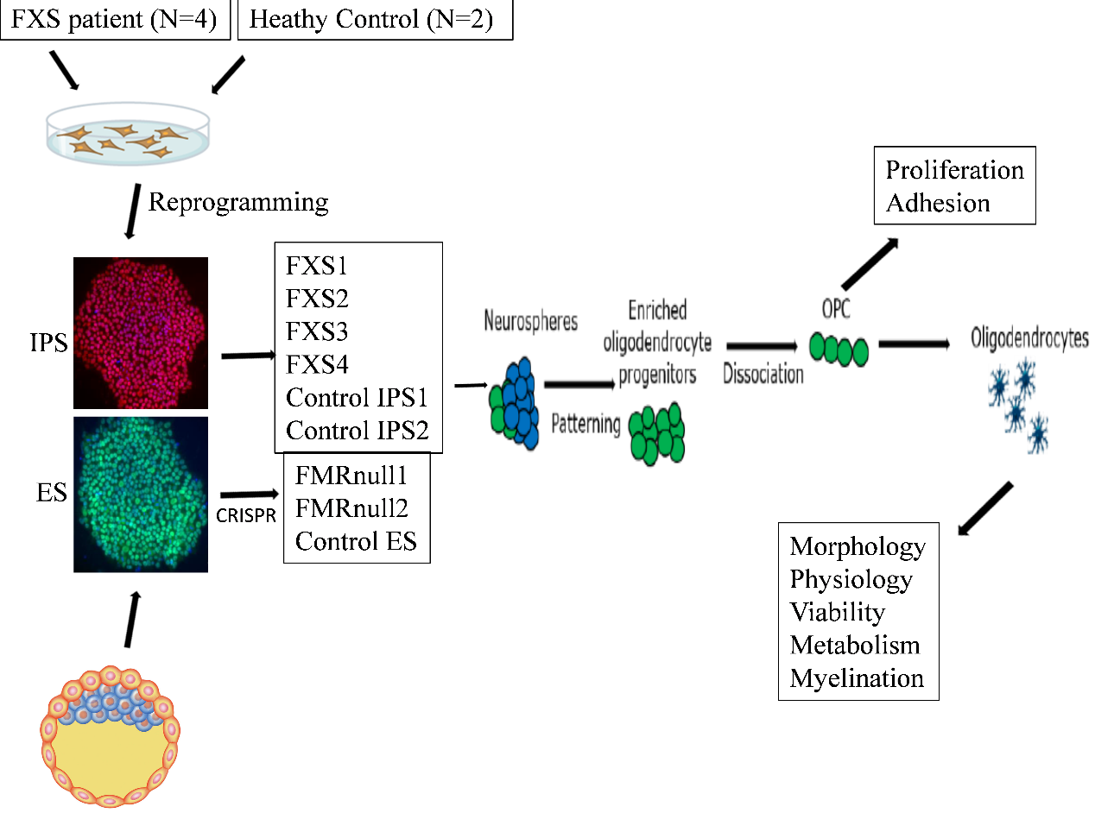

Figure 1: Illustration of overall work plan. IPS of patients with FXS and CRISPR edited FMR1 null ES and paired control were used for experiments. ***W***e investigated the effects of the FXS mutation on efficiency of specification to oligodendrocyte lineage cells, and specific experiments at the OPC and OL stages. Abbreviations: FXS – Fragile X syndrome; IPS – Induced pluripotent stem cell; ES – Embryonic stem cell; OPC – oligoprogenitor cells; OL - oligodendrocytes

* 1. HUMAN PLURIPOTENT STEM CELL LINES (PS) AND THEIR MAINTENANCE/PROPAGATION

The following pluripotent stem cell lines were available for this work from my co-guide’s (SC) laboratory: 1) Induced pluripotent stem cells (IPS) from patients with FXS (N=4), 2) Induced pluripotent stem cells (IPS) from controls (N=2), 3) Control Embryonic stem cells (ES), and FMR1 null ES line (N=2).

ES and IPS lines were maintained on Matrigel-coated (SLS, 354230; 1 in 60 dilution) plates with Essential 8 media (A1517001, Invitrogen). Pluripotency was confirmed through expression of pluripotency markers Oct4 and Nanog. Immunostaining was done by fixing the cells with 4% paraformaldehyde (PFA), washing with phosphate buffered saline (PBS) and permeabilizing with 0.1%Triton X 100 for 15min at room temperature (RT). The cells were then blocked with 1% bovine serum albumin (BSA) in PBS and incubated with respective antibodies overnight at 40C. The following day, they were washed 3 times for 10 min with PBS and incubated with the corresponding secondary antibodies for 1 hour at RT. Nuclei were counterstained with DAPI (4’,6-diamidino-2-phenylindole, Sigma-Aldrich), and coverslips were mounted on slides with FluorSave (345789, Merck, NJ, USA). An Olympus FluoView 1000 microscope was used for fluorescent imaging. Images were processed with ImageJ64 (v 1.47). Regions of interest were selected based on uniform DAPI staining and imaged for two to four fluorescent channels, and immunolabelled cells counted manually. Positive staining was defined as a signal clearly above the background fluorescence.

Western blotting was done to confirm the absence of FMRP in the FMR1 null ES and mutant IPS lines. This was performed using standard method with primary antibody FMRP [F4055, Sigma (1:100 dilution)] incubation at 40C overnight and secondary antibody incubation at RT for 45 min to 1hr. the blots were developed using super ECL (GE health care Cat RPN2232).

Shef-4 control ES lines were used for generating FMR1 null ES lines in SC laboratory using CRISPR/CAS9 technology using following guide RNA sequences for: CACCGCAGCG TTGATCACGT GACG and rev: CACCGTTACA CCCGCAGCGG GCCG. The cells were transfected with the CRISPR/CAS9 constructs along with the guide RNA sequences using nucleofection. Individual clones were cultured in 96-well plates and screened using PCR for genomic deletion. The positive clones were then screened with Western blotting for FMRP and two clones G3 and E6 were used for subsequent analysis. The ES and control IPS lines were karyotyped by G-banding and found to be normal in each of the cases.

* 1. GENERATION AND CHARACTERIZATION OF OLIGODENDROCYTES FROM HUMAN PS.

The protocol for conversion of pluripotent stem cells lines to oligodendrocytes was standardized as per previously published work from SC lab at the University of Edinburgh (Livesey et al., 2016). In brief, to pattern oligodendrocytes, neural stem cell (NSCs) were cultured in fibroblast growth factor (FGF)2 and sonic hedgehog [or small molecules such as puromorphamine and smoothened agonist (SAG)] to generate Olig2+ precursors. These, when maintained in FGF2/platelet-derived growth factor (PDGF), first generated PDGFRa+ OPCs and differentiating O4+ oligodendrocytes upon plating and withdrawal of mitogens. This yielded PDGFRa+ OPCs and immature oligodendrocytes (O4+) and differentiated (MBP+) oligodendrocytes.

Neuralization was achieved by spontaneous embryoid body formation, induced following cell lifting with dispase (17105-041, Life Technologies, CA, USA) and collagenase (17104-019, Life Technologies). Embryoid bodies were cultured for 7 days, with dual-SMAD inhibition [19]. Chemically defined media (CDM) was used, containing 50% Iscove’s modified Dulbecco’s medium (Invitrogen, CA, USA, 50% F12, BSA (5 mg/ml, Europa, Cambridge, UK), 1% chemically defined Lipid 100 (Invitrogen), monothioglycerol (450 µM, Sigma- Aldrich, Gillingham, UK), insulin (7mg/ml, Roche, Basel, Switzerland), transferrin (15 mg/ml, Roche), 1% penicillin/streptomycin, supplemented with N-acetyl cysteine (1 mM, Sigma), activin inhibitor SB431542 (10 µM, R&D Systems, MN, USA), and l-dorsomorphin (2 µM, Merck Millipore, Darmstadt, Germany). The neurospheres were cultured in suspension with media changes every 2–3 days. They were then caudalized by the addition of retinoic acid (1 µM, Sigma) for 7 days. Neurospheres were quality controlled for their morphology and the formation of neural rosettes at this stage, before subsequently being ventralized with the addition of the sonic hedgehog agonist puromorphamine (1 µM, Calbiochem, CA, USA) for 7 days in Advanced Dulbecco’s Modified Eagle medium (DMEM)/F12 (Invitrogen) containing: 1% N-2 supplement (Invitrogen), 1% B27 supplement (Invitrogen), 1% penicillin/streptomycin (Invitrogen), 0.5% GlutaMAX (Invitrogen), and 5 µg/ml heparin (Sigma). Ventral spinal cord patterned progenitor cells were then expanded in the presence of basic FGF2 (10 ng/ml, PeproTech, NJ, USA) for 7 days. Neuronal and glial differentiation was further triggered by FGF2 withdrawal for 2 weeks to generate neurospheres containing OLIG2+. These cells were further expanded for additional 2 weeks in the presence of FGF2 (10 ng/ml), PDGFa (20 ng/ml, PeproTech), puromorphamine (1 µM), and SAG (1 µM, Calbiochem), IGF-1 (interstitial growth factor) (10 ng/ml, PeproTech), T3 (60 ng/ml, Sigma), and 1X ITS (Gibco, NY, USA) before initiating oligodendrocyte differentiation. OPC containing spheres could be maintained in this media for up to 8 weeks. For terminal differentiation of oligodendrocytes, mitogen withdrawal (except for T3 and IGF-1) was done, following single-cell dissociation using papain dissociation system (Worthington Biochemical, NJ, USA) and plating on Matrigel (SLS, 354230; 1 in 100 dilution), fibronectin (20 µg/ml, F2006, Sigma-Aldrich), and laminin (10 µg/ml, L2020, Sigma-Aldrich) coated coverslips (or plates) at a density of 20,000-30,000 cells per 0.3 cm2.

* 1. QUANTITATIVE COMPARISON OF EFFICIENCY OF SPECIFICATION TO (1) OPC (PDGFRA+), IMMATURE OLIGODENDROCYTES (O4+) AND DIFFERENTIATED OLIGODENDROCYTES (MBP+) USING QUANTITATIVE IMMUNOCYTOCHEMISTRY AND FLOW CYTOMETRY

The mutant and control lines were compared in terms of the yield of PDGFRa+ OPCs at day 1, after single-cell dissociation, and immature (O4+) and differentiated (MBP+) oligodendrocytes at day 7. Live staining was performed for PDGFRa (1:200, Cell signalling, MA, USA) and O4 (1:500, R&D systems), after which the cells were fixed with 4% PFA and further incubated with MBP (1:50, Abcam) and DAPI and imaged, as described earlier.

Flow cytometry of oligodendrocytes was performed on a FACSVerse (Becton Dickinson, San Jose, CA) machine. Cells were lifted with Accutase (Sigma) and stained with primary antibody O4/PDGFRa followed by secondary antibodies (see above) 1:3,000. The cells were analysed by forward and side scatter for Alexa Fluor 488 fluorescence through a 530±30 nm band-pass and for Alex Fluor 647 through a 695±40 nm band-pass. Unstained cells were used to set the background fluorescence; a false positive rate of 0.5% was considered acceptable. FACS data was collected and analysed using Flowjo software.

Basic cellular characteristics like cell proliferation and cell viability were also assessed. Proportion of propidium iodide labelled cells determined by flow cytometry were compared between mutant and control lines, for cell viability. To assess cell proliferation, the oligospheres were incubated with 10µM ethynyl deoxy-uridine (EdU, Life Technologies) for 12hr and then dissociated and plated in a 24-well dish on a coverslip. Media was replaced completely after this period and cells cultured for an additional 12 hours in the absence of EdU. The cells were then fixed with 4% PFA and stained according to manufacturer’s instructions using Click-it kit (Life technologies Cat C10340).

* 1. COMPARISON OF OLIGODENDROCYTE MORPHOLOGY BETWEEN GROUPS

O4+positive oligodendrocytes display unique morphology with many elongated and branching processes. The morphology of O4+ cells were compared between patient and control lines using Sholl analysis.

* 1. COMPARISON OF METABOLIC FUNCTION AND PHYSIOLOGY OF OLIGODENDROCYTES BETWEEN GROUPS

The metabolic function of oligodendrocytes (glycolysis) was assessed using the Seahorse XF bioanalyzer in day 7 cultures. The cells were washed with assay medium containing 0.25 g/L or 4.5 g/L glucose (pH adjusted to 7.4) and equilibrated for 1 hr in the incubator at 370C without CO2. The XF24 plate was inserted into the Seahorse analyser, where 4 basal assay cycles were performed, each consisting of 3 minutes of mixing followed by 3 minutes of measuring. After completion, oligomycin (0.5 μM injection volume) was added by automatic pneumatic injection for 3 assay cycles. Extracellular acidification rates (ECARs) were calculated by the addition of 2-deoxyglucose (2DG).

The electrophysiological properties of the above oligodendrocytes were examined with whole-cell patch-clamp recording. The maturation of oligodendrocytes from OPCs (identified using O4 live-staining) recapitulates the equivalent process in rodents (Sontheimer, Trotter, Schachner, & Kettenmann, 1989; Tripathi et al., 2011) by demonstrating a developmental reduction in the outward rectification of sustained voltage-dependent currents. Patient and control lines were compared in terms of maturity of current responses and the degree of shift in current rectification O4+oligodendrocytes at week 1.

* 1. COMPARISON OF THE GROUPS WITH RESPECT TO MYELINATION

Co-culture of PS derived cortical neurons and oligodendrocytes was performed to examine myelination. Anterior neural precursors were generated from PS by dual SMAD inhibition. Further, neuronal differentiation was initiated by the removal of FGF2 and cultures maintained in a 3% O2 atmosphere (Bilican et al., 2014). Oligo-spheres were dissociated with papain and the oligoprogenitors were inoculated onto neuronal cultures and co-cultured for 2 weeks in oligodendrocyte differentiation media with brain derived neurotrophic factor (BDNF) and glial cell derived neurotrophic factor (GDNF). The morphology of MBP+ cells were compared between FMR1 null and control lines using Sholl analysis.

* 1. STATISTICAL ANALYSIS

Results were presented as percentage or means with standard error of means. Deviance from normal distribution was checked according to Shapiro-Wilk test. For normally distributed variables, parametric methods were applied; for all other, non-parametric methods were used. For normal distributions, one-way analysis of variance (ANOVA) and Student t-test were used for comparisons between controls and cases groups. For variables not following normal distributions, Kruskal-Wallis & Mann-Whitney tests were used for comparison between groups.

* 1. DETAILED PROTOCOLS OF CELL CULTURE TECHNIQUES

* + 1. Detailed protocol for thawing and maintenance of pluripotent stem cells (PS).

***Reagents***

Advance DMEM/F12 (Life Technologies, 12634-010)

Knockout Serum Replacement (Life Technologies, 10828-028)

L-Glutamine (Life Technologies, 25030-024)

Penicillin/Streptomycin (Life Technologies, 15070-063)

2-mercaptoethanol (Life Technologies, 31350-010)

Murine bFGF (Peprotech, 450-33)

Essential 8 medium (Life Technologies, A1517001)

Matrigel basement membrane matrix (SLS, 354230)

Geltrex (Life Technologies, A1413301):

CF-1 Mouse Embyronic Fibroblasts (irradiated) (VH Bio, 07GSC-6001G)

Collagenase Type IV (Life Technologies, 17104-019)

Dispase (Life Technologies, 17105-041)

Dulbecco’s phosphate buffered saline (DPBS) (Ca-/Mg-) (Life Technologies, 14190-094)

Dimethyl Sulfoxide (DMSO) (Sigma, D2438)

***Reagent setup***

**KSR base medium**

400ml Advanced DMEM/F12

100ml Knockout Serum Replacement

5ml L-Glutamine

5ml Pen/Strep

1ml 2-mercaptoethanol

**KSR F10 medium**

100ml KSR Base

50ul bFGF (20ug/ml)

**Essential 8 medium**

Add 10ml supplement to 500ml E8 basal medium

**mTeSR1**

Add 100ml supplement to 400ml mTeSR1 Basal medium

**PSC Freezing mix**

45ml Complete E8 media

5ml DMSO

**Collagenase (2mg/ml)**

Weigh out 100mg of collagenase on the microbalance into a 50ml falcon tube. Spray the tube with 70% IMS and place it in the hood. Add 50ml Advanced DMEM/F12 to the collagenase and mix until it is fully dissolved. Once dissolved, place the tube on a steriflip and filter using the aspirator. Label the new tube as “collagenase 2mg/ml” with the date.

**Dispase (1mg/ml)**

Weigh out 50mg of dispase on the microbalance into a 50ml falcon tube. Spray the tube with 70% IMS and place it in the hood. Add 50ml Advanced DMEM/F12 to the dispase and mix until it is fully dissolved. Note: Dispase takes longer to dissolve; ensure that it does not get stuck to the lid. Once dissolved, place the tube on a steriflip and filter using the aspirator. Label the new tube as “dispase 1mg/ml” with the date.

**Matrigel (1:2)**

Matrigel is thawed at 4oC. While thawing, chill a 10ml stripette, 1.5ml tubes, and 1ml tips. Once thawed, dilute the Matrigel at 1:2 with cold Advanced DMEM/F12 using the cold stripette. Create 1ml aliquots in the cold tubes using the cold tips. Store at -20.

**Plate coating**

All PS require plating on coated plates. We used matrigel (1:60) with or without Mouse Embryonic Fibroblasts (MEFs). Different media are required for different coatings. On Matrigel with MEFs (feeder plates) we used KSR F10 media; while on matrigel only (feeder free plates) we used mTeSR1 or Essential 8 media.

**Matrigel coating**

Matrigel was used as the coating on all plates for PS with or without MEFs. We used 1:60 matrigel in advanced DMEM/F12 media.

**For feeder free plate**

When coating for feeders we used all the wells in a 6-well plate. 1ml matrigel (1:2) provides for 5 whole plates. Procedure:

1. Remove an aliquot of 1:2 matrigel from the freezer and thaw slowly in the refrigerator for 30mins.
2. Dilute it in cold Advance DMEM/F12 (1ml in 30ml) to obtain 1:60 matrigel.
3. Add 1ml 1:60 matrigel on each well to be coated. Ensure that the whole well is covered (by tapping).
4. Plates can then be coated for 30mins at 37oC, room temp for 2 hours, or in the refrigerator overnight (If coating overnight, place the plates in a ziplock bag and lay them flat in the refrigerator).
5. Coated plates can be stored for up to 7 days in the refrigerator.

**For feeder (MEF) plate**

When coating for feeders we used the four outer wells of a 6-well plate leaving the middle two empty. 1ml matrigel provides for 4.5 MEF plates and 2 feeder free plates (see below).

1. Remove an aliquot of 1:2 matrigel from the freezer and thaw slowly in the refrigerator for 30mins.
2. Dilute it in cold Advance DMEM/F12 (1ml in 30ml) to obtain 1:60 matrigel.
3. Add 1ml 1:60 matrigel on each well to be coated. Ensure that the whole well is covered (by tapping).
4. Plates can then be coated for 30mins at 37oC, room temperature for 2 hours, or in the refrigerator overnight (If coating overnight, place the plates in a ziplock bag and lay them flat in the refrigerator).
5. Coated plates can be stored for up to 7 days in the refrigerator.
6. Continue with plating MEFs once ready.

**Plating MEFs**

If using KSR F10 medium, PS require a feeder layer. We use CF-1 irradiated MEFs at 2-2.5 x 105 MEFs per well. Each vial of MEFs contain 4x cells which provide for 4.5 6-well plates.

1. Prepare Matrigel plates (following the above protocol).
2. Remove Matrigel from each well and replace it with 2ml KSR base medium.
3. Prepare a 15ml falcon tube containing 9ml KSR base (to wash DMSO off from the cells).
4. Collect the MEFs from LN or -80.
5. Thaw quickly in a water bath.
6. Wash in the 9ml KSR base (previously prepared tube).
7. Centrifuge for 2.5 mins at 2500 RPM.
8. Aspirate the supernatant.
9. Resuspend the MEFs in 9ml KSR base.
10. Add 0.5ml of this solution to each well.
11. Label the plate as “MEF” with date.
12. Transfer the plate to the incubator.
13. Shake back and forth, and side to side a few times to ensure that the colonies are spread out in the dish.
14. Plates can be used once the MEFs have settled (this requires 2hours). Plates can be stored in the incubator for up to 7 days after which unused plates have to be discarded.

**Thawing IPS**

PS are banked and stored in liquid nitrogen. PS cultures that are beyond 60 passages must be replaced with stocks of earlier passages to continue with experiments. PS can take up to one month to recover from thawing; they do not recover at all 25% of the time. In such cases, thaw a new vial after two weeks, if nothing is forthcoming from the first thaw. If the lines are tricky, add rock inhibitor and spike the medium with more FGF.

1. Prepare the tubes with 9ml KSR base – 15ml tubes labeled with line name to be thawed or revived.
2. Prepare the plates – label the plates with line name, new passage number, date, and media to be used in that plate (each vial is thawed into one well).
3. Remove the coating or medium from the new labeled plate.
4. Add 2 ml of the appropriate medium to each well and place the plates in the incubator until you are ready for them later.
5. Collect PS lines from LN or -80.
6. Thaw quickly in water bath (37C).
7. Wash in 9ml KSR base (previously prepared tube).
8. Centrifuge for 2.5 mins at 2500 RPM or allow the cells to settle down with a quick spin as they easily disintegrate at high spin.
9. Aspirate the supernatant.
10. Resuspend the PSCs in 0.5-1ml of appropriate medium (depending on the medium from which they were collected before thawing – as per label on the cryovial).
11. Transfer to the prelabeled well.
12. Transfer the plate to the incubator.
13. Shake back and forth, and side to side a few times to ensure that the colonies are spread out in the dish.
14. Leave the plate undisturbed until the next day.
15. Check and feed daily until colonies start to form; if no colonies are formed after two weeks, trash the culture and restart using a new vial.
16. Once colonies are formed, test for mycoplasma.
17. If negative, move the plate to stock incubator. If positive, treat with mycorazor for 7 days and retest. Discard the plate if it remains positive.

After thawing, the PS culture may need to be cleaned up using one or all of the three cleaning methods (pruning, haircut, and selective passaging).

**Feeding PS**

1. Take the plates out of the incubator, one stack at a time.
2. Process one plate at a time.
3. Remove media from the well using an aspirator and 2 ml aspirator pipette. Note: do not remove the media completely as PS should not dry out. Use a new aspirator pipette for each line in the plate. Using the same pipette can cross-contaminate lines.
4. Add 2 ml pre warmed (RT) fresh medium to each well. Close the plate and move onto the next plate.
5. Repeat until you have refed the whole stack.
6. Put the stack back into the incubator and move onto the next stack.
7. After all the plates have been refed, replace all media into the refrigerator.

**Cleaning PS cultures**

If the PS need to be cleaned up due to differentiation or unhealthy colonies, three methods can be used. These are pruning, haircut, or selective passaging.

Pruning is used to remove non-PS or unhealthy colonies. Haircutting is used if the culture has visibly good colonies that are surrounded by single cells. These single cells can form a monolayer covering the whole well. Selective passaging consists of identifying good colonies from the culture and transferring them onto new plates.

When pruning the cells can be passaged or fed at a later time. When haircuts are performed it is best to passage them immediately. Hence, ensure that the enzyme for passaging is prepared prior to haircuts.

**Pruning PS**

1. Use the objective marker on the microscope to mark colonies to be removed. While unhealthy colonies are identified while viewing under the microscope, turn the objective to marker and mark the colony using it. Work through the well and mark all the colonies that need to be removed.
2. after marking, replace them in the incubator until the line is ready to be pruned and fed.
3. To prune, remove the plate from the incubator and place it in the hood.
4. Prepare a 2ml aspirator pipette by attaching the pipette to an aspirator.
5. Place the 2ml aspirator pipette directly above the marked colonies. Remove each colony by placing the aspirator pipette onto the plate in the position marked and using the vacuum. This should be done quickly to avoid drying out the plate.
6. Repeat until all unhealthy areas are removed from well (only prune one well at a time to prevent drying out).
7. Pruning should always be followed by feeding or passaging.

**Haircut PS**

1. Remove the plate from incubator and place in the hood.
2. Remove medium from the well selected for haircut.
3. Add 0.5ml 2mg/ml Collagenase to the well.
4. After 2-5 mins the single cells would begin to lift and move away from the edges of the colonies. Check this under the microscope.
5. Gently tap the plate to displace all the single cells, and then remove the collagenase.
6. Add 1 ml DPBS to neutralize the enzyme activity.
7. Using a 1ml pipette, gently pipette the DPBS around the well to remove the single cells. The colonies should remain attached.
8. Remove the DPBS.
9. Cells can be fed or passaged after a haircut. As the colonies may lift up overnight after collagenase treatment, it is better to passage them straight after haircut. If planning on passaging, ensure that the required things are ready before you start the haircut.

**Selective passage**

1. Prepare plates for passage – label them with line name, new passage number, date and media to be used in that plate.
2. Remove coating or medium from the new labeled plate.
3. Add 2 ml of pre warmed (RT) medium to each well and place the plates in the incubator until you are ready for them later.
4. Use the objective marker on the microscope to mark the colonies to be passaged. View under the microscope and work through the well marking all colonies that need to be moved to a new plate.
5. After marking replace the plate in the incubator until ready to passage.
6. When ready, remove the plate from the incubator and place it in the hood.
7. Using a 1ml pipette pick the marked colonies and transfer them to the new well containing 2ml media.
8. Continue until you have removed all the marked colonies (confirm under the microscope).
9. After transferring is completed, break the colonies in the new plate by pipetting gently with a 1ml pipette.
10. Replace the plate in the incubator.
11. Shake back and forth, and side to side a few times to ensure that the colonies are spread out in the dish.
12. Do not touch the plate until the next day.

**Passaging PS**

PS are passaged when the wells are around 80% confluent (to prevent colonies from differentiating) or a majority of the colonies are big. If there are only a few colonies in the culture the cells are passaged when the colonies are large to prevent death or differentiation in the center of the colony.

1. Prepare the tubes – 15ml tubes labeled with the line name to be passaged.
2. Prepare the plates – label plates with the line name, new passage number, date, and media to be used in that plate.
3. Remove coating or medium from the new labeled plate.
4. Add 2 ml of the pre warmed (RT) medium to each well and place the plates in the incubator until you are ready for them later.
5. Calculate how much Dispase/Collagenase you would need (0.75-1ml per well to be passaged).
6. Make Dispase/Collagenase enzyme mix (1:1).
7. Remove the plates to be passaged from the incubator and place them in the hood.
8. Remove medium from the wells to be passaged (one line at a time).
9. Add 0.75-1ml Dispase/Collagenase enzyme mix to each well.
10. Repeat step 7-9 if other lines on the same plate or other plates need to be passaged.
11. Replace the plate in the incubator and wait for 20-30mins until the colonies lift up. Check the plates every 10-15mins for the same.
12. Once the colonies have lifted remove the plate from the incubator and place in the hood.
13. Add 2ml DPBS to each well.
14. Using the DPBS, flush the colonies from the well and transfer them to the labeled 15ml falcon tube.
15. Pipette the colonies up and down gently to mechanically break them up. The number of times this needs to be done would depend on the line; some break up very easily. Do not excessively break them up as this would limit their survival as PSCs.
16. Allow them to settle in the tube for 1-2 mins (no more than 5 mins).
17. Once they have settled to the bottom of the tube remove the supernatant using the aspirator.
18. Wash by adding 2ml DPBS and shake the tube to ensure that the pellet is washed.
19. Allow to settle again (Do not leave them too long in DPBS as this affects survival).
20. Remove by aspirating the supernatant.
21. Resuspend the pellet in 0.5ml per well. (If 1:3, resuspend in 1.5ml; if 3:6 resuspend in 3ml etc).
22. Add 0.5ml of cells to each well of the previously labeled plate containing 2ml medium.
23. Transfer the plate back to the incubator.
24. Shake back and forth, and side to side a few times to ensure that the colonies are spread out in the dish.
25. Do not touch the plate until the next day.

**Freezing PS**

PS can be stored in liquid nitrogen. Once banked they can be thawed when required or transported on dry ice.

1. Prepare the tubes – 15ml tubes labeled with line name to be frozen.
2. Prepare the cryovials – label with line name, new passage number, date, and the media which was used in the plate that the line came from.
3. Calculate how much Dispase/Collagenase you would need (0.75-1ml per well to be passaged).
4. Make Dispase/Collagenase enzyme mix (1:1).
5. Remove the plates to be passaged from the incubator and place them in the hood.
6. Remove medium from the wells to be passaged (one line at a time).
7. Add 0.75-1ml Dispase/Collagenase enzyme mix to each well.
8. Repeat step 7-9 if other lines on the same plate or other plates need to be banked.
9. Place the plate back in the incubator and leave for 20-30mins until the colonies lift up. Check the plates every 10-15mins.
10. Once the colonies have lifted remove the plate from the incubator and place in the hood.
11. Add 2ml DPBS to each well.
12. Using the DPBS flush the colonies from the well and transfer them to the labeled 15ml falcon tube.
13. Pipette the colonies up and down gently to mechanically break them up. Limit this to once or twice. You should not break them up as in passaging; they may not survive the thawing process.
14. Allow to settle in the tube for 1-2 mins (no more than 5 mins).
15. Once they have settled to the bottom of the tube remove the supernatant using the aspirator.
16. Wash by adding 2ml DPBS and shake the tube to ensure that the pellet is washed.
17. Allow to settle again.
18. Remove by aspirating the supernatant.
19. Resuspend pellet in 1 ml per well of PSC freezing mix and transfer to the labeled cryovial.
20. Transfer vials in pre chilled Mr. Frosty box to -80℃. After 24 hours transfer them to liquid nitrogen (all boxes need to be catalogued before they move down to LN).

**Pelleting PS**

Pellets should be made only from feeder free cultures to avoid MEF contamination

1. Prepare the tubes – 15ml tubes labeled with line name to be pelleted.
2. Prepare 1.5ml tubes labeled with line name, passage number, and date.
3. Make Dispase/Collagenase enzyme mix (1:1).
4. Remove the plates to be passaged from the incubator and place them in the hood.
5. Remove medium from the wells to be passaged (one line at a time).
6. Add 0.75-1ml Dispase/Collagenase enzyme mix to each well.
7. Repeat step 7-9 if other lines on the same plate or other plates need to be pelleted.
8. Replace the plate in the incubator and leave for 20-30mins until the colonies lift up. Check the plates every 10-15mins.
9. Once the colonies have lifted remove the plate from the incubator and place in the hood.
10. Add 2ml DPBS to each well.
11. Using the DPBS flush the colonies from the well and transfer them to the labeled 15ml falcon tube (mechanically breaking up colonies is not required).
12. Allow them to settle in the tube for 1-2 mins (no more than 5 mins).
13. Once they have settled to the bottom of the tube remove the supernatant using the aspirator.
14. Wash by adding 1ml DPBS (per well) and shake the tube to ensure that the pellet is washed.
15. Move the cells and DPBS to a labeled 1.5ml eppendorf (1 well per eppendorf).
16. Centrifuge at 3000 RPM for 3-5mins.
17. Decant off the DPBS.
18. Replace in the centrifuge and spin at full speed for a few seconds.
19. Using a pipette remove as much DPBS as possible.
20. Close the tube and place in dry ice/liquid nitrogen to snap freeze for a few minutes
21. Place in bag in the freezer.
    * 1. Detailed protocol for generation of oligodendrocyte lineage cells from PS

***Media recipe and reagents***

**Phase I**

CDM (recipe and expansion below) 100ml

N-acetyl cysteine (Sigma A9165) 200ul (500x)

Activin Inhibitor (R & D Systems 1614/1) 100ul (1000x)

L-Dorsomorphin (Merck 171260) 20ul (5000x)

**Phase II**

CDM (recipe below) 100ml

N-acetyl cysteine 200ul (500x)

FGF+H (see below for recipe) 25ul (5ng/ml)

Retinoic acid (Sigma R2625) 10ul (10,000x)

**Phase III**

Adv DMEM/F12 (Invitrogen 12634-010) 100ml

Pen/strep (Invitrogen 15070-063) 1ml (1%)

B27 (Invitrogen 17504-044) 1ml (1%)

N2 (Invitrogen 17502-048) 500ul (0.5%)

Glutamax (Invitrogen 35050-038) 500ul (0.5%)

FGF+H (see below for recipe) 25ul (5ng/ml)

Puromorphamine (Merck 540220-5MG) 100ul (1000x)

Retinoic acid (Sigma R2625) 100ul (1000x)

**Phase III-FGF**

Adv DMEM/F12 (Invitrogen 12634-010) 100ml

Pen/strep (Invitrogen 15070-063) 1ml (1%)

B27 (Invitrogen 17504-044) 1ml (1%)

N2 (Invitrogen 17502-048) 500ul (0.5%)

Glutamax (Invitrogen 35050-038) 500ul (0.5%)

Puromorphamine (Merck 540220-5MG) 50ul (2000x)

Retinoic acid (Sigma R2625) 100ul (1000x)

**Oligo proliferation medium**

Adv DMEM/F12 (Invitrogen 12634-010) 100ml

Pen/strep (Invitrogen 15070-063) 1ml (1%)

N2 (Invitrogen 17502-048) 1ml (1%)

B27 (Invitrogen 17504-044) 1ml (1%)

Heparin (5mg/ml) (Sigma H3149) 100ul (1000x)

Puromorphamine (Merck 540220-5MG) 100ul (1uM)

Glutamax (Invitrogen 35050-038) 1ml (1%)

bFGF (Peprotech, 450-33) 50ul (10ng/ml)

PDGF-α  (Peprotech, 10013A) 100ul (20ng/ml)

IGF (Peprotech, AF10011) 50ul (10ng/ml)

T3 (Sigma, T6397) 150ul (60ng/ml)

SAG (Millipore, 566660) 100ul (1uM)

**Oligo differentiation medium**

Adv DMEM/F12 (Invitrogen 12634-010) 100ml

Pen/strep (Invitrogen 15070-063) 1ml (1%)

N2 (Invitrogen 17502-048) 1ml (1%)

B27 (Invitrogen 17504-044) 1ml (1%)

Heparin (5mg/ml) (Sigma H3149) 100ul (1000x, 5ug/ml)

Glutamax (Invitrogen 35050-038) 1ml (1%)

IGF 50ul (10ng/ml)

T3 150ul (60ng/ml)

Insulin transferrin solution (Invitrogen 51500-056) 1ml

**CDM (Chemically Defined Medium) – 500ml**

IMDM (Invitrogen 21980-32) 250ml (50%)

F12 (Invitrogen 31765-027) 250ml (50%)

BSA (Europa EQBAC62 0050) 2.5g (5mg/ml)

CD Lipid 100x (Invitrogen 11905-031) 5ml (1%)

Monothioglycerol (Sigma M6145) 20ml (450mM)

Insulin (Roche 1376497) 350ul (7mg/ml)

Transferrin (Roche 652202) 250ul (15mg/ml)

Pen/Strep (Invitrogen 15070-063) 5ml (1%)

**Stocks:**

Retinoic acid 1mM in ethanol

Puromorphamine 1mM in DMSO

L-Dorsomorphin 10mM

Activin Inhibitor (SB431542) 10mM in DMSO

(10mg in 2.4ml DMSO)

N-acetyl cysteine 500mM in ddH2O (anti-oxidant)

**FGF/Heparin (20ug/ml)**

FGF2

Heparin (Sigma H3149)

1. Make 2mg/ml heparin in Adv DMEM/F12
2. Make 20ug/ml FGF2 in PBS + 0.1% BSA
3. Add 10ul Heparin stock to 1ml FGF stock
4. Aliquot 50ul – 20ug/ml stock

The protocol for conversion of pluripotent stem cell lines to oligodendrocytes was standardized (Magnani et al. 2016) (figure 2).

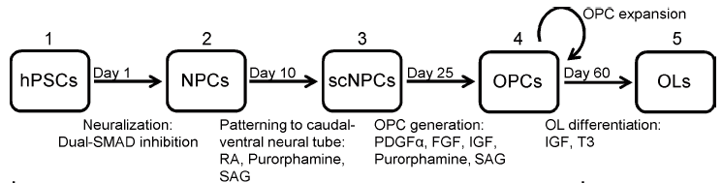

Figure 2: Protocol for conversion of pluripotent stem cells to oligodendrocytes

In brief, to specify oligodendrocytes, neural stem cell (NSCs) are cultured in FGF2 and Shh (or small molecules such as puromorphamine or SAG) to generate Olig2+ precursors. These PDGFRα+ oligoprogenitors (OPCs) differentiated into O4+ oligodendrocytes upon plating and withdrawal of mitogens. This yielded PDGFRα+-oligoprogenitors (Figure 3), immature oligodendrocytes (O4+), and differentiated (MBP+) oligodendrocytes.

The detailed protocol is as follows:

Day -7: Expand PSC line from 2 wells to 6 wells on a fresh matrigel coated plate using the Dispase-Collagenase method.

Day 0 (PSC usually require 7 days to expand): Once the wells are confluent, use the dispase-collagenase method to lift the PSCs. Remove supernatant and resuspend in 10-12ml of Phase I medium and transfer to a 10cm low attachment dish without coating and place in 20% O2 incubator at 37℃.

Feed Mon-Wed-Fri with Phase I for 1 week. Since spheres are small, for feeding, transfer to a 15ml tube and allow to settle before removing the medium and replacing with fresh 10-12 ml Phase I. ­­­­­­

Day 7: Swirl the plate until the spheres accumulate in the center of the plate. Gently remove medium from the sides of the plate using an aspirator. Change the medium to Phase II.

Feed Mon-Wed-Fri with Phase II for 1 week.

Day 14: Plate down the spheres (5-6 per well) on a pre-coated 1:100 laminin plate. Incubate for 2-4 days.

Check after 48 hours for appearance of rosettes. If rosettes are few, wait for further 48 hours; continue feeding with Phase II medium. Else proceed with lifting**.**

Day 16 (or 18): Lift the rosettes onto Phase III medium either by selectively picking using a P1000 pipette or using a sterile scraper. Transfer to a 10cm dish and top up medium to 10-12ml.

Feed Mon-Wed-Fri with Phase III for 1 week.

Day 23: Swirl the plate until the spheres accumulate in the center of the plate. Gently remove medium from the sides of the plate using an aspirator. Change the medium to Phase III-FGF.

Feed Mon-Wed-Fri with Phase III-FGF for 2 weeks.

Day 37: Swirl the plate until the spheres accumulate in the center of the plate. Gently remove medium from the sides of the plate using an aspirator. Change the medium to Oligo Proliferation Medium.

Wait for at least 2 weeks, before using the spheres for dissociations and plate downs for experiments. Spheres in the Oligo Proliferation medium can be maintained for 2 months.

Day 51: Dissociate for plate-downs and check for Olig2, PDGFRa expression at week 1, and O4, MBP expression at week 2-3. Feed with Oligo differentiation medium every 2 days.

The plates can be maintained for 3-4 weeks in Oligo differentiation medium.

**Chopping Spheres**

Once spheres reach between 5-10mm they require chopping. This is done early in the culture and then approximately once a month as and when required. Chopping encourages the proliferation of progenitors and removal of neurons.

Whenever possible, all spheres of a batch should be chopped on the same day (i.e. control and mutant from the same batch)

1. When spheres are ready to be chopped, prepare the blades by washing in 100% ethanol followed by autoclaving (Prepare these a day or two in advance).
2. Place the blades in a petri dish in an orientation that makes it easy for picking up with your fingers (do not let them touch each other if you are using more than one).
3. Make up DNase by adding 500ul of Advance DMEM/F12 (if it does not dissolve quickly, it indicates that it has been exposed to moisture and hence, should not be used).
4. Add a further 4.5ml Advance DMEM to the DNase and mix thoroughly (increase the concentration of DNase if required).
5. Prepare a fresh 90mm dish, labeled with cell line name, derivation, passage number, medium, and date (Affix the cell line name on the bottom of the dish also).
6. Place plate containing the spheres to be chopped in the hood.
7. Swirl the plate until the spheres are all in the center.
8. Remove as much of the medium as possible using an aspirator pipette (leaving only a small amount of medium to chop spheres in).
9. In the dish, chop the spheres using a sterile blade until you can no longer see any lumps, turning the plate every now and then to ensure even chopping. Keep the blade flat whilst chopping. All spheres should be roughly the same size.
10. Use 5mL of Advanced DMEM/F12 to wash off the chopped spheres; collect and transfer them to a prelabeled 15ml tube.
11. Pipette them up and down a couple of times using the 5ml stripette.
12. Centrifuge the spheres for 1 min at 400rcf.
13. Remove the supernatant.
14. Add 500ul DNase (increase the volume depending on the number of chopped spheres) and pipette up and down. Maintain at 37oC for 10 mins. Shake the tube occasionally.
15. After DNase treatment top up the spheres with 10mL Advanced DMEM to wash them. Allow them to settle and remove the supernatant. This may be repeated once more if necessary. Add 12mL oligo proliferation medium and transfer to a fresh prelabeled plate.
16. Place the dish on the orbital shaker in the incubator.
17. The next day allow the cells to settle in a 15ml tube (to remove debris and dead cells).
18. Remove the supernatant.
19. Resuspend in 12mL medium and transfer back to the dish.
20. Replace on the orbital shaker in the incubator.

**Plate coating**

All plates and coverslips must be coated before use. First, with Poly-ornithine and then with Laminin/Matrigel/Fibronectin mixture. Plates should be made in the hood.

Poly-ornithine coating

1. Use forceps or 2ml pipette with suction to handle coverslips; place one coverslip in each well if required (24 well plates only).
2. Calculate the total amount of poly-ornithine coating required (See table below)
3. Make up a 1:100 dilution of Poly-ornithine (within 3 months of opening) in Water for Embryo Transfer in sufficient volume for the plates to be coated.
4. Mix the solution gently.
5. Pipette the required amount of 1:100 Poly-ornithine to each well as shown in table below.
6. Very gently push the coverslip back to the bottom of the well using a pipette tip or a 2ml pipette as they have a tendency to float to the surface on addition of poly-ornithine.
7. Place the plates in a bag labeled Poly-ornithine and the date. Leave at RT in TC overnight. (no longer than 24 hours as Poly-ornithine can be toxic to cells)
8. The next morning, aspirate the polyornithine off. Add Water for Embryo Transfer to each well, enough to fill half the well. Dry by suction. DO NOT touch the center of the coverslip with the suction pipette.
9. Repeat the wash and dry process in step 8 (for a total of 3 washes)
10. Leave the plates fully open under the hood to be air dried and expose the plates to UV for an hour.
11. Place the plates back in a plastic bag in the refrigerator. The plates can be stored for up to 1 month.

|  |  |  |
| --- | --- | --- |
| **Plate** | **Coating type** | **Volume of poly-ornithine** |
| 4 well | Dry coating | 500ul |
| 24 well + coverslip | Dry coating | 500ul |
| 24 well | Wet coating | 500ul |
| 12 well | Semi-dry coating | 1ml |
| 12 well | Wet coating | 1ml |
| 6 well | Wet coating | 1ml |

**Laminin/Matrigel/Fibronectin (L/M/F) coating**

1. Calculate total amount of L/M/F required for coating. (see table below)
2. Prepare L/M/F per 1ml Laminin, 20μl Matrigel, and 20μl Fibronectin. This should be done immediately prior to coating so that it remains cold. Keep it on ice.
3. Remove the prepared poly-ornithine plates from the refrigerator and place in the hood.
4. Pipette the correct amount of L/M/F coating solution to each well/coverslip (volumes in below table). For dry plates try to place the 40ul drop in the center of the coverslip. For wet plating ensure that the whole well is covered.
5. Place the plates in plastic bag labelled with L/M/F, whether dry or wet coated, and the date. Place in the refrigerator overnight. Coating can also be done in 4 hours at 37oC if required earlier.

|  |  |  |
| --- | --- | --- |
| **Plate** | **Coating type** | **Volume of L/M/F** |
| 4 well | Dry coating | 40ul |
| 24 well + coverslip | Dry coating | 100ul |
| 24 well | Wet coating | 250ul |
| 12 well | Semi-dry coating | 400ul |
| 12 well | Wet coating | 600ul |
| 6 well | Wet coating | 1ml |

**Dissociation of oligoprogenitor spheres**

To generate a monolayer of oligoprogenitors (which can be used to make oligodendrocytes), the oligospheres have to be dissociated.

Oligoprogenitor spheres are dissociated using papain dissociation system.

1. Take all the vials that will be needed out of the refrigerator and warm to RT. Always warm up one extra vial of both papain (vial 2) and DNase (vial 3) each in case one vial is not enough.

Reconstitute the dissociation solutions

1. Add 32 mL of Earle’s balanced salt solution (EBSS) (vial 1) to the albumin ovomucoid inhibitor mixture (vial 4) and allow the contents to dissolve while preparing the other components.
2. Reconstitute for the first use, then store at 2-8℃ and reuse.
3. Add 5 mL of EBSS (vial 1) to a papain vial (vial 2). Place vial 2 in a 37°C water bath for ten minutes or until the papain is completely dissolved and the solution appears clear.
4. The solution should be used promptly but can be left at room temperature during the dissociation.
5. Add 500 µL of EBSS (vial 1) to a DNase vial (vial 3) and mix gently. Add 250 µL of this solution into 2×15mL sterile tubes and label them as Papain/DNase and Inhibitor/DNase respectively.
6. Mix gently, as DNase is sensitive to shear denaturation.
7. Add 5mL of the papain solution (from step 2) into the “Papain/DNase” tube. Mix gently.
8. This preparation contains a final concentration of approximate 20 units/ml papain and 0.005% DNase.
9. Add 2.7 mL EBSS (vial 1) and 300 µL reconstituted albumin-ovomucoid inhibitor solution (vial 4) into the “Inhibitor/DNase” tube. Mix gently.

Dissociation of spheres

1. Collect spheres with similar sizes and transfer them to a 15mL tube. Add ~10-13mL of DPBS (~fill the tube) to wash the spheres. Wait a couple of minutes till all spheres settle to the bottom and then remove the supernatant.
2. Add 500μL of Papain/DNase and incubate the tube at 37°C for 30-60 mins. Shake the tube occasionally (~once/10min). Keep an eye on the spheres while dissociating; if they start breaking up quickly incubate for lesser time.

The volume of Papain/DNase is dependent on the total volume of spheres. The volume of the Papain should be ~2 times the volume of spheres.

1. Set up the P1000 to 500μL and pipette up and down until no more spheres can be dissociated. One can be relatively vigorous to get a high yield of cells; however, pay attention to avoid too many bubbles.
2. Allow the spheres to settle down. If required repeat the procedure.
3. Centrifuge at 2.5 RPM for 5 minutes and remove the supernatant. This removes the papain so as to stop the dissociation. Re-suspend the pellet in 300μL of Inhibitor/DNase.
4. Prepare discontinuous density gradient: Add 1mL of reconstituted albumin-ovomucoid inhibitor solution (vial 4) into a new 15mL tube. Carefully layer the cell suspension (from step 15) on top. Wait for a while until all spheres/clumps settle at the bottom. The interface between the two layers of the gradient should be clearly visible.
5. Slowly collect the upper layer and the supernatant of the lower layer. Avoid taking any spheres/clumps and transfer this to the previous tube (or a new one if spheres/clumps are left in the previous tube).

The tip should be placed at the interface between the two layers so that the upper layer that we are targeting, can be collected completely.

1. Centrifuge at 2.5 RPM for 3 minutes and use the P1000 to remove the supernatant. Add 1mL of the oligo proliferation medium to re-suspend the pellet.
2. Conduct cell counting as usual and plate down the requisite number of cells according to the experiment.
   * 1. Detailed protocol for generation of cortical neurons and oligo-neuron cocultures

***Reagents***

Advance DMEM/F12 (Life Technologies, 12634-010)

Accutase (Sigma, A6964)

Penicillin/Streptomycin (Life Technologies, 15070-063)

Murine bFGF (Peprotech, 450-33)

Matrigel basement membrane matrix (SLS, 354230)

Laminin (Sigma, L2020-1MG)

DPBS (Ca-/Mg-) (Life Technologies, 14190-094)

DMSO (Sigma, D2438)

Activin Inhibitor (R & D Systems, 1614/1)

LDN193189 (Stratech, S2618)

IMDM (Life Technologies 21980-32)

F12 (Life Technologies 31765-027)

BSA (Europa EQBAC62 0050)

CD Lipid 100x (Life Technologies, 11905-031)

Monothioglycerol (Sigma, M6145)

Insulin (Roche 1376497)

Transferrin (Roche 652202)

Pen/Strep (Life Technologies, 15070-063)

Glutamax (Life Technologies, 35050-038)

B27 (Life Technologies, 17504-044)

N2 (Life Technologies, 17502-048)

Penicillin-Streptomycin-Fungizone (PSF) (Life Technologies, 15240-062)

***Medium***

**Chemically Defined medium (CDM)**

250ml IMDM

250ml F12

5g BSA

5ml CD Lipid 100x

20ul Monothioglycerol

350ul Insulin

250ul Transferrin

5ml Pen/Strep

**Neuralization medium (Phase I)**

100ml CDM

200ul N-acetyl cysteine

100ul Activin Inhibitor

100ul LDN (100uM)

**RosV2 F2.5**

100ml Advanced DMEM/F12

1ml PSF

1ml Glutamax

1ml N2

100ul B27

12.5ul FGF

**RosV2 F10**

100ml Advanced DMEM/F12

1ml PSF

1ml Glutamax

1ml N2

100ul B27

50ul FGF

**Plating medium**

10ml Advanced DMEM/F12

100ul PSF

100ul Glutamax

50ul N2

100ul B27

10ul Heparin

1.25ul FGF

**Default Medium**

100ml Advanced DMEM/F12

1ml PSF

500ul Glutamax

500ul N2

200ul B27

100ul Heparin (2mg/ml)

**Default + Forskolin**

100ml Advanced DMEM/F12

1ml PSF

500ul Glutamax

500ul N2

200ul B27

100ul Heparin

100ulForskolin

**Co-culture medium (Oligo differentiation medium + BDNF + GDNF)**

100ml Advanced DMEM/F12

1ml PSF

1ml Glutamax

1ml N2

1ml B27

100ul Heparin (5mg/ml)

50ul BDNF

50ul GDNF

50ul IGF

150ul T3

1ml Insulin transferrin solution

**Freezing mix**

45ml RosV2 base without bFGF

5ml DMSO

**Stocks**

LDN 100uM in DMSO

Activin Inhibitor 10mM in DMSO (10mg in 2.4ml DMSO)

(SB431542)

N-acetyl cysteine 500mM in ddH2O (anti-oxidant)

**FGF (20ug/ml)**

FGF2

1. Make 20ug/ml FGF2 in PBS + 0.1% BSA.
2. Aliquot 500ul and 100ul – 20ug/ml stock.

**Plate coating**

All cortical neural precursor cells (cNPCs) need to be plated on coated plates. We used Matrigel (1:100) or Laminin (1:100).

Matrigel is used on all plates for later passages of cNPCs (once they are past P5). Prior to this time or after thawing cNPCs are plated on laminin.

**Matrigel coating**

Matrigel is diluted to 1:100 for cNPCs (usually in 6 well plates).

1. Remove an aliquot of 1:2 Matrigel from the freezer and thaw slowly in the refrigerator.
2. Dilute in cold Advance DMEM/F12 (1ml in 50ml) to give 1:100 Matrigel.
3. Add 1ml 1:100 Matrigel to each well of a 6 well plate to be coated. Ensure that whole well is covered (by tapping).
4. Label plate as “MG 1:100” with date.
5. Plates can then be incubated for 1hour at 37oC, or room temperature for a couple of hours or in the refrigerator overnight (If coating overnight, place the plates in a ziplock bag and lay them flat in the refrigerator).
6. Plates can be stored for up to 7 days in the refrigerator.

**Laminin coating**

Laminin is diluted to 1:100 for cNPCs.

1. Remove an aliquot of Laminin from freezer and thaw slowly in the refrigerator for a few mins.
2. Dilute in cold Advance DMEM/F12 (100ul in 10ml) to give 1:100 Laminin.
3. Add the appropriate amount of 1:100 Laminin to each well to be coated (see table below). Ensure that whole well is covered (by tapping).
4. Label the plate as “Lam 1:100” with date.
5. Plates can then be coated for 4 hours at 37oC, or in the refrigerator overnight (If coating overnight, place the plates in a zip-lock bag and lay them flat in the refrigerator).
6. Plates can be stored for up to 7 days in the refrigerator.

|  |  |
| --- | --- |
| Well plate | Amount of 1:100 laminin for coating |
| 96 | 100ul |
| 24 or 4 | 300ul |
| 12 | 500ul |
| 6 | 1ml |

Procedure at a glance

All neurospheres are fed Mon-Wed-Fri

Day 0 Lift PS to Phase I medium

Feed Mon-Wed-Fri

Day 7 Change plate and medium to RosV2 F2.5

Feed Mon-Wed-Fri

Day 14 Prepare 1:100 laminin 6 well plate

Day 16-20 Plate down RosV2 F2.5 spheres in laminin 6 well plate

Day 17 Prepare 1:100 laminin 96/ 24 well plate (2-4 wells per line)

Day 18-22 Pick neural rosettes and dissociate using Accutase and plate in RosV2 F10 medium

Feed Mon-Wed-Fri (Expand as monolayer and follow cNPC maintenance protocol)

**Lifting IPS to Phase I for neural conversion – Day 0**

Neural conversions and other experiments should be performed with feeder free cultures only.

1. Prepare the tubes – 15ml tubes labeled with line name to be passaged.
2. Prepare 90mm Sterlin dishes – label plates with line name, new passage number, date, and media (Phase I) to be used in that plate.
3. Calculate how much Dispase/Collagenase you will need (0.75-1ml per well to be passaged).
4. Make Dispase/Collagenase enzyme mix (1:1).
5. Remove the plates to be passaged from the incubator and place them in the hood.
6. Remove medium from the wells to be passaged (one line at a time).
7. Add 0.75-1ml Dispase/Collagenase enzyme mix to each well.
8. Repeat step 7-9 if other lines or other plates need to be lifted to Phase 1.
9. Place the plate back in the incubator and leave for 20-30mins until the colonies lift up. Check the plates every 10-15mins.
10. Once the colonies have lifted, remove the plate from the incubator and place in the hood.
11. Add 2ml DPBS to each well.
12. Using the DPBS flush the colonies from the well and transfer them to the labeled 15ml falcon tube.
13. Do not Pipette the colonies up and down to mechanically break them up as the colonies should remain as big as possible for neural conversion (EB formation).
14. Allow them to settle in the tube for 1-2 mins (no more than 5 mins).
15. Once they have settled to the bottom of the tube remove the supernatant using an aspirator.
16. Wash by adding 2-5ml DPBS and shake the tube to ensure that the pellet is washed.
17. Allow to settle again (Do not leave them too long in DPBS, as it affects survival. Also, only the bigger colonies need to settle and not the single cells).
18. Remove by aspirating the supernatant.
19. Add 10ml of Phase I Medium.
20. Transfer the cells to a 90mm labeled dish.
21. Place on the shaker in the incubator to form EBs and then neurospheres.

**Neural conversion**

Dual SMAD inhibition (Phase I) rapidly differentiates pluripotent cells into neuroectoderm. This method causes differentiation by blocking two signaling pathways utilized by SMADs: Bone morphogenetic protein (BMP) and Transforming growth factor beta (TGFbeta).

The resulting neuroectoderm cells can then be patterned to become many types of neural cells or be allowed to differentiate by default to become cortical forebrain cNPCs.

**Day 1**

After lifting the PS, check the cells on the shaker. If the medium is cloudy it must be changed, if not it can be left until the following day before changing.

**Feeding spheres**

Spheres are feed 3 times a week (Monday, Wednesday, and Friday).

Deal with one stack at a time. Do not stack higher than 6 dishes high.

**Day 1-7**

The first medium change after lifting PS must be done by settling the spheres. Thereafter it is done by swirling the plates until the spheres come to the center of the dish.

1. For the first medium change after lifting the PS (Day1 or 2). Prepare 15ml centrifuge tubes with the line name.
2. Remove the dish from the incubator (stop the shaker if necessary).
3. Place the dish in the hood.
4. Using a 10ml stripette transfer the spheres and the medium to the labeled centrifuge tube.
5. Allow the sphere to settle for a minute or two then aspirate off the medium.
6. Resuspend the spheres in 10ml Phase I medium and transfer them back to the 90mm dish.
7. Place it back on the shaker in the incubator and ensure the shaker is turned on.
8. From this point on, the spheres are fed every 2-3 days.
9. 2-3 days later remove the dish from the incubator and place in the hood.
10. Swirl the plate until all the spheres come to the middle of the dish.
11. Using an aspirator pipette, aspirate gently around the edge of the plate to remove most of the medium.
12. Replace with 10-13ml phase I medium.
13. Place the dish back on the shaker in the incubator and turn on the shaker.

**Day 7-16**

After 7 days in phase I medium the spheres would have become neuroectoderms. At this point the medium is changed to a default neural medium to allow default conversion (without adding any patterning factors).

1. On day 7 the dishes are removed from the incubator and placed in the hood.
2. Swirl the dish until all the spheres are in the center.
3. Using an aspirator pipette, aspirate gently around the edge of the plate to remove half of the medium.
4. Replace with 5-6ml RosV2 F2.5 medium.
5. Label the dish as RosV2 F2.5 with the date.
6. Replace on the shaker in the incubator and turn on the shaker.
7. From this point the spheres are feed every 2-3 days.
8. 2-3 days later remove the dish from the incubator and place in the hood.
9. Swirl the plate until all the spheres have come to the middle of the dish.
10. Using an aspirator pipette, aspirate gently around the edge of the plate to remove most of the medium.
11. Replace with 10-13ml RosV2 F2.5 medium.
12. Replace on the shaker in the incubator and turn on the shaker.

Spheres are monitored after day 7-10 in RosV2 F2.5 to observe for neural rosette formation (this usually takes until day 14, but some lines may take up to day 18 before any rosettes are seen). Once rosettes are observed, the spheres are left for 2 more days before plating down (see “plating down neural rosettes” procedure below).

**Plating down neural rosettes**

Two days after neural rosettes are seen in the spheres, they are plated down on 1:100 laminin (see coating protocol above)

1. Prepare a 6-well plate with laminin coating (1:100).
2. Prepare a 15ml tube and label with line name.
3. Remove the dish from the incubator (stop the shaker if necessary).
4. Place the dish in the hood.
5. Using a 10ml stripette transfer the spheres and the medium to the labeled centrifuge tube.
6. Allow the spheres to settle for a minute or two and aspirate off the medium.
7. Resuspend the spheres in 6-12ml RosV2 F2.5 medium (volume depends on number of spheres).
8. Remove the laminin from the dish.
9. Distribute the spheres as equally as possible between the wells (the total number of wells would depend on the number of spheres; not more than 15 spheres should be placed per well).
10. Place the plate in the incubator and shuffle side to side, and back and forth to spread out the spheres (this would enable you to see the boundaries of each sphere for the next step).
11. One day after plating, observe the spheres. If there are many floating (dead) spheres, remove them and replace the medium with 2ml RosV2 F2.5 medium.
12. After 2-3 days check the plated down spheres and determine whether they are ready to be picked (2 days is usually adequate).
13. If ready, prepare a 96/24-well plate by coating with 1:100 laminin (can be done in advance). The number of wells would depend on the number of spheres that are ready to be picked. Roughly, 6-10 spheres can be placed per well in a 96-well plate.
14. If not ready, top up the medium with RosV2 F2.5 every 2-3 days until the spheres are ready for picking.

**Picking neural rosettes**

Rosettes must be selected from the plated down spheres as the cultures are not always pure and cells may be at different stages of neuralization.

1. Precoat a 96/24-well plate with 1:100 Laminin (4 hours in advance @ 37oC or in the refrigerator overnight) at a rate of one well per 6-10 rosettes (spheres) planned to be picked.
2. Prepare the plates – label them with line name, derivation, and date.
3. Prepare 15ml tubes (one per line) for collection of the spheres.
4. Use the objective marker on the microscope to mark the spheres to be selected. While viewing the colonies under the microscope when the desired sphere is seen, turn the objective to the marker and mark the neural rosettes with the marker. Work through the well marking all rosettes that are to be picked.
5. Once they are marked replace in the incubator until ready.
6. Optional (see step 8), when cultures are tricky, very dense, not pure, or non-neuronal cell types have arisen in the culture, the EVOS microscope must be used to select the rosette spheres. The EVOS microscope is prepared by placing it in the hood, spraying and cleaning with 70% IMS, followed by UV irradiation for 20mins. If the spheres are clearly neural and separated from one another easily, EVOS may not be necessary.
7. When ready, remove the plate from the incubator and place in the hood.
8. Either using the EVOS (for difficult lines) or by eye, remove the selected rosettes using a P200 and transfer them into the labeled tube.
9. Place 6-10 rosette spheres into each tube; this is sufficient for a single derivation of one line.
10. Spin for 1min at 1000 RPM.
11. Aspirate the medium.
12. Resuspend in 500ul Accutase. Pipette up and down and leave for 5mins.
13. Using a P200, pipette up and down again. Observe if lumps are still visible. If not move to step 15.
14. If lumps are still visible, leave for another 5 mins and then pipette up and down again, to reduce the lumps.
15. Add 1ml Advanced DMEM/F12.
16. Centrifuge for 2.5mins at 2500 RPM.
17. Aspirate the coating off the plate.
18. Aspirate off the supernatant from the cells and resuspend in 200ul RosV2 F10.
19. Transfer the cells to the well of a 96-well plate.
20. Place the plate in the hypoxic (3% O2) incubator.
21. Check the cells (cNPCs) the next day. If it contains much debris, perform a complete medium change.
22. Monitor the cells daily. Feed every 2-3 days until confluent.
23. Once 100% confluent, passage them to 2 wells of a 96-well plate. Refer flowchart below for size of well to passage onto after confluency (previously coated in 1:100 laminin).
24. cNPCs are fed every 2-3 days by topping up the medium. After the first refeed never remove all the medium from cNPCs.

**Passaging cNPCs**

cNPCs can be passaged to allow bulking up for experiments from the same line and derivation.

1. Check cNPCs daily.
2. Once 90-100% confluent, they are ready for passage.
3. Prewarm RosV2 F10, Accutase, and Advanced DMEM/F12.
4. Prepare coated plates (as above); this can be done in advance.
5. Label the plates with line name, derivation number, passage number, and date.
6. Label 15ml tubes for each line.
7. Remove the plates from the incubator and place in the hood.
8. Aspirate off the medium and replace with Accutase (0.75 ml for 6 wells).
9. Leave at room temperature for 2-3 mins.
10. After 5 mins tap the side of the plate to ensure that the cells are lifting or check under the microscope.
11. Add Advanced DMEM/F12 (to neutralize Accutase) to each well (1ml for 6 wells).
12. Using a P1000, pipette around the well to ensure that all cells are detached.
13. It is important at this stage to ensure that the cells are in single cell suspension by pipetting (avoid excess bubbles).
14. Transfer the cell suspension to the labeled 15ml tube.
15. Centrifuge for 2.5mins at 2500 RPM.
16. Aspirate the supernatant.
17. Resuspend the cells in RosV2 F10 (2ml per well of a 6-well plate).
18. Aspirate the coating from the well.
19. Transfer the cells to the well.
20. Place the plate in a hypoxic incubator and shuffle the cells to ensure that they spread over the whole well.

**Freezing cNPCs**

1. Check cNPCs daily under a microscope.
2. Once 90% confluent, they are ready for passage or freezing.
3. Prewarm cNPC freezing mix, Accutase, and Advanced DMEM/F12.
4. Label cryovials with line name, derivation number, passage number, and date. Label 15ml tubes for each line.
5. Remove the plates from the incubator and place in the hood.
6. Aspirate off the medium and replace with Accutase (0.75 ml for 6 wells).
7. Leave at room temperature for 2-3 mins.
8. After 2-3 mins tap the side of the plate to ensure that the cells are lifting or check under the microscope.
9. Add Advanced DMEM/F12 (to neutralize Accutase), to each well (1ml for 6 wells).
10. Using a P1000, pipette around the well to ensure that all cells are detached.
11. It is important at this stage to ensure that the cells are in single cell suspension by pipetting (avoid excess bubbles).
12. Transfer the cell suspension to the labeled 15ml tube.
13. Centrifuge for 2.5mins at 2500 RPM.
14. Aspirate the supernatant.
15. Resuspend the cells in 1ml cNPC freezing mix (1 vial per well of a 6-well plate).
16. Transfer 1ml of cells and freezing mix to each labeled cryovial.
17. Transfer the vials to Mr. Frosty box and place in -80oC freezer overnight and then transfer to liquid nitrogen.

**Neuronal differentiation and co-culture**

Procedure at a glance

**Day 0** Lift cNPCs and plate down in Default medium (wet plating) or Plating medium (dry plating)

Feed Mon/Wed/Fri

**Day 7**  Change medium to Default+Forskolin

Feed Mon/Wed/Fri

**Day 21** Change medium to Oligo differentiation media +BDNF+GDNF

Feed Mon/Wed/Fri

**Day 35** Fix cells for immunocytochemistry

**Plating down of cNPCs to make cortical neurons**

Once cNPCs are confluent and have been bulked up adequately to perform an experiment (plate down), lift the cells as below and plate.

1. Check cNPCs daily.
2. Once 90-100% confluent, they are ready to be plated down.
3. Prewarm RosV2 F10/Default, Accutase, and Advanced DMEM/F12.
4. Prepare coated plates (as above); this should be done in advance.
5. Label the plates with line name, derivation number, passage number, and date.
6. Label 15ml tubes for each line.
7. Remove the plates from the incubator and place in the hood.
8. Aspirate off the medium and replace with Accutase (0.75 ml for 6 wells).
9. Leave at room temperature for 2-3 mins.
10. After 2-3 mins, tap the side of the plate to ensure that the cells are lifting or check under the microscope.
11. Add Advanced DMEM/F12 (to neutralize Accutase) to each well (1ml for 6 wells).
12. Using a P1000, pipette around the well to ensure that all cells are detached.
13. It is important at this stage to ensure that the cells are in single cell suspension by pipetting (avoid excess bubbles).
14. Transfer the cell suspension to the labeled 15ml tube.
15. Centrifuge for 2.5mins at 2500 RPM.
16. Aspirate the supernatant.
17. Resuspend the cells in Plating medium (if dry plating) or Default medium (if wet plating), usually in 0.5-1ml medium.
18. Count the cells using a hemocytometer.
19. Remove the prepared LMF plates from the refrigerator/incubator and place in the hood.
20. Once cells are ready, remove the L/M/F drop from the coverslips carefully using an aspirator.
21. Plate 35,000 cells in 500μl default media per well of a 24-well plate on the coverslip.
22. Place in the hypoxic incubator (3% oxygen) for 3-4 hours allowing the cells to attach.
23. The next day, check if the cells are still attached.
24. On day 3, add 500ul of Default medium to each well (gently) and replace in the incubator.

**Feeding and medium changes for differentiation**

From this stage onwards the plates are fed with the same media until taken up for experiments. Check the plates under the microscope at least twice a week at all stages.

After day 7 add Forskolin to the default media and feed the cultures. Forskolin encourages the cNPCs to exit the cell proliferation cycle.

Day 7

1. Pre-warm Default + Forskolin medium.
2. Remove the plates from the incubator.
3. Top up the well with medium (do not remove existing media at this stage).

Day 10, 14, and 18

1. Pre-warm Default + Forskolin medium.
2. Remove the plates from the incubator.
3. Remove about half the media gently and replace gently (see below for rough guide of volumes to remove and add).

|  |  |  |
| --- | --- | --- |
| **Plate** | **Volume to remove** | **Volume of add** |
| 24 well | ~800ul | ~1ml |
| 12 well | ~1ml | ~1.5ml |
| 6 well | ~1.5ml | 2ml |

**Day 21 (Co-culture)**

At this point, change the medium; incubate the neurons in co-culture medium for one hour. In parallel, dissociate the oligospheres with Papain as detailed earlier and plate them on the neuronal layer. These cultures are usually done on coverslips in a 24-well dish. Hence, use the plating densities given in the above Table (wet plating). From this point onwards, the plates are fed with the same media until day 35, when they are taken up for experiments. Check the plates under the microscope at least twice a week at all stages.

1. **RESULTS**
   1. FMR1 NULL ES AND FXS IPS AS A MODEL SYSTEM

To interrogate the specific objectives of this project, multiple control and FXS patient derived IPS were available from my co-guide (SC) laboratory (Table 2); these were generated from donor fibroblasts using integration free Sendai virus. To complement FXS IPS, two clones (G3 and E6) of FMR1 null (knock-out) ES generated using CRISPR/Cas9 genome editing (deletion of 5’UTR and exon-1) were also available from SC laboratory (Appendix figure 1).

**Table 2: PS lines used for oligodendrocyte differentiation**

|  |  |  |
| --- | --- | --- |
| **Control/FXS/edited** | **Age (years)/Sex** | **Repeat size** |
| FXS IPS 1 | 23/M | 222 |
| FXS IPS 2 | 22/M | >200 |
| FXS IPS 3 | 20/M | >200 |
| FXS IPS 4 | 4/M | >200 |
| Control IPS1 | 14/M | 16 |
| Control IPS2 | 76/M |  |
| Control ES | NA/M |  |
| Edited ES | NA/M |  |

ES and IPS lines were maintained on Matrigel-coated plates and with Essential 8 media. Pluripotency was confirmed through expression of pluripotency markers Oct4 and Nanog (Figure 3A). Immunocytochemistry for the PS confirmed that all the lines were pluripotent before the initiation of oligodendrocyte differentiation. Further, Western blot analysis confirmed the absence of FMRP in FXS IPS and both clones of the FMR1 null ES (Figure 3B).

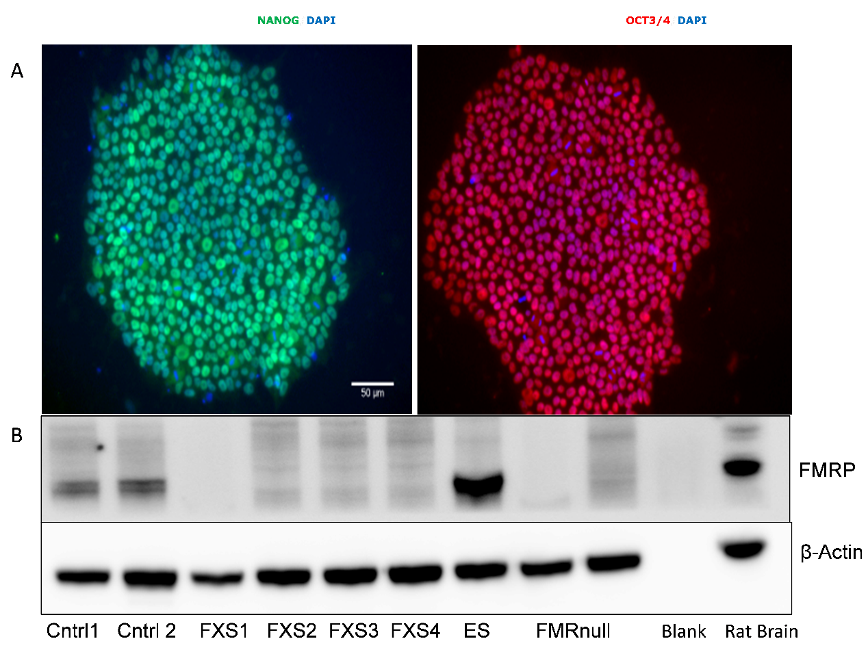

Figure 3: Characterization of PS. A) Representative staining identifies Nanog and Oct3/4 positive control IPS1. Scale bar 50µm. B) FMRP Western blot of the FXS IPS, FMR1 null ES, control IPS, and control ES. The FMR1 null ES and FXS IPS show the absence of FMRP.

* 1. GENERATION AND BASIC CHARACTERIZATION OF OLIGODENDROCYTES FROM MUTANT AND CONTROL PS

Oligodendrocytes were generated using the 90-day protocol previously described in the methods section (Fig. 4A) from FXS IPS 1-4, FMR1 null 1-2, control IPS 1-2 and control ES. Overall, there were no differences in the efficiency of specification to oligoprogenitors and oligodendrocytes (Figure 4B-C). Quantitative flow cytometry performed 1 week after differentiation revealed that cultures gave rise to a majority of (Fig. 4C) O4-labelled oligodendrocytes (ES, 48±5%; control IPS1, 45±4%; control IPS2, 47±4%; FMR1 null1, 44±4%; FMR1 null2, 46±4%; FXS IPS1, 44±5%; FXS IPS2, 45±4%; FXS IPS3, 45±7%; FXS IPS4, 46±4%). Notably, O4+ oligodendrocytes exhibited high co-expression of myelin basic protein (MBP) on immunocytochemistry (ES, 85±5%; control IPS1, 80±4%; control IPS2, 84±5%; FMR1 null1, 79±5%; FMR1 null2, 78±4%; FXS IPS1, 78±4%; FXS IPS2, 80±4%; FXS IPS3, 85±4%; FXS IPS4, 81±6%). The remaining cells were a mixture of astrocytes and oligoprogenitors, with only few neurons (Figure 5).

It was noted that the FXS IPS and FMR1 null ES derived oligodendrocytes stayed in culture for a shorter duration than those derived from controls (Figure 6). The cells were seen to float off within 9.2±1.6 days in the mutant cell lines (FMR1 null1, 8±2; FMR1 null2, 8±2; FXS IPS1, 10±3; FXS IPS2, 9±3%; FXS IPS3, 12±5; FXS IPS4, 8±3), whereas they floated off after 20.3±0.6 days in control cell lines (ES, 21±3; control IPS1, 20±2%; control IPS2, 20±2). However, cellular proliferation rates (Figure 7, 8) and viability (Figure 9) were not different across mutant and control oligodendrocytes.

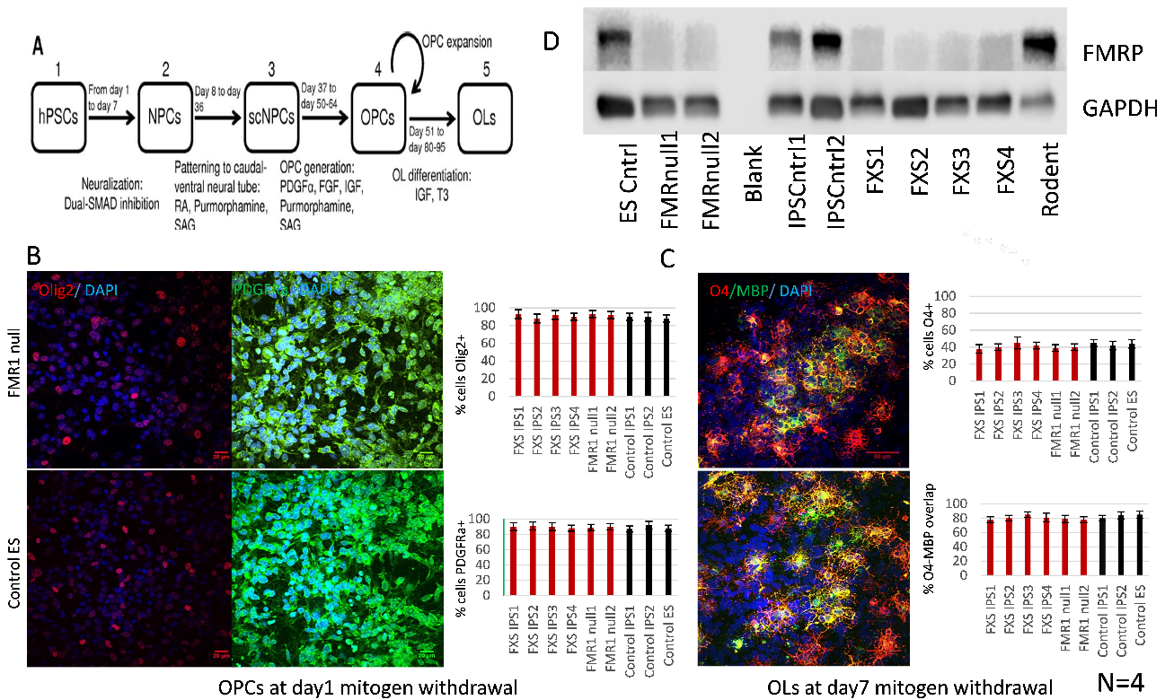

Figure 4: Efficiency of specification of oligoprogenitors and oligodendrocytes. A) Schematic of the 90-day protocol used to generate oligodendrocytes from PS. B) Left panel: Representative staining of cells 1-day post-mitogen removal identifying OLIG2+ and PDGFRa+ progenitors. Scale bar 20 µm. Right panel: Percentage of OLIG2+ cells PDGFRa+ cells in day 1 cultures. C) Left panel: Representative staining of cells 1-week post-mitogen removal identifying O4+ and MBP+ progenitors. Scale bar 50 µm. Right panel: Percentage of O4+ cells and O4-MBP overlap in day 7 cultures. D) FMRP Western blot of the oligodendrocytes derived from FXS IPS, FMR1 null ES, control IPS and control ES, FMR1 null ES and FXS IPS derived oligodendrocytes showing the absence of FMRP. Abbreviations: DAPI, 4’,6-diamidino-2-phenylindole; MBP, myelin basic protein; PDGFRa, platelet derived growth receptor alpha.

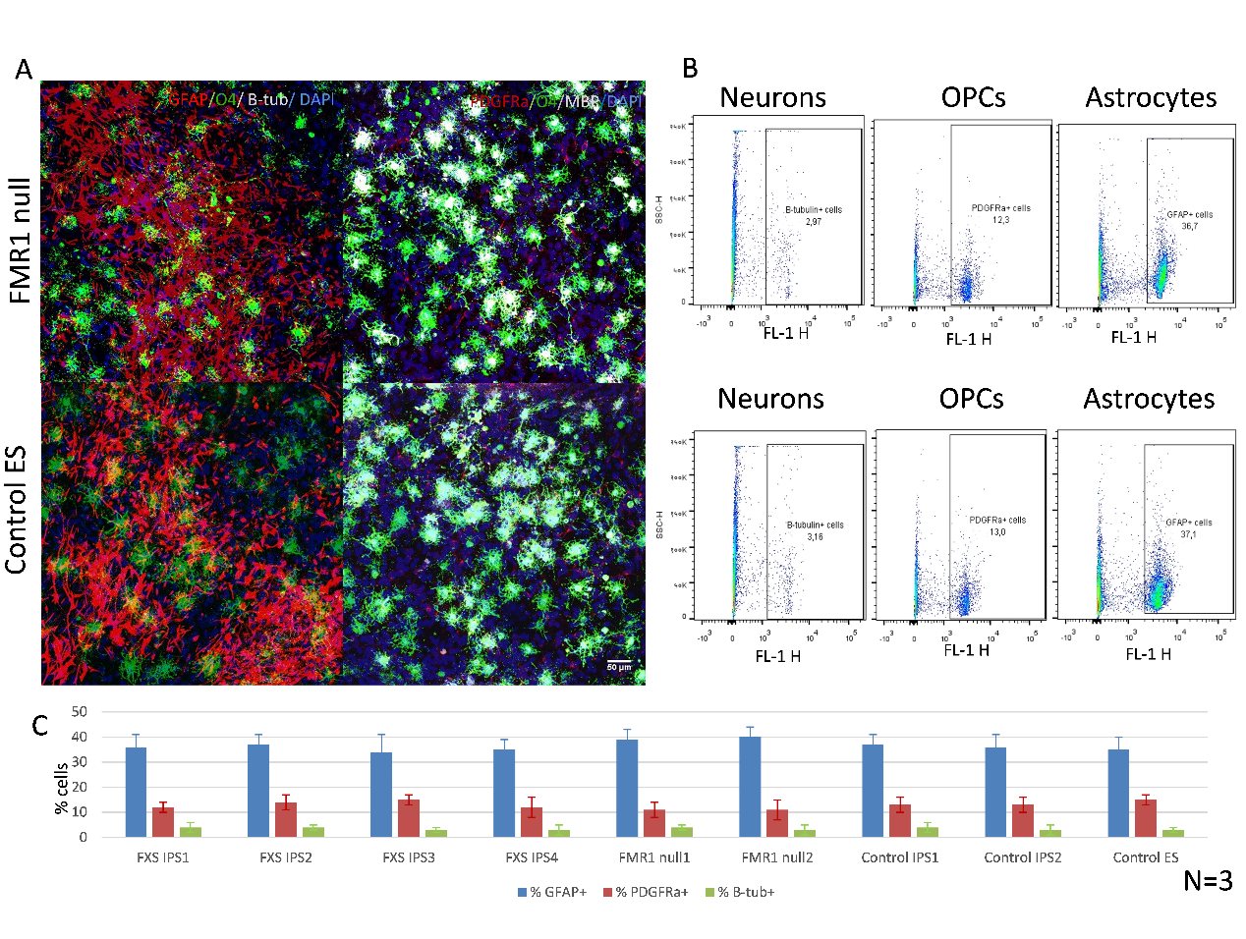

Figure 5: Non-oligodendrocytes in 1-week cultures. A) Representative staining of cells 7-day post-mitogen removal identifying GFAP+ astrocytes, PDGFRa+ oligoprogenitors, and Beta-tubulin+ neurons. Scale bar 20 µm. B) Representative quantification of cells using flow cytometry. C) Percentage of GFAP+ astrocytes, PDGFRa+ oligoprogenitors, and Beta-tubulin+ neurons in day 7 cultures. Abbreviations: DAPI, 4’,6-diamidino-2-phenylindole; MBP, myelin basic protein; PDGFRa, platelet derived growth receptor alpha, GFAP, glial fibrillary acidic protein.

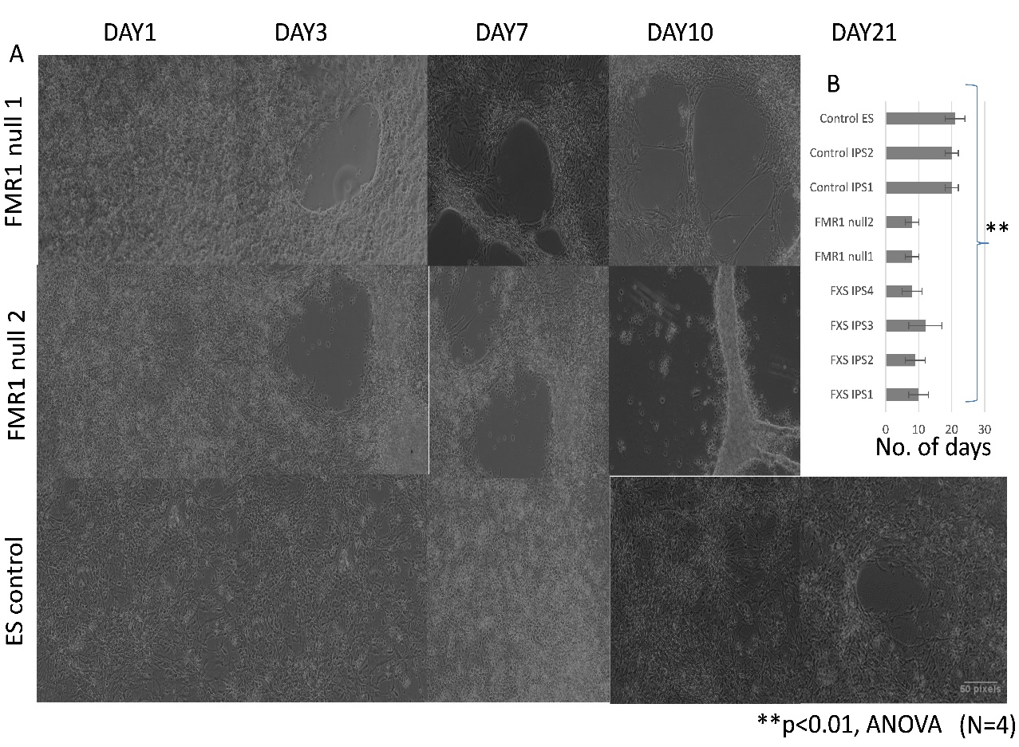

Figure 6: Oligoprogenitor platedowns from FXS/FMR1 null background stay in culture for shorter duration. A) Representative phase contrast images at specific time points from day 1-21. B) Quantification of the number of days that each cell line stayed in culture before floating off.

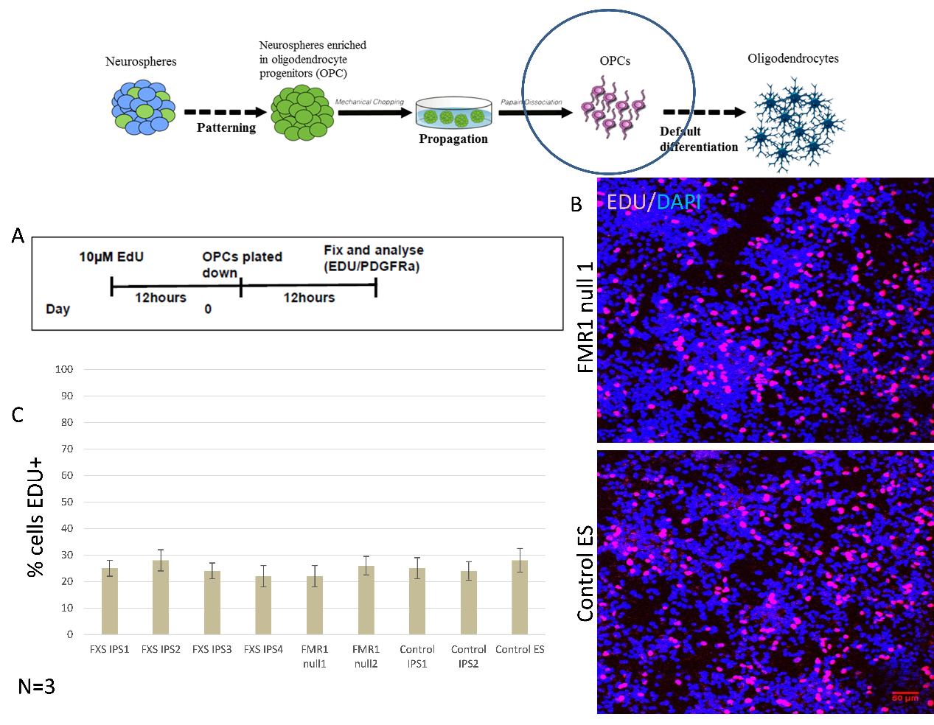

Figure 7: Cell proliferation assay in oligodendrocyte lineage cells. A) Protocol used to examine cellular proliferation at 12 hours post platedowns. B) Representative staining at 12 hours identifies EdU+ cells in the S phase of cell cycle. Scale bar 50µm. C) Percentage of EdU+ cells at 12 hours. Abbreviations: DAPI, 4’,6-diamidino-2-phenylindole; EdU, 5-ethynyl-2’-deoxyuridine; OPC, oligoprogenitor cells.

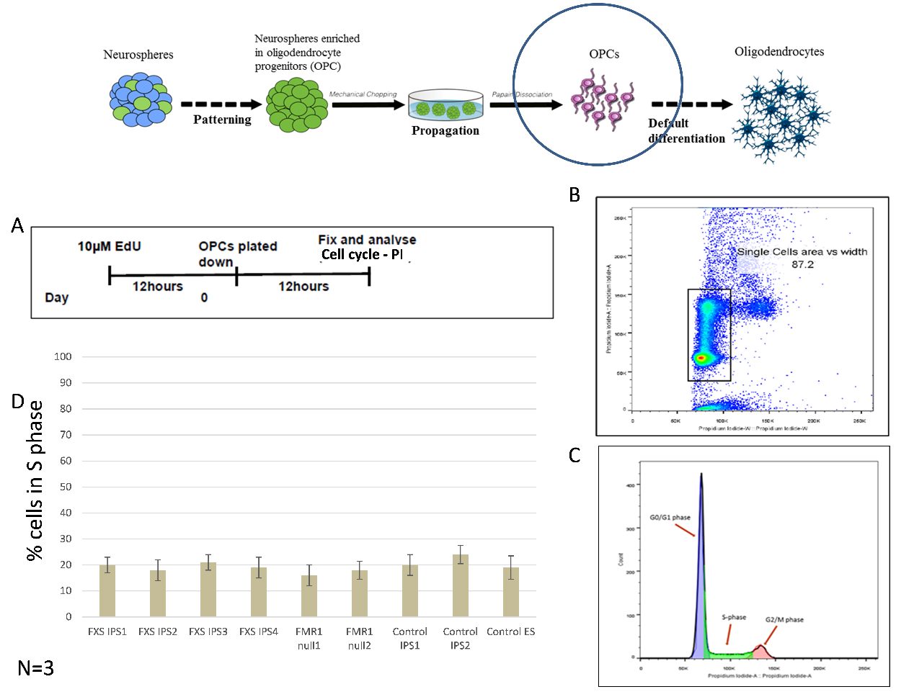

Figure 8: Cell cycle analysis in oligodendrocyte lineage cells. A) Protocol used to examine cell cycle at 12 hours post platedowns by flow cytometry. B) Representative flow cytometer scatter plot for cell cycle assay. Dot plot for PI, to show gating of single cells using width versus area parameters. C) Illustrates PI area parameter histogram plot of the singlet cells to determine percentage of cells in G0/G1, S and G2/M phases of the cell cycle D) Percentage of cells in S phase. Abbreviations: PI, propidium iodide; OPC, oligoprogenitor cells.

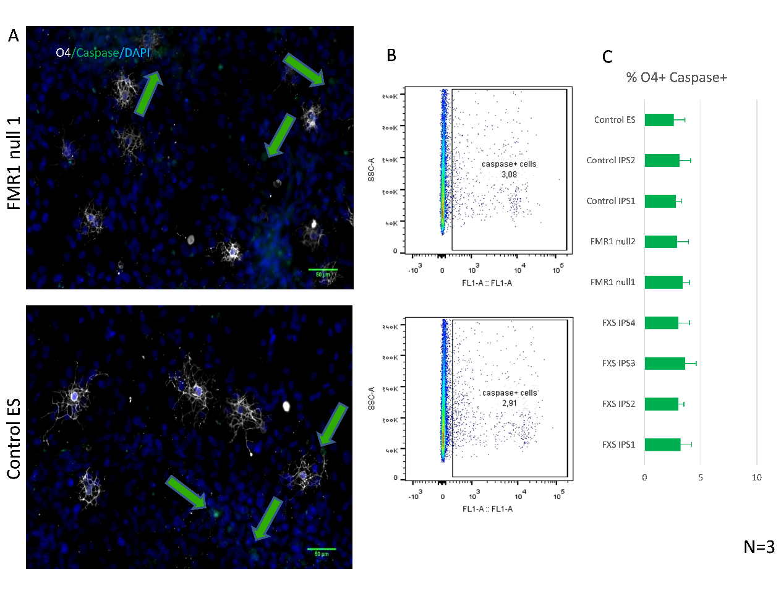

Figure 9: Viability analysis of oligodendrocytes at 1 week using Cell event Caspase 3/7 reagent. A) Representative staining of O4+ oligodendrocytes and Caspase+ apoptotic cells in day 7 cultures. Scale bar 50µm. B) Quantitative flow cytometry in day 7 oligodendrocytes. C) Percentage of Caspase+ cells in day 7 oligodendrocytes.

* 1. MORPHOLOGY OF OLIGODENDROCYTES

O4+positive oligodendrocytes display unique morphology with many elongated and branching processes. This is particularly important as these cells are usually in contact with multiple axons during the process of myelination. The morphology of O4+ cells were compared between mutant and control lines using Sholl analysis. Oligodendrocytes from FXS/FMR1 null background were morphologically different from those from controls. They were found to have reduced arborization in Sholl analysis (Figure 10). This analysis was done using high magnification images (63x). One obvious question was whether this morphological difference is due to differences in cell health/viability. As previously described, this was examined in day 7 cultures (Figure 9), but no differences were found between mutant and control lines.

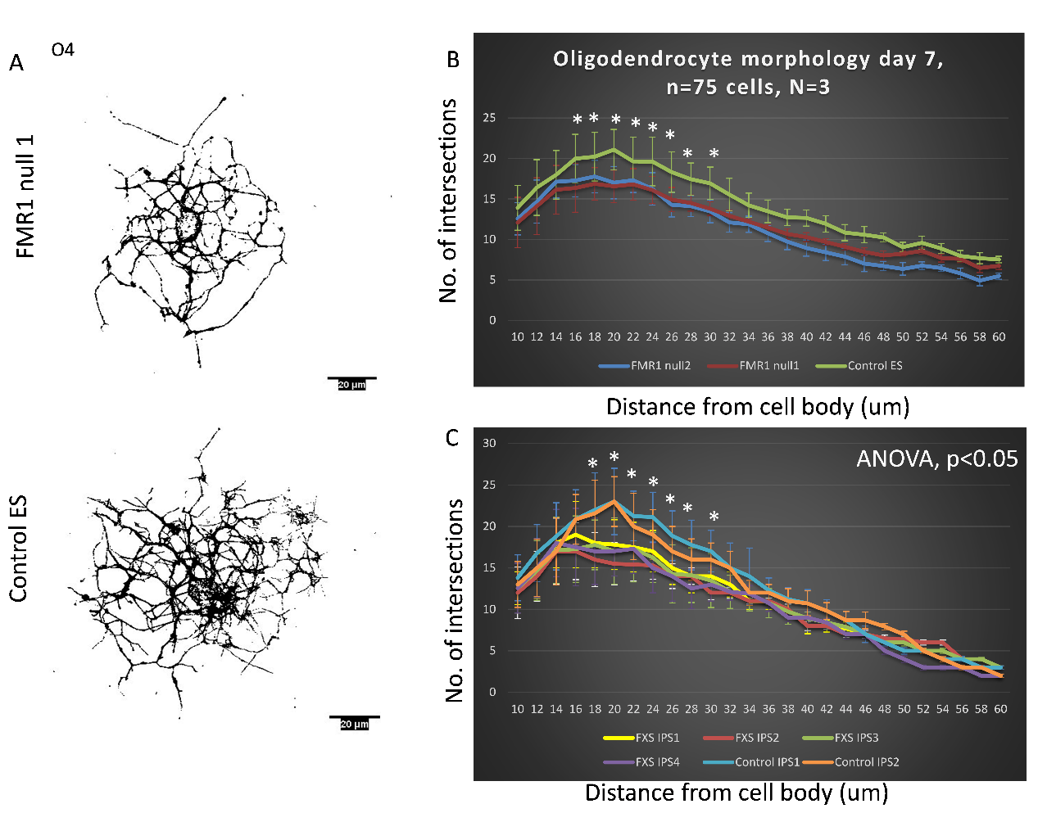

Figure 10: Sholl analysis performed on week 1 O4+ oligodendrocytes. A) Representative thresholded images of O4+ cells at day 7. Scale bar 20µm. B) Comparison of morphology between FMR1 null ES and control ES derived oligodendrocytes. C) Comparison of morphology between FXS IPS and control IPS derived oligodendrocytes.

* 1. GLYCOLYTIC ASSAY IN OLIGODENDROCYTES

Differences in glycolytic capacity have been known to cause cell death and process retraction in oligodendrocytes (Rone et al., 2016). Hence, the metabolic function of oligodendrocytes (glycolysis stress test) was assessed using the Seahorse XF bioanalyzer on day 7, to examine differences between mutant and control oligodendrocytes in glycolytic function (Figure 11A).

During glycolysis, glucose is converted to pyruvate, and subsequently lactate. This increases the net production of protons leading to their extrusion into the extracellular compartment. The resultant acidification of the medium surrounding the cell is measured by the instrument as the extracellular acidification rate (ECAR). The assay workflow is as follows. Initially, ECAR measurements are performed on cells incubated without glucose or pyruvate. They are first injected with a saturating concentration of glucose. The cells utilize the injected glucose, catabolizing it through the glycolysis, thus rapidly increasing the ECAR. This is recorded as the basal rate of glycolysis. This is followed by a second injection of oligomycin. Oligomycin is an adenosine triphosphate (ATP) synthase inhibitor; the subsequent inhibition of mitochondrial ATP production forces the energy production to shift to the glycolytic pathway. This additionally elevates ECAR and the maximum glycolytic capacity is thence recorded. The final injection is 2-deoxy-glucose (2-DG), a glucose analogue. It competitively binds to glucose hexokinase, thus inhibiting glycolysis. The glycolytic reserve is calculated as the difference between maximum glycolytic capacity and basal rate of glycolysis. The ratio of glycolytic reserve to maximum glycolytic capacity in percentage forms the glycolytic reserve percentage.

There were no differences across groups with respect to basal glycolysis, glycolytic reserve capacity, and glycolytic reserve. However, there was significant difference found in terms of glycolytic reserve percentage, with mutant cultures exhibiting higher values in comparison to controls (Figure 11B-C). A higher level of glycolysis reserve percentage is usually shown by cells that are under some manner of stress.

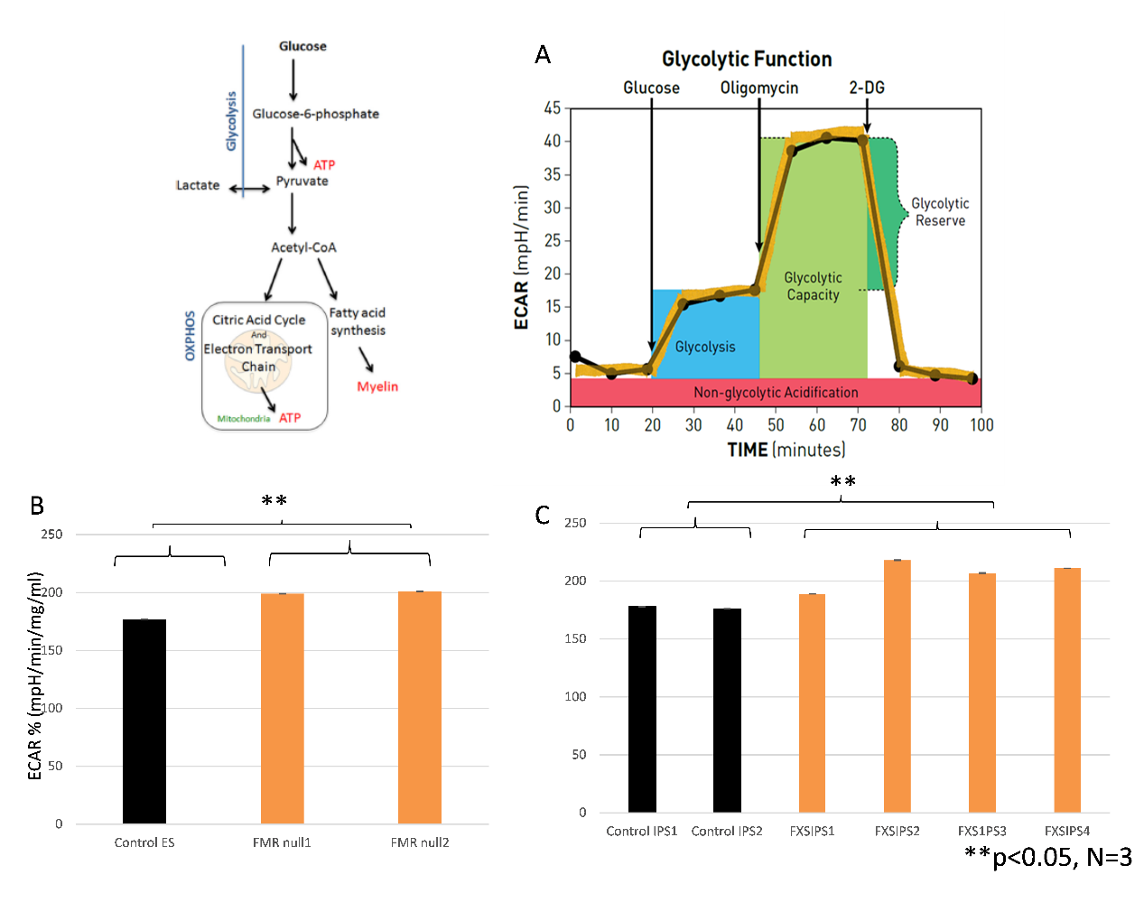

Figure 11: Glycolysis stress test of oligodendrocytes at 1 week. A) Extracellular acidification is measured by serial addition of glucose, oligomycin and 2-deoxyglucose to measure glycolysis, glycolytic capacity, and glycolytic reserve, respectively. B) Quantified comparison of extracellular acidification rate between FMR1 null ES and control ES derived oligodendrocytes. C) Quantified comparison of extracellular acidification rate between FXS IPS and control IPS derived oligodendrocytes. Abbreviations: ECAR, extracellular acidification rate, 2DG, 2-deoxy glucose.

* 1. ELECTROPHYSIOLOGY OF OLIGODENDROCYTES

The electrophysiological properties of oligodendrocytes were examined using whole-cell patch-clamp recording. The maturation of oligodendrocytes from OPCs (identified using O4 live-staining) recapitulates the equivalent process in rodents (Sontheimer et al., 1989; Tripathi et al., 2011) by demonstrating a developmental reduction in the outward rectification of sustained voltage-dependent currents (Livesey et al., 2016). Patient and control lines were compared in terms of maturity of current responses and the degree of shift in current rectification in week 1 O4*+* oligodendrocytes (Figure 12). Preliminary experiments did not reveal any differences across groups with respect to capacitance and input resistance.

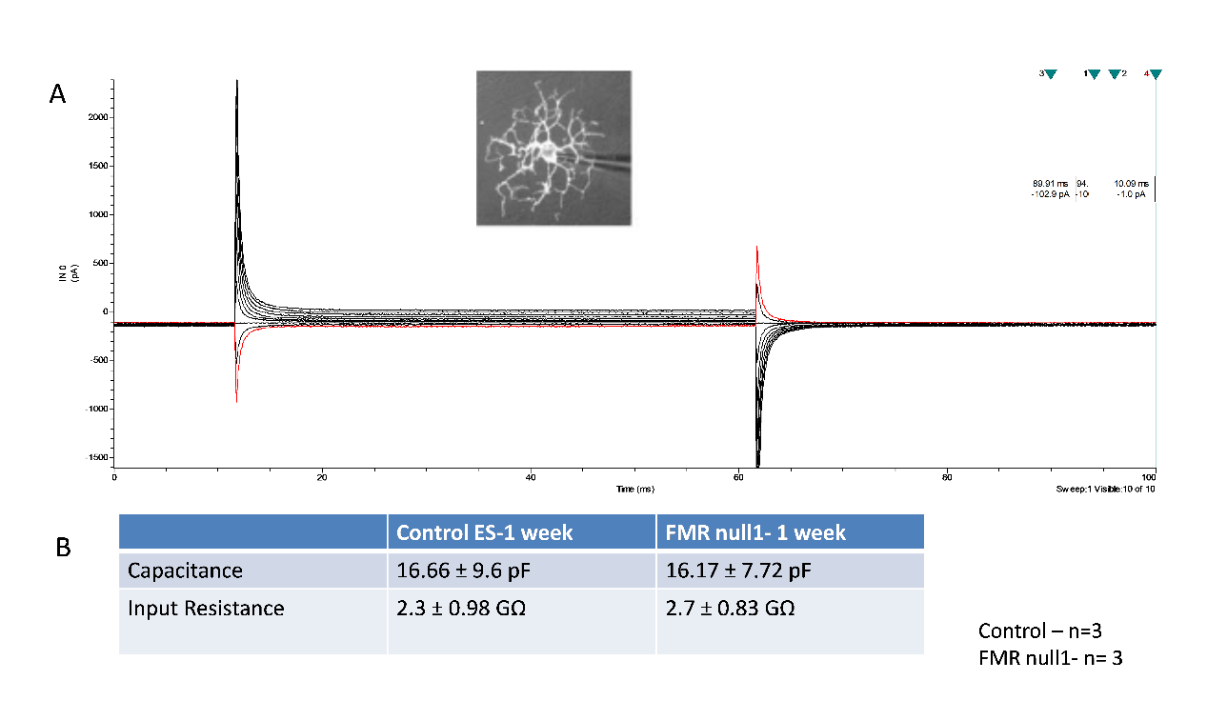

Figure 12: Electrophysiology of 1-week old oligodendrocytes. A) Whole‐cell current recordings from week 1 O4+ oligodendrocyte in response to a voltage‐step protocol that involved incremental application of 20 mV voltage steps from a holding potential of –84 mV. B) Quantification of input resistance and capacitance compared across FMR1 null ES and control ES derived oligodendrocytes.

* 1. MYELINATION ASSAY

Co-culture of PS derived cortical neurons and oligodendrocytes from the same genetic background was performed to examine myelination. The morphology of MBP+ cells were compared between FMR1 null and control lines using Sholl analysis. Oligodendrocytes from FXS/FMR1 null background were different from those from controls in terms of myelin arborization. They were found to have reduced arborization in Sholl analysis (Figure. 13).

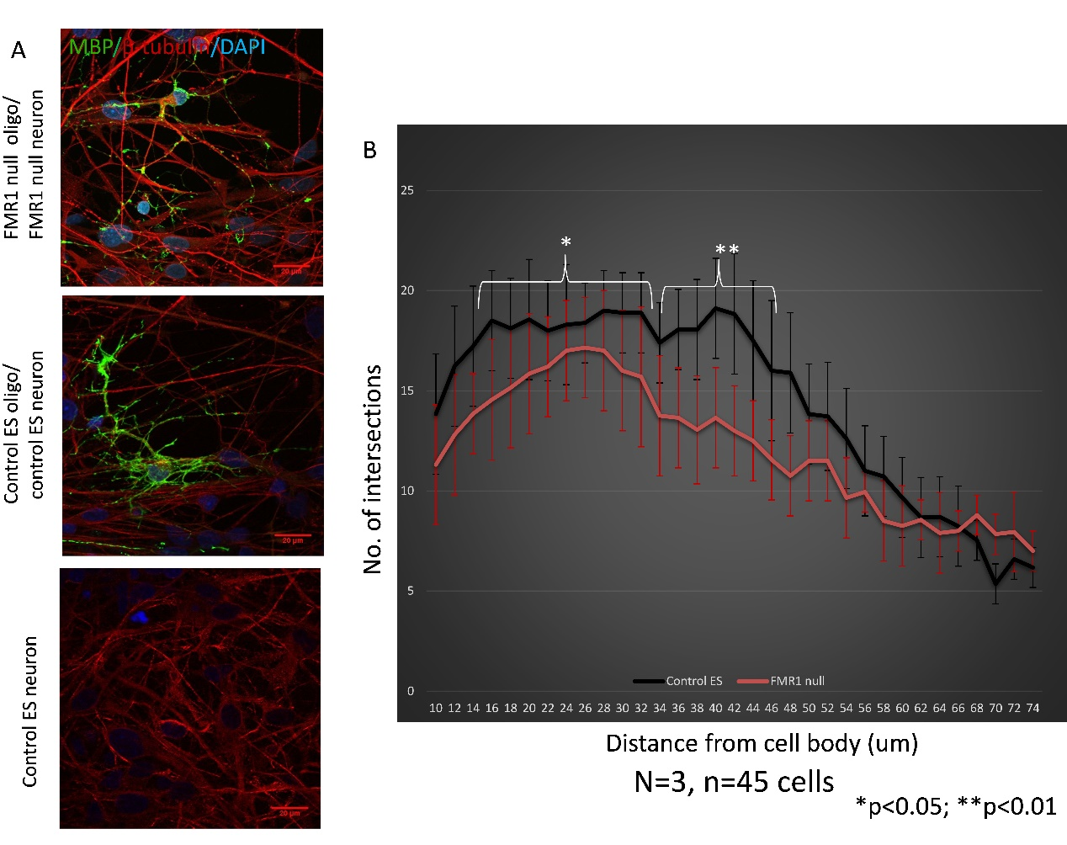

Figure 13: Arborization of myelin in oligodendrocytes co-cultured with IPS derived neurons for 14 days. A) Representative staining of MBP+ oligodendrocytes cultured on β-tubulin+ neurons on day 14. Scale bar 20µm. B) Comparison of myelin arborization between FMR1 null ES and control ES derived oligodendrocytes on day 14.

1. **DISCUSSION**

We derived oligodendrocyte lineage cells using pre-generated and validated IPS from patients with Fragile X Syndrome (FXS) and unrelated healthy controls, to study quantitative differences with respect to structure, physiology, metabolic function, and myelination. These findings were also confirmed using FMR1 null ES lines and paired controls to establish a causal link to the FMR1 mutation. The findings, although novel and encouraging, have to be discussed in the light of various limitations of this study. We have used relatively few number of patients IPS lines. The patients and controls were not age matched. Age is known to have an effect on the efficiency of reprogramming to IPS (Khoo et al., 2020). However, once de-differentiated to IPS, they are similar to ES lines. In addition, we have used FMR1 null ES and paired control ES to confirm all the results from IPS comparisons. However, there is a need to confirm most of the findings using larger set of patient lines, and confirmation in gene corrected IPS lines. Similarly, in vitro myelination models are largely inadequate to understand disease biology. In vivo myelination systems are best for examination of compact myelin formation by oligodendrocytes.

Some of the preliminary findings include morphological defect in patient/mutant lines with reduced oligodendrocyte arborization, myelin arborization defect in patient/mutant lines when co-cultured with neurons, glycolytic defect with increased glycolytic reserve percentage in patient/mutant lines, and adhesion defect with patient/mutant lines floating off earlier than controls from culture dishes. There were no differences in efficiency of specification, proliferation, viability and physiology.

* 1. MORPHOLOGICAL DIFFERENCES

The comparison of mutant and control lines revealed that the mutant oligodendrocytes exhibit the morphological defect of reduced branching.

Oligodendrocytes have the dynamic capability to extend processes, sense axons, and myelinate approximately 40 different axons (Allen & Lyons, 2018). Process extension and axonal contact are crucial for myelination. To initiate the process of myelination, immature post-mitotic oligodendrocytes first extend several cytoplasmic protrusions/filipodia (similar to growth cones in developing neurons), to locate axons suitable for myelination. Initially, the microfilament-rich filipodia extend, following which they are invaded by microtubules. This further enlarges these processes converting them to lamellipodia. To accommodate this quick, directed growth, microfilament polymerization and branching increases in the oligodendrocyte cytoskeleton in response to extracellular matrix/axonal signals. Some of these signals include Jagged-1, (Decker, Avellana-Adalid, Nait-Oumesmar, Durbec, & Baron-Van Evercooren, 2000; Fewou, Ramakrishnan, Bussow, Gieselmann, & Eckhardt, 2007) which associates with Notch-1 receptors (Fan et al., 2018; Q. D. Hu et al., 2003; S. Wang et al., 1998; Watkins, Basu, & Bogenhagen, 2008), and Lingo-1, which interacts with the Nogo receptor to inhibit process outgrowth, and thereby myelination (Mi et al., 2005; Shao et al., 2017). Other signals include the binding of laminin-α2 with the β1-integrin receptors on oligodendrocytes, to promote initial process extension (Colognato et al., 2002; J. Hu, Deng, Wang, & Xu, 2009; Ly, Stewart, & Pallen, 2018; Morissette & Carbonetto, 1995; Relucio, Menezes, Miyagoe-Suzuki, Takeda, & Colognato, 2012) leading to an activating dephosphorylation at the inhibitory Tyr531 site, in the nonreceptor tyrosine kinase Fyn. The subsequent activation of the integrin-linked kinase (ILK), particularly interesting new cysteine-histidine-rich protein (PINCH), and α-parvin, leads to the polymerization of actin (Bauer et al., 2009; Liang, Draghi, & Resh, 2004). Further, WAVE 1 (the neural Wiskott-Aldrich syndrome protein/Arp2/3 complex), and paxillin are activated at focal adhesion sites, catalyzing the mobilization of downstream modulators of actin polymerization and microtubule assembly. This happens via the focal adhesion kinase (FAK) mediated activation of RhoGTPases (Cdc42 and Rac1) (Bacon, Lakics, Machesky, & Rumsby, 2007; Chun, Rasband, Sidman, Habib, & Vartanian, 2003; Kim, 2008; O'Meara et al., 2013). Fyn activation blocks the inhibitory actions of RhoA, through phosphorylation of the small GTPase proteins p190/p250 RhoGAP (Kippert, Trajkovic, Rajendran, Ries, & Simons, 2007; Taniguchi et al., 2003; Wolf, Wilkes, Chao, & Resh, 2001). Inhibition of RhoA leads to hyperextension of oligodendrocyte processes and increased branching (Liang et al., 2004). Fyn activation also induces tyrosine phosphorylation of FAK (also known as protein tyrosine kinase (PTK2)), which has an inhibitory effect on process expansion/elaboration in the presence of fibronectin-rich extracellular matrix (Lafrenaye & Fuss, 2010).

FMRP interacts with many of the above stated processes and pathways. It binds to and controls the translation of mRNAs downstream of metabotropic glutamate receptor (mGluR) activation, which includes striatal-enriched protein tyrosine phosphatase (STEP; Ptpn5). STEP dephosphorylates Fyn (Goebel-Goody et al., 2012), which is a key mediator of oligodendrocyte process expansions as explained above. In addition, FMRP interacts directly with the cytoplasmic proteins CYFIP1 and CYFIP2, which link FMRP to the RhoGTPase pathway (Bonaccorso et al., 2015), allowing it to regulate cytoskeletal remodeling through modulation of actin polymerization and microtubule assembly in the oligodendrocytes. Integrin-linked kinase, a focal adhesion protein regulated by FMRP, has been found to regulate oligodendrocyte cytoskeleton, morphology and adhesion (Michalski, Cummings, O'Meara, & Kothary, 2016).

Interestingly, the morphological differences that we have found are similar to what has been described in neurons from FXS patients. Human FXS ES derived neurons have significantly smaller somata, and shorter and less tortuous neurites than control neurons (Telias, Kuznitsov-Yanovsky et al., 2015). The authors suggest that the downregulation of FMR1 impairs the process of neuronal maturation at a very early stage. Morphological defects have been found in neurons isolated from FMR1 null mice (Castren, 2006; Comery et al., 1997; Irwin, Galvez, & Greenough, 2000; Thomas, Combe, Dyar, & Inglis, 2008). However, only one study so far has reported similar results in human post mortem FXS brains (Irwin et al., 2001). A study using neurons differentiated from FXS IPS has also shown reduced arborization of neurites (Doers et al., 2014).

* 1. ADHESION DEFECTS

The oligodendrocytes from FXS patients and FMR1 null oligodendrocytes show clear adhesions deficits when cultured as monolayer. This indicates possible defects in the extracellular matrix (ECM) in the mutant background. ECM in the central nervous system confers elasticity and contributes to signalling pathways that impact adhesion and repulsion (Kleinman, Philp, & Hoffman, 2003). These molecules include proteoglycans, glycosaminoglycans, and non-collagenous glycoproteins (e.g., laminin, fibronectin) (Rutka et al., 1988). These molecules are also particularly important neurodevelopmentally as they form physical and biochemical barriers and paths that guide cell migration, axonal growth, and dendritic spine formation. Matrix metalloproteinases (MMPs) are a family of extracellular endopeptidases that cleave various components of the ECM (Gururajan, Grenet, Lahti, & Kidd, 1998). A stringent balance of proteolytic enzymes and their inhibitors is essential for appropriate maintenance of ECM structures. Proteolytic cleavage of cell-to-cell adhesion proteins such as N- or E-cadherins by MMPs can also influence various neurodevelopmental processes.

FMRP directly influences the above processes by regulating the translation of MMP-2 and MMP-9. FMRP regulates the translation of the MMP-2 and MMP-9 mRNAs in the hippocampus (Janusz et al., 2013) and FMR1 null mice exhibit higher levels of MMP-2 and MMP-9 activity in the hippocampus in comparison to their wild type counterparts (Sidhu, Dansie, Hickmott, Ethell, & Ethell, 2014). Transgenic FMR1/MMP-9 double null mice do not have many FXS associated features, indicating that MMP-9 activity is required for these features to develop. In addition, pharmacogenetic inhibition of MMP-9 translation reverses FMR1 null phenotypes (Gkogkas et al., 2014). Similar findings have been reported in the Drosophila model of FXS, where overexpression of MMP rescues the nervous system defects in the *dfmrp* null flies. Integrins and Eph receptors are considered the likely mediators of MMP-9 effects in FMR1 null neurons (Ethell & Ethell, 2007). As previously stated, Integrin-linked kinase has been found to regulate oligodendrocyte cytoskeleton, morphology and adhesion (Michalski et al., 2016).

Another adhesion molecule which is directly regulated by FMRP is protocadherin 10 (PCDH10). PCDH10 has also been independently associated with autism spectrum disorders (Morrow et al., 2008). The activity-dependent transcription factor myocyte enhancer factor 2 (MEF2) and FMRP cooperatively regulate the expression of PCDH10. FMRP also directly regulates the expression of N-cadherin, an important adhesion molecule with direct effects on cellular migration (La Fata et al., 2014). Other cadherins which have been associated with autism per se are CDH5, CDH8, CDH9, CDH10, CDH13, CDH15, PCDH10, PCDH19 and PCDHb4, mostly through genome-wide association studies (Redies, Hertel, & Hubner, 2012).

* 1. METABOLIC DEFECTS

Glycolytic defects, albeit subtle, were identified in FXS and FMR1 null oligodendrocytes. These cells had an elevated glycolysis reserve percentage, which is the ratio of glycolytic reserve to maximal glycolytic capacity expressed as percentage. As maximal glycolytic capacity is the sum total of glycolytic reserve and basal glycolysis, the elevated glycolysis reserve percentage indirectly indicates an increase in glycolytic reserve, reduction in basal glycolysis, or both. However, absolute values of basal glycolysis, glycolytic reserve, and maximal glycolytic capacity were not significantly different between mutant and control oligodendrocytes.

In vitrocultured post-mitotic adult human oligodendrocytes have distinct metabolic properties compared to oligodendrocytes derived from post-natal rat brain; the human cells primarily utilize glycolysis for ATP production (Rone et al., 2016). Glycolysis in oligodendrocytes produces lactate, and the lactate provided by or through the myelin sheath is crucial for neuronal survival by metabolic coupling via the monocarboxylate transporter (MCT)1.

Human oligodendrocytes in vitro are resistant to metabolic stress (low nutrient and glucose) and exposure to pro-inflammatory mediators (tumour necrosis factor), when compared to those from post-natal rat brain (Cui et al., 2013). Metabolic stress in multiple sclerosis appears to cause a sub-lethal injury response characterized by retraction of the cell processes, and a significant reduction in glycolytic ATP production (Lassmann, 2013; Rao et al., 2017; Rone et al., 2016). A similar metabolic stress state could be speculated to be operational in FXS oligodendrocytes leading to aberrant morphology and glycolytic dysfunction.

There is literature on the relationship between *FMR1* mutation and metabolic processes. A rebalance of the metabolism (increasing glycolysis while decreasing oxidative phosphorylation) or a metabolic amplification (increasing glycolysis while maintaining/increasing oxidative phosphorylation) has been reported in peripheral blood cells of FXTAS patients (Napoli et al., 2016). Abnormalities in mitochondrial morphology and membrane potential has also been reported in fibroblasts (Nobile et al., 2020). Altered mitochondrial bioenergetics and oxidative phosphorylation has been recently reported in the *FMR1* knockout mouse model (D'Antoni et al., 2020; Shen et al., 2019). We did not examine mitochondrial bioenergetics in this work, and this is a limitation. It will be important to examine the metabolic balance (glycolysis versus oxidative phosphorylation) in FXS and FMR1 null derived oligodendrocytes in future experiments.

* 1. MYELINATION DEFECTS

Myelination deficits were identified in FXS and FMR1 null oligodendrocytes. This finding, as previously stated, are very preliminary in view of inherent technical limitations of in vitro 2D system of myelination.

There is very limited literature on the influence of FMRP on myelination. The majority of FMRP knock-out mouse studies have focused on neurons and astrocytes, and not on oligodendrocytes. Pacey et al. (2013) showed that FMRP knockout mice display abnormal myelination of axons starting from the first postnatal week. This corresponds to the equivalent time in human brain development when FXS symptoms become apparent. My experimental observation of abnormal myelination in FMR1 null oligodendrocytes in similar to this finding.

It is suggested that the binding of FMRP with myelin basic protein (MBP) mRNA may mediate this effect (Darnell et al., 2011; Giampetruzzi et al., 2013; Z. Li et al., 2001; H. Wang et al., 2004). Another myelin related transcript, proteolipid protein (PLP) (Giampetruzzi et al., 2013) is also negatively regulated by FMRP. Microtubule associated protein 1B (MAP1B) is yet another well-defined FMRP target demonstrated to be important for myelination (Darnell et al., 2011; Gonzalez-Billault et al., 2002; Lu et al., 2004). The Sox family transcription factors, Nkx6.2, and Brn-1/2, established FMRP targets (Kunde et al., 2011) are known to be involved in the functional regulation of myelination-mediating glia (Emery, 2010). Brain-2 (Brn-2), a Class III POU transcription factor, plays a part in driving the transition from promyelinating to myelinating oligodendrocytes (Friedrich, Schlierf, Tamm, Bosl, & Wegner, 2005). Interaction of FMRP and Brn-2 has been demonstrated by multiple groups using photoactivatable-ribonucleoside-enhanced crosslinking and immunoprecipitation assay (Darnell et al., 2011; Miyashiro et al., 2003). Other regulators of myelination in oligodendrocytes are micro RNAs (miRNA) (Svaren, 2014). FMRP regulates the miRNA pathway through direct association with the miRNAs or by its interaction with the components of miRNA biogenesis (Jin et al., 2004). The miRNAs regulated by FMRP include miR-219, miRNA-338, miRNA-138, miR-124 and miR-144 (Jeon, Ryu, & Bahn, 2017). MiR-219 is relatively specific to oligodendrocytes and its target mRNAs are Sox6, Hes5, PDGFRa, ZFP238, FoxJ3, Evolv7, and ENPP6 (Svaren, 2014; Zhao et al., 2010). These mRNAs inhibit pro-proliferation transcription factors, and hence enhance oligodendrocyte differentiation. MiRNA-338 is also relatively specific to oligodendrocytes and its targets are Sox6 and Hes5 (Yi et al., 2010). MiRNA-138 is mostly known for its role in synaptic development and dendritic arborization, but also stimulates cytoskeletal rearrangements in oligodendrocytes (Bicker, Lackinger, Weiss, & Schratt, 2014).

It is also possible that the morphological defects in the FXS/FMR1 null oligodendrocytes directly contribute to myelin dysfunction. As oligodendrocyte processes trap onto numerous axons simultaneously, regulation of rapid protein induction at the site of activation is critical for performing and maintaining myelination (Laursen, Chan, & Ffrench-Constant, 2011). Polyribosomes and several myelin-related mRNAs have been observed in distal oligodendrocyte processes, in proximity to the new myelin sheaths (Barbarese et al., 1995). It has also been shown that MBP synthesizing polysomes are rapidly activated in the distal oligodendrocyte processes ((Colman, Kreibich, Frey, & Sabatini, 1982; Saab & Nave, 2017).

As these results are preliminary, we are establishing better models to examine the influence of FMRP on myelination in a systematic manner. This includes 3D myelinoids and in vivo myelination assays by transplantation of IPS derived oligoprogenitors into myelination deficient mice.

Three dimensional myelinoids have been established by two groups this year. The first group (Madhavan et al., 2019) induced neocortical organoids till day 50, after which PDGFa and IGF-1 were used (days 50-60) to induce oligodendrocyte specification, followed by addition of T3 (days 60-70) to induce oligodendrocyte differentiation and myelination, with demonstration of compact myelin at 30 weeks. This model was further used to examine monogenic leukodystrophy and to test promyelinating drugs. The second group (Marton et al., 2019) also performed single cell RNA sequencing to show transcriptional maturation oligodendrocyte lineage cells, in addition to functional changes as assessed by electrophysiology and electron microscopy for compact myelin.

The gold standard assay to examine myelination is in vivo myelination by human cell transplantation in myelination deficient mice. This has been robustly standardized by Steven Goldman group over the last many years (Osipovitch et al., 2019; J.Y. Wang et al., 2013; Windrem et al., 2017; Windrem et al., 2014). To establish this method (J.Y. Wang et al., 2013), fluorescence activated cell sorting was used to enrich populations of IPS derived glial progenitors and these were then injected into the corpus callosum (Windrem et al., 2008) of newborn homozygous shiverer (*Shi/Shi*) x rag-/- immunodeficient mice. Within 12 to 18 weeks, these transplanted cells were able to robustly myelinate the corpus callosum and capsules, with widespread distribution throughout the forebrain white matter tracts. Successful establishment of humanized glial chimeric mice using control IPS derived glial progenitors was followed by a similar approach using cells from a disease background, specifically Schizophrenia (Windrem et al., 2017) and Huntington’s disease (Osipovitch et al., 2019). After neonatal implantation into myelin-deficient shiverer mice, glial progenitors from both disease backgrounds show reduced white matter expansion and hypomyelination relative to controls. A similar approach is ongoing to examine in vivo myelination using IPS derived glial progenitors from FXS background and paired controls.

1. **ABSTRACT**

*Background*: The role of oligodendrocytes in FXS has not been directly examined in a human model system. Oligodendrocytes are the myelin producing cells in the human brain. Studies in humans using diffusion tensor imaging studies, and knockout studies in rodents studies have already identified myelination related abnormalities in FXS.

*Methods*: We used oligodendrocytes derived from IPS of patients with FXS *(*N=4*)* and controls *(*N=2*)* to examine this question, using this model system. The role of FMRP was further confirmed using two clones of CRISPR edited FMR1 null ES and paired control. *W*e investigated the effects of the FXS mutation on efficiency of specification to oligodendrocytes, oligodendrocyte morphology, metabolic function and myelination.

*Results*: There were no differences in the efficiency of specification to oligoprogenitors and oligodendrocytes, cell proliferation, or viability. Differentiated oligodendrocytes from FXS/FMR1 null background were morphologically different from control cells with significant reduction of branches at one-week post mitogen withdrawal. Differences in glycolytic capacity have been known to cause process retraction in oligodendrocytes. Metabolic assays *(*glycolysis stress test) revealed significant differences between FMR1 null and control lines in terms of glycolysis reserve percentage.

Metabolic and morphological differences in oligodendrocytes from FXS/FMR1 null background indicate that these cells may have reduced ability to myelinate neurons.This was directly examined using in vitro myelination assays with co-cultures of human oligodendrocyte with human neurons, wherein FMR1 null oligodendrocytes showed reduced myelin arborization.

*Conclusions*: We have directly examined the role of *FMR1* mutation on oligodendrocytes using FXS IPS and FMR1 null ES with paired controls and identified preliminary cellular phenotypes of defective morphology, metabolism, and myelination.

1. **SUMMARY AND FUTURE DIRECTIONS**

The role of glial cells, specifically oligodendrocytes in FXS is poorly understood and yet there are multiple lines of evidence from rodent and human studies implicating dysfunction of oligodendrocytes. Crucially, multiple human brain magnetic resonance imaging studies show aberrant white matter connectivity in FXS, when compared to unaffected individuals. Against this background we have used multiple FXS patient IPS lines as well as FMR1 null ES line with isogenic control to address the cellular consequences of FXS mutation on human oligodendrocytes.

Our results indicate that the oligodendrocytes in FXS have clear morphological differences from control oligodendrocytes. In addition, they show subtle differences in metabolic function. Also, preliminary myelination experiments showed impaired myelin arborization. There were no differences in terms of efficiency of specification to the oligodendrocyte lineage, or in cell proliferation and viability.

There are many ways in which these experiments can be taken forward. Firstly, there is a need to confirm these findings in larger numbers of FXS IPS lines; and more importantly with gene corrected controls to establish causation beyond any doubt. Hypomyelination needs to be further established in FXS using three dimensional myelinoid systems and in vivo transplantation of glial progenitors in myelination deficient mice. Furthermore, the molecular basis of these cellular changes needs to be examined using whole transcriptome and proteome approaches.

1. **REFERENCES**

Allen, N. J., & Lyons, D. A. (2018). Glia as architects of central nervous system formation and function. *Science, 362*(6411), 181-185.

Alpatov, R., Lesch, B. J., Nakamoto-Kinoshita, M., Blanco, A., Chen, S., Stutzer, A., et al. (2014). A chromatin-dependent role of the fragile X mental retardation protein FMRP in the DNA damage response. *Cell, 157*(4), 869-881.

Apartis, E., Blancher, A., Meissner, W. G., Guyant-Marechal, L., Maltete, D., De Broucker, T., et al. (2012). FXTAS: new insights and the need for revised diagnostic criteria. *Neurology, 79*(18), 1898-1907.

Ardhanareeswaran, K., Mariani, J., Coppola, G., Abyzov, A., & Vaccarino, F. M. (2017). Human induced pluripotent stem cells for modelling neurodevelopmental disorders. *Nat Rev Neurol, 13*(5), 265-278.

Avior, Y., Sagi, I., & Benvenisty, N. (2016). Pluripotent stem cells in disease modelling and drug discovery. *Nat Rev Mol Cell Biol, 17*(3), 170-182.

Avitzour, M., Mor-Shaked, H., Yanovsky-Dagan, S., Aharoni, S., Altarescu, G., Renbaum, P., et al. (2014). FMR1 epigenetic silencing commonly occurs in undifferentiated fragile X-affected embryonic stem cells. *Stem Cell Reports, 3*(5), 699-706.

Back, S. A., Luo, N. L., Borenstein, N. S., Levine, J. M., Volpe, J. J., & Kinney, H. C. (2001). Late oligodendrocyte progenitors coincide with the developmental window of vulnerability for human perinatal white matter injury. *J Neurosci, 21*(4), 1302-1312.

Bacon, C., Lakics, V., Machesky, L., & Rumsby, M. (2007). N-WASP regulates extension of filopodia and processes by oligodendrocyte progenitors, oligodendrocytes, and Schwann cells-implications for axon ensheathment at myelination. *Glia, 55*(8), 844-858.

Barateiro, A., Brites, D., & Fernandes, A. (2016). Oligodendrocyte Development and Myelination in Neurodevelopment: Molecular Mechanisms in Health and Disease. *Curr Pharm Des, 22*(6), 656-679.

Barbarese, E., Koppel, D. E., Deutscher, M. P., Smith, C. L., Ainger, K., Morgan, F., et al. (1995). Protein translation components are colocalized in granules in oligodendrocytes. *J Cell Sci, 108 ( Pt 8)*, 2781-2790.

Barnea-Goraly, N., Eliez, S., Hedeus, M., Menon, V., White, C. D., Moseley, M., et al. (2003). White matter tract alterations in fragile X syndrome: preliminary evidence from diffusion tensor imaging. *Am J Med Genet B Neuropsychiatr Genet, 118B*(1), 81-88.

Barrette, B., Nave, K. A., & Edgar, J. M. (2013). Molecular triggers of neuroinflammation in mouse models of demyelinating diseases. *Biol Chem, 394*(12), 1571-1581.

Bassell, G. J., & Warren, S. T. (2008). Fragile X syndrome: loss of local mRNA regulation alters synaptic development and function. *Neuron, 60*(2), 201-214.

Battistella, G., Niederhauser, J., Fornari, E., Hippolyte, L., Gronchi Perrin, A., Lesca, G., et al. (2013). Brain structure in asymptomatic FMR1 premutation carriers at risk for fragile X-associated tremor/ataxia syndrome. *Neurobiol Aging, 34*(6), 1700-1707.

Bauer, M., Brakebusch, C., Coisne, C., Sixt, M., Wekerle, H., Engelhardt, B., et al. (2009). Beta1 integrins differentially control extravasation of inflammatory cell subsets into the CNS during autoimmunity. *Proc Natl Acad Sci U S A, 106*(6), 1920-1925.

Ben Jehuda, R., Shemer, Y., & Binah, O. (2018). Genome Editing in Induced Pluripotent Stem Cells using CRISPR/Cas9. *Stem Cell Rev, 14*(3), 323-336.

Bicker, S., Lackinger, M., Weiss, K., & Schratt, G. (2014). MicroRNA-132, -134, and -138: a microRNA troika rules in neuronal dendrites. *Cell Mol Life Sci, 71*(20), 3987-4005.

Bilican, B., Livesey, M. R., Haghi, G., Qiu, J., Burr, K., Siller, R., et al. (2014). Physiological normoxia and absence of EGF is required for the long-term propagation of anterior neural precursors from human pluripotent cells. *PLoS One, 9*(1), e85932.

Bittel, D. C., Kibiryeva, N., & Butler, M. G. (2007). Whole genome microarray analysis of gene expression in subjects with fragile X syndrome. *Genet Med, 9*(7), 464-472.

Bogin, B. (1994). Adolescence in evolutionary perspective. *Acta Paediatr Suppl, 406*, 29-35; discussion 36.

Bonaccorso, C. M., Spatuzza, M., Di Marco, B., Gloria, A., Barrancotto, G., Cupo, A., et al. (2015). Fragile X mental retardation protein (FMRP) interacting proteins exhibit different expression patterns during development. *Int J Dev Neurosci, 42*, 15-23.

Brasa, S., Mueller, A., Jacquemont, S., Hahne, F., Rozenberg, I., Peters, T., et al. (2016). Reciprocal changes in DNA methylation and hydroxymethylation and a broad repressive epigenetic switch characterize FMR1 transcriptional silencing in fragile X syndrome. *Clin Epigenetics, 8*, 15.

Brown, S. S., & Stanfield, A. C. (2015). Fragile X premutation carriers: A systematic review of neuroimaging findings. *J Neurol Sci, 352*(1-2), 19-28.

Brunberg, J. A., Jacquemont, S., Hagerman, R. J., Berry-Kravis, E. M., Grigsby, J., Leehey, M. A., et al. (2002). Fragile X premutation carriers: characteristic MR imaging findings of adult male patients with progressive cerebellar and cognitive dysfunction. *AJNR Am J Neuroradiol, 23*(10), 1757-1766.

Bureau, I., Shepherd, G. M., & Svoboda, K. (2008). Circuit and plasticity defects in the developing somatosensory cortex of FMR1 knock-out mice. *J Neurosci, 28*(20), 5178-5188.

Butt, A. M., Duncan, A., Hornby, M. F., Kirvell, S. L., Hunter, A., Levine, J. M., et al. (1999). Cells expressing the NG2 antigen contact nodes of Ranvier in adult CNS white matter. *Glia, 26*(1), 84-91.

Byne, W., Dracheva, S., Chin, B., Schmeidler, J. M., Davis, K. L., & Haroutunian, V. (2008). Schizophrenia and sex associated differences in the expression of neuronal and oligodendrocyte-specific genes in individual thalamic nuclei. *Schizophr Res, 98*(1-3), 118-128.

Bystron, I., Rakic, P., Molnar, Z., & Blakemore, C. (2006). The first neurons of the human cerebral cortex. *Nat Neurosci, 9*(7), 880-886.

Callan, M. A., Clements, N., Ahrendt, N., & Zarnescu, D. C. (2012). Fragile X Protein is required for inhibition of insulin signaling and regulates glial-dependent neuroblast reactivation in the developing brain. *Brain Res, 1462*, 151-161.

Castets, M., Schaeffer, C., Bechara, E., Schenck, A., Khandjian, E. W., Luche, S., et al. (2005). FMRP interferes with the Rac1 pathway and controls actin cytoskeleton dynamics in murine fibroblasts. *Hum Mol Genet, 14*(6), 835-844.

Castren, M. (2006). Differentiation of neuronal cells in fragile X syndrome. *Cell Cycle, 5*(14), 1528-1530.

Castren, M., Tervonen, T., Karkkainen, V., Heinonen, S., Castren, E., Larsson, K., et al. (2005). Altered differentiation of neural stem cells in fragile X syndrome. *Proc Natl Acad Sci U S A, 102*(49), 17834-17839.

Chandran, S., Svendsen, C., Compston, A., & Scolding, N. (1998). Regional potential for oligodendrocyte generation in the rodent embryonic spinal cord following exposure to EGF and FGF-2. *Glia, 24*(4), 382-389.

Chen, X., Duan, H., Xiao, L., & Gan, J. (2018). Genetic and Epigenetic Alterations Underlie Oligodendroglia Susceptibility and White Matter Etiology in Psychiatric Disorders. *Front Genet, 9*, 565.

Chun, S. J., Rasband, M. N., Sidman, R. L., Habib, A. A., & Vartanian, T. (2003). Integrin-linked kinase is required for laminin-2-induced oligodendrocyte cell spreading and CNS myelination. *J Cell Biol, 163*(2), 397-408.

Coffee, B., Zhang, F., Ceman, S., Warren, S. T., & Reines, D. (2002). Histone modifications depict an aberrantly heterochromatinized FMR1 gene in fragile x syndrome. *Am J Hum Genet, 71*(4), 923-932.

Coffee, B., Zhang, F., Warren, S. T., & Reines, D. (1999). Acetylated histones are associated with FMR1 in normal but not fragile X-syndrome cells. *Nat Genet, 22*(1), 98-101.

Coffee, R. L., Jr., Williamson, A. J., Adkins, C. M., Gray, M. C., Page, T. L., & Broadie, K. (2012). In vivo neuronal function of the fragile X mental retardation protein is regulated by phosphorylation. *Hum Mol Genet, 21*(4), 900-915.

Cohen, S., Masyn, K., Adams, J., Hessl, D., Rivera, S., Tassone, F., et al. (2006). Molecular and imaging correlates of the fragile X-associated tremor/ataxia syndrome. *Neurology, 67*(8), 1426-1431.

Colak, D., Zaninovic, N., Cohen, M. S., Rosenwaks, Z., Yang, W. Y., Gerhardt, J., et al. (2014). Promoter-bound trinucleotide repeat mRNA drives epigenetic silencing in fragile X syndrome. *Science, 343*(6174), 1002-1005.

Colman, D. R., Kreibich, G., Frey, A. B., & Sabatini, D. D. (1982). Synthesis and incorporation of myelin polypeptides into CNS myelin. *J Cell Biol, 95*(2 Pt 1), 598-608.

Colognato, H., Baron, W., Avellana-Adalid, V., Relvas, J. B., Baron-Van Evercooren, A., Georges-Labouesse, E., et al. (2002). CNS integrins switch growth factor signalling to promote target-dependent survival. *Nat Cell Biol, 4*(11), 833-841.

Comery, T. A., Harris, J. B., Willems, P. J., Oostra, B. A., Irwin, S. A., Weiler, I. J., et al. (1997). Abnormal dendritic spines in fragile X knockout mice: maturation and pruning deficits. *Proc Natl Acad Sci U S A, 94*(10), 5401-5404.

Crawford, D. C., Acuna, J. M., & Sherman, S. L. (2001). FMR1 and the fragile X syndrome: human genome epidemiology review. *Genet Med, 3*(5), 359-371.

Cui, Q. L., Kuhlmann, T., Miron, V. E., Leong, S. Y., Fang, J., Gris, P., et al. (2013). Oligodendrocyte progenitor cell susceptibility to injury in multiple sclerosis. *Am J Pathol, 183*(2), 516-525.

D'Antoni, S., de Bari, L., Valenti, D., Borro, M., Bonaccorso, C. M., Simmaco, M., et al. (2020). Aberrant mitochondrial bioenergetics in the cerebral cortex of the Fmr1 knockout mouse model of fragile X syndrome. *Biol Chem, 401*(4), 497-503.

Darnell, J. C., Van Driesche, S. J., Zhang, C., Hung, K. Y., Mele, A., Fraser, C. E., et al. (2011). FMRP stalls ribosomal translocation on mRNAs linked to synaptic function and autism. *Cell, 146*(2), 247-261.

Dawson, J., Hotchin, N., Lax, S., & Rumsby, M. (2003). Lysophosphatidic acid induces process retraction in CG-4 line oligodendrocytes and oligodendrocyte precursor cells but not in differentiated oligodendrocytes. *J Neurochem, 87*(4), 947-957.

De Los Angeles, A., Ferrari, F., Xi, R., Fujiwara, Y., Benvenisty, N., Deng, H., et al. (2015). Hallmarks of pluripotency. *Nature, 525*(7570), 469-478.

De Rubeis, S., Pasciuto, E., Li, K. W., Fernandez, E., Di Marino, D., Buzzi, A., et al. (2013). CYFIP1 coordinates mRNA translation and cytoskeleton remodeling to ensure proper dendritic spine formation. *Neuron, 79*(6), 1169-1182.

Decker, L., Avellana-Adalid, V., Nait-Oumesmar, B., Durbec, P., & Baron-Van Evercooren, A. (2000). Oligodendrocyte precursor migration and differentiation: combined effects of PSA residues, growth factors, and substrates. *Mol Cell Neurosci, 16*(4), 422-439.

Dehay, C., Kennedy, H., & Kosik, K. S. (2015). The outer subventricular zone and primate-specific cortical complexification. *Neuron, 85*(4), 683-694.

Devys, D., Lutz, Y., Rouyer, N., Bellocq, J. P., & Mandel, J. L. (1993). The FMR-1 protein is cytoplasmic, most abundant in neurons and appears normal in carriers of a fragile X premutation. *Nat Genet, 4*(4), 335-340.

Ding, X. Q., Sun, Y., Braass, H., Illies, T., Zeumer, H., Lanfermann, H., et al. (2008). Evidence of rapid ongoing brain development beyond 2 years of age detected by fiber tracking. *AJNR Am J Neuroradiol, 29*(7), 1261-1265.

Doers, M. E., Musser, M. T., Nichol, R., Berndt, E. R., Baker, M., Gomez, T. M., et al. (2014). iPSC-derived forebrain neurons from FXS individuals show defects in initial neurite outgrowth. *Stem Cells Dev, 23*(15), 1777-1787.

Eberhart, D. E., Malter, H. E., Feng, Y., & Warren, S. T. (1996). The fragile X mental retardation protein is a ribonucleoprotein containing both nuclear localization and nuclear export signals. *Hum Mol Genet, 5*(8), 1083-1091.

Eiges, R., Urbach, A., Malcov, M., Frumkin, T., Schwartz, T., Amit, A., et al. (2007). Developmental study of fragile X syndrome using human embryonic stem cells derived from preimplantation genetically diagnosed embryos. *Cell Stem Cell, 1*(5), 568-577.

Elango, R., & Verma, I. C. (1996). Fragile X syndrome among children with mental retardation. *Indian J Pediatr, 63*(4), 533-538.

Emery, B. (2010). Regulation of oligodendrocyte differentiation and myelination. *Science, 330*(6005), 779-782.

Ethell, I. M., & Ethell, D. W. (2007). Matrix metalloproteinases in brain development and remodeling: synaptic functions and targets. *J Neurosci Res, 85*(13), 2813-2823.

Ettle, B., Schlachetzki, J. C. M., & Winkler, J. (2016). Oligodendroglia and Myelin in Neurodegenerative Diseases: More Than Just Bystanders? *Mol Neurobiol, 53*(5), 3046-3062.

Fan, H., Zhao, J. G., Yan, J. Q., Du, G. Q., Fu, Q. Z., Shi, J., et al. (2018). Effect of Notch1 gene on remyelination in multiple sclerosis in mouse models of acute demyelination. *J Cell Biochem, 119*(11), 9284-9294.

Fancy, S. P., Baranzini, S. E., Zhao, C., Yuk, D. I., Irvine, K. A., Kaing, S., et al. (2009). Dysregulation of the Wnt pathway inhibits timely myelination and remyelination in the mammalian CNS. *Genes Dev, 23*(13), 1571-1585.

Fatemi, S. H., & Folsom, T. D. (2010). The role of fragile X mental retardation protein in major mental disorders. *Neuropharmacology, 60*(7-8), 1221-1226.

Fatemi, S. H., Kneeland, R. E., Liesch, S. B., & Folsom, T. D. (2010). Fragile X mental retardation protein levels are decreased in major psychiatric disorders. *Schizophr Res, 124*(1-3), 246-247.

Fernandez, E., Rajan, N., & Bagni, C. (2013). The FMRP regulon: from targets to disease convergence. *Front Neurosci, 7*, 191.

Fewou, S. N., Ramakrishnan, H., Bussow, H., Gieselmann, V., & Eckhardt, M. (2007). Down-regulation of polysialic acid is required for efficient myelin formation. *J Biol Chem, 282*(22), 16700-16711.

Fields, R. D. (2008). Oligodendrocytes changing the rules: action potentials in glia and oligodendrocytes controlling action potentials. *Neuroscientist, 14*(6), 540-543.

Filley, C. M., Brown, M. S., Onderko, K., Ray, M., Bennett, R. E., Berry-Kravis, E., et al. (2015). White matter disease and cognitive impairment in FMR1 premutation carriers. *Neurology, 84*(21), 2146-2152.

Folsom, T. D., Thuras, P. D., & Fatemi, S. H. (2015). Protein expression of targets of the FMRP regulon is altered in brains of subjects with schizophrenia and mood disorders. *Schizophr Res, 165*(2-3), 201-211.

Friedman, J. I., Tang, C., Carpenter, D., Buchsbaum, M., Schmeidler, J., Flanagan, L., et al. (2008). Diffusion tensor imaging findings in first-episode and chronic schizophrenia patients. *Am J Psychiatry, 165*(8), 1024-1032.

Friedrich, R. P., Schlierf, B., Tamm, E. R., Bosl, M. R., & Wegner, M. (2005). The class III POU domain protein Brn-1 can fully replace the related Oct-6 during schwann cell development and myelination. *Mol Cell Biol, 25*(5), 1821-1829.

Garg, S., & Green, J. (2018). Studying child development in genetic models of ASD. *Prog Brain Res, 241*, 159-192.

Gaughwin, P. M., Caldwell, M. A., Anderson, J. M., Schwiening, C. J., Fawcett, J. W., Compston, D. A., et al. (2006). Astrocytes promote neurogenesis from oligodendrocyte precursor cells. *Eur J Neurosci, 23*(4), 945-956.

Gholizadeh, S., Halder, S. K., & Hampson, D. R. (2015). Expression of fragile X mental retardation protein in neurons and glia of the developing and adult mouse brain. *Brain Res, 1596*, 22-30.

Giampetruzzi, A., Carson, J. H., & Barbarese, E. (2013). FMRP and myelin protein expression in oligodendrocytes. *Mol Cell Neurosci, 56*, 333-341.

Girimaji, S. C., & Srinath, S. (2010). Perspectives of intellectual disability in India: epidemiology, policy, services for children and adults. *Curr Opin Psychiatry, 23*(5), 441-446.

Girimaji, S. C. R., Shoba, V., Manjunath, K. R., Chethan, G. K., Srinath, S., & Sheshadri, S. P. (2001). A Clinical Study Of Physical, Behavioural And Cognitive Phenotype In Fragile X Syndrome. *Annals of Indian Academy of Neurology, 4*(2), 89-94.

Gkogkas, C. G., Khoutorsky, A., Cao, R., Jafarnejad, S. M., Prager-Khoutorsky, M., Giannakas, N., et al. (2014). Pharmacogenetic inhibition of eIF4E-dependent Mmp9 mRNA translation reverses fragile X syndrome-like phenotypes. *Cell Rep, 9*(5), 1742-1755.

Goebel-Goody, S. M., Wilson-Wallis, E. D., Royston, S., Tagliatela, S. M., Naegele, J. R., & Lombroso, P. J. (2012). Genetic manipulation of STEP reverses behavioral abnormalities in a fragile X syndrome mouse model. *Genes Brain Behav, 11*(5), 586-600.

Gogtay, N., Giedd, J. N., Lusk, L., Hayashi, K. M., Greenstein, D., Vaituzis, A. C., et al. (2004). Dynamic mapping of human cortical development during childhood through early adulthood. *Proc Natl Acad Sci U S A, 101*(21), 8174-8179.

Gonzalez-Billault, C., Engelke, M., Jimenez-Mateos, E. M., Wandosell, F., Caceres, A., & Avila, J. (2002). Participation of structural microtubule-associated proteins (MAPs) in the development of neuronal polarity. *J Neurosci Res, 67*(6), 713-719.

Gulden, F. O., & Sestan, N. (2014). Neurobiology: building a bigger brain. *Nature, 515*(7526), 206-207.

Gururajan, R., Grenet, J., Lahti, J. M., & Kidd, V. J. (1998). Isolation and characterization of two novel metalloproteinase genes linked to the Cdc2L locus on human chromosome 1p36.3. *Genomics, 52*(1), 101-106.

Haas, B. W., Barnea-Goraly, N., Lightbody, A. A., Patnaik, S. S., Hoeft, F., Hazlett, H., et al. (2009). Early white-matter abnormalities of the ventral frontostriatal pathway in fragile X syndrome. *Dev Med Child Neurol, 51*(8), 593-599.

Haberl, M. G., Zerbi, V., Veltien, A., Ginger, M., Heerschap, A., & Frick, A. (2015). Structural-functional connectivity deficits of neocortical circuits in the Fmr1 (-/y) mouse model of autism. *Sci Adv, 1*(10), e1500775.

Halevy, T., Czech, C., & Benvenisty, N. (2015). Molecular mechanisms regulating the defects in fragile X syndrome neurons derived from human pluripotent stem cells. *Stem Cell Reports, 4*(1), 37-46.

Hall, S. S., Dougherty, R. F., & Reiss, A. L. (2016). Profiles of aberrant white matter microstructure in fragile X syndrome. *Neuroimage Clin, 11*, 133-138.

Hall, S. S., Jiang, H., Reiss, A. L., & Greicius, M. D. (2013). Identifying large-scale brain networks in fragile X syndrome. *JAMA Psychiatry, 70*(11), 1215-1223.

Hammarback, J. A., Obar, R. A., Hughes, S. M., & Vallee, R. B. (1991). MAP1B is encoded as a polyprotein that is processed to form a complex N-terminal microtubule-binding domain. *Neuron, 7*(1), 129-139.

Hantash, F. M., Goos, D. M., Crossley, B., Anderson, B., Zhang, K., Sun, W., et al. (2011). FMR1 premutation carrier frequency in patients undergoing routine population-based carrier screening: insights into the prevalence of fragile X syndrome, fragile X-associated tremor/ataxia syndrome, and fragile X-associated primary ovarian insufficiency in the United States. *Genet Med, 13*(1), 39-45.

Haroutunian, V., Katsel, P., Roussos, P., Davis, K. L., Altshuler, L. L., & Bartzokis, G. (2014). Myelination, oligodendrocytes, and serious mental illness. *Glia, 62*(11), 1856-1877.

Hashimoto, R., Srivastava, S., Tassone, F., Hagerman, R. J., & Rivera, S. M. (2011). Diffusion tensor imaging in male premutation carriers of the fragile X mental retardation gene. *Mov Disord, 26*(7), 1329-1336.

Hazlett, H. C., Poe, M. D., Lightbody, A. A., Styner, M., MacFall, J. R., Reiss, A. L., et al. (2012). Trajectories of early brain volume development in fragile X syndrome and autism. *J Am Acad Child Adolesc Psychiatry, 51*(9), 921-933.

Hill, M. K., Archibald, A. D., Cohen, J., & Metcalfe, S. A. (2010). A systematic review of population screening for fragile X syndrome. *Genet Med, 12*(7), 396-410.

Hinds, H. L., Ashley, C. T., Sutcliffe, J. S., Nelson, D. L., Warren, S. T., Housman, D. E., et al. (1993). Tissue specific expression of FMR-1 provides evidence for a functional role in fragile X syndrome. *Nat Genet, 3*(1), 36-43.

Hippolyte, L., Battistella, G., Perrin, A. G., Fornari, E., Cornish, K. M., Beckmann, J. S., et al. (2014). Investigation of memory, executive functions, and anatomic correlates in asymptomatic FMR1 premutation carriers. *Neurobiol Aging, 35*(8), 1939-1946.

Hoeft, F., Carter, J. C., Lightbody, A. A., Cody Hazlett, H., Piven, J., & Reiss, A. L. (2010). Region-specific alterations in brain development in one- to three-year-old boys with fragile X syndrome. *Proc Natl Acad Sci U S A, 107*(20), 9335-9339.

Hof, P. R., Haroutunian, V., Friedrich, V. L., Jr., Byne, W., Buitron, C., Perl, D. P., et al. (2003). Loss and altered spatial distribution of oligodendrocytes in the superior frontal gyrus in schizophrenia. *Biol Psychiatry, 53*(12), 1075-1085.

Hoffmann, M. D., Aschenbrenner, S., Grosse, S., Rapti, K., Domenger, C., Fakhiri, J., et al. (2019). Cell-specific CRISPR-Cas9 activation by microRNA-dependent expression of anti-CRISPR proteins. *Nucleic Acids Res*.

Holleran, L., Ahmed, M., Anderson-Schmidt, H., McFarland, J., Emsell, L., Leemans, A., et al. (2014). Altered interhemispheric and temporal lobe white matter microstructural organization in severe chronic schizophrenia. *Neuropsychopharmacology, 39*(4), 944-954.

Hu, J., Deng, L., Wang, X., & Xu, X. M. (2009). Effects of extracellular matrix molecules on the growth properties of oligodendrocyte progenitor cells in vitro. *J Neurosci Res, 87*(13), 2854-2862.

Hu, Q. D., Ang, B. T., Karsak, M., Hu, W. P., Cui, X. Y., Duka, T., et al. (2003). F3/contactin acts as a functional ligand for Notch during oligodendrocyte maturation. *Cell, 115*(2), 163-175.

Hulbert, S. W., & Jiang, Y. H. (2016). Monogenic mouse models of autism spectrum disorders: Common mechanisms and missing links. *Neuroscience, 321*, 3-23.

Irwin, S. A., Galvez, R., & Greenough, W. T. (2000). Dendritic spine structural anomalies in fragile-X mental retardation syndrome. *Cereb Cortex, 10*(10), 1038-1044.

Irwin, S. A., Patel, B., Idupulapati, M., Harris, J. B., Crisostomo, R. A., Larsen, B. P., et al. (2001). Abnormal dendritic spine characteristics in the temporal and visual cortices of patients with fragile-X syndrome: a quantitative examination. *Am J Med Genet, 98*(2), 161-167.

Jakovcevski, I., Filipovic, R., Mo, Z., Rakic, S., & Zecevic, N. (2009). Oligodendrocyte development and the onset of myelination in the human fetal brain. *Front Neuroanat, 3*, 5.

Jakovcevski, I., Mo, Z., & Zecevic, N. (2007). Down-regulation of the axonal polysialic acid-neural cell adhesion molecule expression coincides with the onset of myelination in the human fetal forebrain. *Neuroscience, 149*(2), 328-337.

Jakovcevski, I., & Zecevic, N. (2005). Sequence of oligodendrocyte development in the human fetal telencephalon. *Glia, 49*(4), 480-491.

Janusz, A., Milek, J., Perycz, M., Pacini, L., Bagni, C., Kaczmarek, L., et al. (2013). The Fragile X mental retardation protein regulates matrix metalloproteinase 9 mRNA at synapses. *J Neurosci, 33*(46), 18234-18241.

Jeon, S. J., Ryu, J. H., & Bahn, G. H. (2017). Altered Translational Control of Fragile X Mental Retardation Protein on Myelin Proteins in Neuropsychiatric Disorders. *Biomol Ther (Seoul), 25*(3), 231-238.

Jin, P., Zarnescu, D. C., Ceman, S., Nakamoto, M., Mowrey, J., Jongens, T. A., et al. (2004). Biochemical and genetic interaction between the fragile X mental retardation protein and the microRNA pathway. *Nat Neurosci, 7*(2), 113-117.

Kamm, C., & Zettl, U. K. (2012). Autoimmune disorders affecting both the central and peripheral nervous system. *Autoimmun Rev, 11*(3), 196-202.

Kessler, F. H., Woody, G., Portela, L. V., Tort, A. B., De Boni, R., Peuker, A. C., et al. (2007). Brain injury markers (S100B and NSE) in chronic cocaine dependents. *Braz J Psychiatr, 29*(2), 134-139.

Khoo, T. S., Jamal, R., Abdul Ghani, N. A., Alauddin, H., Hussin, N. H., & Abdul Murad, N. A. (2020). Retention of Somatic Memory Associated with Cell Identity, Age and Metabolism in Induced Pluripotent Stem (iPS) Cells Reprogramming. *Stem Cell Rev Rep*.

Kim, S. H. (2008). Antagonistic effect of EGF on FAK phosphorylation/dephosphorylation in a cell. *Cell Biochem Funct, 26*(5), 539-547.

Kippert, A., Trajkovic, K., Rajendran, L., Ries, J., & Simons, M. (2007). Rho regulates membrane transport in the endocytic pathway to control plasma membrane specialization in oligodendroglial cells. *J Neurosci, 27*(13), 3560-3570.

Kleinman, H. K., Philp, D., & Hoffman, M. P. (2003). Role of the extracellular matrix in morphogenesis. *Curr Opin Biotechnol, 14*(5), 526-532.

Klemmer, P., Meredith, R. M., Holmgren, C. D., Klychnikov, O. I., Stahl-Zeng, J., Loos, M., et al. (2011). Proteomics, ultrastructure, and physiology of hippocampal synapses in a fragile X syndrome mouse model reveal presynaptic phenotype. *J Biol Chem, 286*(29), 25495-25504.

Kleopa, K. A., Orthmann-Murphy, J., & Sargiannidou, I. (2010). Gap junction disorders of myelinating cells. *Rev Neurosci, 21*(5), 397-419.

Kohlhauser, C., Mosgoller, W., Hoger, H., & Lubec, B. (2000). Myelination deficits in brain of rats following perinatal asphyxia. *Life Sci, 67*(19), 2355-2368.

Kumar, S., Mattan, N. S., & de Vellis, J. (2006). Canavan disease: a white matter disorder. *Ment Retard Dev Disabil Res Rev, 12*(2), 157-165.

Kumari, D., & Usdin, K. (2010). The distribution of repressive histone modifications on silenced FMR1 alleles provides clues to the mechanism of gene silencing in fragile X syndrome. *Hum Mol Genet, 19*(23), 4634-4642.

Kunde, S. A., Musante, L., Grimme, A., Fischer, U., Muller, E., Wanker, E. E., et al. (2011). The X-chromosome-linked intellectual disability protein PQBP1 is a component of neuronal RNA granules and regulates the appearance of stress granules. *Hum Mol Genet, 20*(24), 4916-4931.

La Fata, G., Gartner, A., Dominguez-Iturza, N., Dresselaers, T., Dawitz, J., Poorthuis, R. B., et al. (2014). FMRP regulates multipolar to bipolar transition affecting neuronal migration and cortical circuitry. *Nat Neurosci, 17*(12), 1693-1700.

Lafrenaye, A. D., & Fuss, B. (2010). Focal adhesion kinase can play unique and opposing roles in regulating the morphology of differentiating oligodendrocytes. *J Neurochem, 115*(1), 269-282.

Lassmann, H. (2013). Multiple sclerosis: lessons from molecular neuropathology. *Exp Neurol, 262 Pt A*, 2-7.

Lau, P., Verrier, J. D., Nielsen, J. A., Johnson, K. R., Notterpek, L., & Hudson, L. D. (2008). Identification of dynamically regulated microRNA and mRNA networks in developing oligodendrocytes. *J Neurosci, 28*(45), 11720-11730.

Laursen, L. S., Chan, C. W., & Ffrench-Constant, C. (2011). Translation of myelin basic protein mRNA in oligodendrocytes is regulated by integrin activation and hnRNP-K. *J Cell Biol, 192*(5), 797-811.

Lee, Y., Morrison, B. M., Li, Y., Lengacher, S., Farah, M. H., Hoffman, P. N., et al. (2012). Oligodendroglia metabolically support axons and contribute to neurodegeneration. *Nature, 487*(7408), 443-448.

Li, C., Sasaki, Y., Takei, K., Yamamoto, H., Shouji, M., Sugiyama, Y., et al. (2004). Correlation between semaphorin3A-induced facilitation of axonal transport and local activation of a translation initiation factor eukaryotic translation initiation factor 4E. *J Neurosci, 24*(27), 6161-6170.

Li, Z., Zhang, Y., Ku, L., Wilkinson, K. D., Warren, S. T., & Feng, Y. (2001). The fragile X mental retardation protein inhibits translation via interacting with mRNA. *Nucleic Acids Res, 29*(11), 2276-2283.

Liang, X., Draghi, N. A., & Resh, M. D. (2004). Signaling from integrins to Fyn to Rho family GTPases regulates morphologic differentiation of oligodendrocytes. *J Neurosci, 24*(32), 7140-7149.

Lin, S., Fan, L. W., Pang, Y., Rhodes, P. G., Mitchell, H. J., & Cai, Z. (2005). IGF-1 protects oligodendrocyte progenitor cells and improves neurological functions following cerebral hypoxia-ischemia in the neonatal rat. *Brain Res, 1063*(1), 15-26.

Livesey, M. R., Magnani, D., Cleary, E. M., Vasistha, N. A., James, O. T., Selvaraj, B. T., et al. (2016). Maturation and electrophysiological properties of human pluripotent stem cell-derived oligodendrocytes. *Stem Cells, 34*(4), 1040-1053.

Lu, R., Wang, H., Liang, Z., Ku, L., O'Donnell W, T., Li, W., et al. (2004). The fragile X protein controls microtubule-associated protein 1B translation and microtubule stability in brain neuron development. *Proc Natl Acad Sci U S A, 101*(42), 15201-15206.

Ly, P. T. T., Stewart, C., & Pallen, C. J. (2018). PTPalpha is required for laminin-2-induced Fyn-Akt signaling to drive oligodendrocyte differentiation. *J Cell Sci, 131*(15).

Madhavan, M., Nevin, Z. S., Shick, H. E., Garrison, E., Clarkson-Paredes, C., Karl, M., et al. (2019). Induction of myelinating oligodendrocytes in human cortical spheroids. *Nat Methods, 15*(9), 700-706.

Makinodan, M., Rosen, K. M., Ito, S., & Corfas, G. (2012). A critical period for social experience-dependent oligodendrocyte maturation and myelination. *Science, 337*(6100), 1357-1360.

Marton, R. M., Miura, Y., Sloan, S. A., Li, Q., Revah, O., Levy, R. J., et al. (2019). Differentiation and maturation of oligodendrocytes in human three-dimensional neural cultures. *Nat Neurosci, 22*(3), 484-491.

Mauney, S. A., Pietersen, C. Y., Sonntag, K. C., & Woo, T. W. (2015). Differentiation of oligodendrocyte precursors is impaired in the prefrontal cortex in schizophrenia. *Schizophr Res, 169*(1-3), 374-380.

Mi, S., Miller, R. H., Lee, X., Scott, M. L., Shulag-Morskaya, S., Shao, Z., et al. (2005). LINGO-1 negatively regulates myelination by oligodendrocytes. *Nat Neurosci, 8*(6), 745-751.

Michalski, J. P., Cummings, S. E., O'Meara, R. W., & Kothary, R. (2016). Integrin-linked kinase regulates oligodendrocyte cytoskeleton, growth cone, and adhesion dynamics. *J Neurochem, 136*(3), 536-549.

Mighdoll, M. I., Tao, R., Kleinman, J. E., & Hyde, T. M. (2015). Myelin, myelin-related disorders, and psychosis. *Schizophr Res, 161*(1), 85-93.

Miller, D. J., Duka, T., Stimpson, C. D., Schapiro, S. J., Baze, W. B., McArthur, M. J., et al. (2012). Prolonged myelination in human neocortical evolution. *Proc Natl Acad Sci U S A, 109*(41), 16480-16485.

Miyashiro, K. Y., Beckel-Mitchener, A., Purk, T. P., Becker, K. G., Barret, T., Liu, L., et al. (2003). RNA cargoes associating with FMRP reveal deficits in cellular functioning in Fmr1 null mice. *Neuron, 37*(3), 417-431.

Morissette, N., & Carbonetto, S. (1995). Laminin alpha 2 chain (M chain) is found within the pathway of avian and murine retinal projections. *J Neurosci, 15*(12), 8067-8082.

Morris, J. K., Chomyk, A., Song, P., Parker, N., Deckard, S., Trapp, B. D., et al. (2015). Decrease in levels of the evolutionarily conserved microRNA miR-124 affects oligodendrocyte numbers in Zebrafish, Danio rerio. *Invert Neurosci, 15*(3), 4.

Morrow, E. M., Yoo, S. Y., Flavell, S. W., Kim, T. K., Lin, Y., Hill, R. S., et al. (2008). Identifying autism loci and genes by tracing recent shared ancestry. *Science, 321*(5886), 218-223.

Mullin, A. P., Gokhale, A., Moreno-De-Luca, A., Sanyal, S., Waddington, J. L., & Faundez, V. (2013). Neurodevelopmental disorders: mechanisms and boundary definitions from genomes, interactomes and proteomes. *Transl Psychiatry, 3*, e329.

Napoli, E., Song, G., Schneider, A., Hagerman, R., Eldeeb, M. A., Azarang, A., et al. (2016). Warburg effect linked to cognitive-executive deficits in FMR1 premutation. *FASEB J, 30*(10), 3334-3351.

Nave, K. A., & Werner, H. B. (2014). Myelination of the nervous system: mechanisms and functions. *Annu Rev Cell Dev Biol, 30*, 503-533.

Nishiyama, A., Komitova, M., Suzuki, R., & Zhu, X. (2009). Polydendrocytes (NG2 cells): multifunctional cells with lineage plasticity. *Nat Rev Neurosci, 10*(1), 9-22.

Nobile, V., Palumbo, F., Lanni, S., Ghisio, V., Vitali, A., Castagnola, M., et al. (2020). Altered mitochondrial function in cells carrying a premutation or unmethylated full mutation of the FMR1 gene. *Hum Genet, 139*(2), 227-245.

O'Meara, R. W., Michalski, J. P., Anderson, C., Bhanot, K., Rippstein, P., & Kothary, R. (2013). Integrin-linked kinase regulates process extension in oligodendrocytes via control of actin cytoskeletal dynamics. *J Neurosci, 33*(23), 9781-9793.

Ohashi, S., Koike, K., Omori, A., Ichinose, S., Ohara, S., Kobayashi, S., et al. (2002). Identification of mRNA/protein (mRNP) complexes containing Puralpha, mStaufen, fragile X protein, and myosin Va and their association with rough endoplasmic reticulum equipped with a kinesin motor. *J Biol Chem, 277*(40), 37804-37810.

Onnink, A. M., Zwiers, M. P., Hoogman, M., Mostert, J. C., Dammers, J., Kan, C. C., et al. (2015). Deviant white matter structure in adults with attention-deficit/hyperactivity disorder points to aberrant myelination and affects neuropsychological performance. *Prog Neuropsychopharmacol Biol Psychiatry, 63*, 14-22.

Osipovitch, M., Asenjo Martinez, A., Mariani, J. N., Cornwell, A., Dhaliwal, S., Zou, L., et al. (2019). Human ESC-Derived Chimeric Mouse Models of Huntington's Disease Reveal Cell-Intrinsic Defects in Glial Progenitor Cell Differentiation. *Cell Stem Cell, 24*(1), 107-122 e107.

Owens, K. M., Dohany, L., Holland, C., DaRe, J., Mann, T., Settler, C., et al. (2018). FMR1 premutation frequency in a large, ethnically diverse population referred for carrier testing. *Am J Med Genet A, 176*(6), 1304-1308.

Pacey, L. K., & Doering, L. C. (2007). Developmental expression of FMRP in the astrocyte lineage: implications for fragile X syndrome. *Glia, 55*(15), 1601-1609.

Pacey, L. K., Xuan, I. C., Guan, S., Sussman, D., Henkelman, R. M., Chen, Y., et al. (2013). Delayed myelination in a mouse model of fragile X syndrome. *Hum Mol Genet, 22*(19), 3920-3930.

Park, C. Y., Halevy, T., Lee, D. R., Sung, J. J., Lee, J. S., Yanuka, O., et al. (2015). Reversion of FMR1 Methylation and Silencing by Editing the Triplet Repeats in Fragile X iPSC-Derived Neurons. *Cell Rep, 13*(2), 234-241.

Patel, J., Lukkes, J. L., & Shekhar, A. (2018). Overview of genetic models of autism spectrum disorders. *Prog Brain Res, 241*, 1-36.

Patmanathan, S. N., Gnanasegaran, N., Lim, M. N., Husaini, R., Fakiruddin, K. S., & Zakaria, Z. (2018). CRISPR/Cas9 in Stem Cell Research: Current Application and Future Perspective. *Curr Stem Cell Res Ther, 13*(8), 632-644.

Petanjek, Z., Judas, M., Simic, G., Rasin, M. R., Uylings, H. B., Rakic, P., et al. (2011). Extraordinary neoteny of synaptic spines in the human prefrontal cortex. *Proc Natl Acad Sci U S A, 108*(32), 13281-13286.

Pieretti, M., Zhang, F. P., Fu, Y. H., Warren, S. T., Oostra, B. A., Caskey, C. T., et al. (1991). Absence of expression of the FMR-1 gene in fragile X syndrome. *Cell, 66*(4), 817-822.

Pietrobono, R., Tabolacci, E., Zalfa, F., Zito, I., Terracciano, A., Moscato, U., et al. (2005). Molecular dissection of the events leading to inactivation of the FMR1 gene. *Hum Mol Genet, 14*(2), 267-277.

Pombo, P. M., Barettino, D., Ibarrola, N., Vega, S., & Rodriguez-Pena, A. (1999). Stimulation of the myelin basic protein gene expression by 9-cis-retinoic acid and thyroid hormone: activation in the context of its native promoter. *Brain Res Mol Brain Res, 64*(1), 92-100.

Portis, S., Giunta, B., Obregon, D., & Tan, J. (2012). The role of glycogen synthase kinase-3 signaling in neurodevelopment and fragile X syndrome. *Int J Physiol Pathophysiol Pharmacol, 4*(3), 140-148.

Posthuma, D., & Polderman, T. J. (2013). What have we learned from recent twin studies about the etiology of neurodevelopmental disorders? *Curr Opin Neurol, 26*(2), 111-121.

Qi, Y., Cai, J., Wu, Y., Wu, R., Lee, J., Fu, H., et al. (2001). Control of oligodendrocyte differentiation by the Nkx2.2 homeodomain transcription factor. *Development, 128*(14), 2723-2733.

Rakic, S., & Zecevic, N. (2003). Early oligodendrocyte progenitor cells in the human fetal telencephalon. *Glia, 41*(2), 117-127.

Rana, P., Khan, A. R., Modi, S., Hemanth Kumar, B. S., Javed, S., Tripathi, R. P., et al. (2012). Altered brain metabolism after whole body irradiation in mice: a preliminary in vivo 1H MRS study. *Int J Radiat Biol, 89*(3), 212-218.

Rao, V. T. S., Khan, D., Cui, Q. L., Fuh, S. C., Hossain, S., Almazan, G., et al. (2017). Distinct age and differentiation-state dependent metabolic profiles of oligodendrocytes under optimal and stress conditions. *PLoS One, 12*(8), e0182372.

Redies, C., Hertel, N., & Hubner, C. A. (2012). Cadherins and neuropsychiatric disorders. *Brain Res, 1470*, 130-144.

Reiss, A. L., Hagerman, R. J., Vinogradov, S., Abrams, M., & King, R. J. (1988). Psychiatric disability in female carriers of the fragile X chromosome. *Arch Gen Psychiatry, 45*(1), 25-30.

Relucio, J., Menezes, M. J., Miyagoe-Suzuki, Y., Takeda, S., & Colognato, H. (2012). Laminin regulates postnatal oligodendrocyte production by promoting oligodendrocyte progenitor survival in the subventricular zone. *Glia, 60*(10), 1451-1467.

Ren, Y., Wang, H., & Xiao, L. (2013). Improving myelin/oligodendrocyte-related dysfunction: a new mechanism of antipsychotics in the treatment of schizophrenia? *Int J Neuropsychopharmacol, 16*(3), 691-700.

Renaud, M., Perriard, J., Coudray, S., Sevin-Allouet, M., Marcel, C., Meissner, W. G., et al. (2015). Relevance of corpus callosum splenium versus middle cerebellar peduncle hyperintensity for FXTAS diagnosis in clinical practice. *J Neurol, 262*(2), 435-442.

Rinholm, J. E., & Bergersen, L. H. (2012). Neuroscience: The wrap that feeds neurons. *Nature, 487*(7408), 435-436.

Rivkin, M. J., Flax, J., Mozell, R., Osathanondh, R., Volpe, J. J., & Villa-Komaroff, L. (1995). Oligodendroglial development in human fetal cerebrum. *Ann Neurol, 38*(1), 92-101.

Rone, M. B., Cui, Q. L., Fang, J., Wang, L. C., Zhang, J., Khan, D., et al. (2016). Oligodendrogliopathy in Multiple Sclerosis: Low Glycolytic Metabolic Rate Promotes Oligodendrocyte Survival. *J Neurosci, 36*(17), 4698-4707.

Rowley, C. D., Bazin, P. L., Tardif, C. L., Sehmbi, M., Hashim, E., Zaharieva, N., et al. (2015). Assessing intracortical myelin in the living human brain using myelinated cortical thickness. *Front Neurosci, 9*, 396.

Rutka, J. T., De Armond, S. J., Giblin, J., McCulloch, J. R., Wilson, C. B., & Rosenblum, M. L. (1988). Effect of retinoids on the proliferation, morphology and expression of glial fibrillary acidic protein of an anaplastic astrocytoma cell line. *Int J Cancer, 42*(3), 419-427.

Saab, A. S., & Nave, K. A. (2017). Myelin dynamics: protecting and shaping neuronal functions. *Curr Opin Neurobiol, 47*, 104-112.

Schaefer, G. B., & Mendelsohn, N. J. (2008). Genetics evaluation for the etiologic diagnosis of autism spectrum disorders. *Genet Med, 10*(1), 4-12.

Scharf, S. H., Jaeschke, G., Wettstein, J. G., & Lindemann, L. (2015). Metabotropic glutamate receptor 5 as drug target for Fragile X syndrome. *Curr Opin Pharmacol, 20*, 124-134.

Semple, B. D., Blomgren, K., Gimlin, K., Ferriero, D. M., & Noble-Haeusslein, L. J. (2013). Brain development in rodents and humans: Identifying benchmarks of maturation and vulnerability to injury across species. *Prog Neurobiol, 106-107*, 1-16.

Shao, Z., Lee, X., Huang, G., Sheng, G., Henderson, C. E., Louvard, D., et al. (2017). LINGO-1 Regulates Oligodendrocyte Differentiation through the Cytoplasmic Gelsolin Signaling Pathway. *J Neurosci, 37*(12), 3127-3137.

Sharma, D., Gupta, M., & Thelma, B. K. (2001). Expansion mutation frequency and CGG/GCC repeat polymorphism in FMR1 and FMR2 genes in an Indian population. *Genet Epidemiol, 20*(1), 129-144.

Shelton, A. L., Cornish, K. M., Godler, D., Bui, Q. M., Kolbe, S., & Fielding, J. (2017). White matter microstructure, cognition, and molecular markers in fragile X premutation females. *Neurology, 88*(22), 2080-2088.

Shen, M., Wang, F., Li, M., Sah, N., Stockton, M. E., Tidei, J. J., et al. (2019). Reduced mitochondrial fusion and Huntingtin levels contribute to impaired dendritic maturation and behavioral deficits in Fmr1-mutant mice. *Nat Neurosci, 22*(3), 386-400.

Sheridan, S. D., Theriault, K. M., Reis, S. A., Zhou, F., Madison, J. M., Daheron, L., et al. (2011). Epigenetic characterization of the FMR1 gene and aberrant neurodevelopment in human induced pluripotent stem cell models of fragile X syndrome. *PLoS One, 6*(10), e26203.

Sidhu, H., Dansie, L. E., Hickmott, P. W., Ethell, D. W., & Ethell, I. M. (2014). Genetic removal of matrix metalloproteinase 9 rescues the symptoms of fragile X syndrome in a mouse model. *J Neurosci, 34*(30), 9867-9879.

Silbereis, J. C., Pochareddy, S., Zhu, Y., Li, M., & Sestan, N. (2016). The Cellular and Molecular Landscapes of the Developing Human Central Nervous System. *Neuron, 89*(2), 248-268.

Sontheimer, H., Trotter, J., Schachner, M., & Kettenmann, H. (1989). CHANNEL EXPRESSION CORRELATES WITH DIFFERENTIATION STAGE DURING THE DEVELOPMENT OF OLIGODENDROCYTES FROM THEIR PRECURSOR CELLS IN CULTURE. *Neuron, 2*(2), 1135-1145.

Stacpoole, S. R., Spitzer, S., Bilican, B., Compston, A., Karadottir, R., Chandran, S., et al. (2013). High yields of oligodendrocyte lineage cells from human embryonic stem cells at physiological oxygen tensions for evaluation of translational biology. *Stem Cell Reports, 1*(5), 437-450.

Stark, A. K., Uylings, H. B., Sanz-Arigita, E., & Pakkenberg, B. (2004). Glial cell loss in the anterior cingulate cortex, a subregion of the prefrontal cortex, in subjects with schizophrenia. *Am J Psychiatry, 161*(5), 882-888.

Steele, C. J., Bailey, J. A., Zatorre, R. J., & Penhune, V. B. (2013). Early musical training and white-matter plasticity in the corpus callosum: evidence for a sensitive period. *J Neurosci, 33*(3), 1282-1290.

Stiles, J., & Jernigan, T. L. (2010). The basics of brain development. *Neuropsychol Rev, 20*(4), 327-348.

Stolt, C. C., Schlierf, A., Lommes, P., Hillgartner, S., Werner, T., Kosian, T., et al. (2006). SoxD proteins influence multiple stages of oligodendrocyte development and modulate SoxE protein function. *Dev Cell, 11*(5), 697-709.

Stolt, C. C., & Wegner, M. (2010). SoxE function in vertebrate nervous system development. *Int J Biochem Cell Biol, 42*(3), 437-440.

Sung, Y. J., Conti, J., Currie, J. R., Brown, W. T., & Denman, R. B. (2000). RNAs that interact with the fragile X syndrome RNA binding protein FMRP. *Biochem Biophys Res Commun, 275*(3), 973-980.

Svaren, J. (2014). MicroRNA and transcriptional crosstalk in myelinating glia. *Neurochem Int, 77*, 50-57.

Swanson, M. R., Wolff, J. J., Shen, M. D., Styner, M., Estes, A., Gerig, G., et al. (2018). Development of White Matter Circuitry in Infants With Fragile X Syndrome. *JAMA Psychiatry, 75*(5), 505-513.

Taniguchi, S., Liu, H., Nakazawa, T., Yokoyama, K., Tezuka, T., & Yamamoto, T. (2003). p250GAP, a neural RhoGAP protein, is associated with and phosphorylated by Fyn. *Biochem Biophys Res Commun, 306*(1), 151-155.

Taverna, E., Gotz, M., & Huttner, W. B. (2014). The cell biology of neurogenesis: toward an understanding of the development and evolution of the neocortex. *Annu Rev Cell Dev Biol, 30*, 465-502.

Tebbenkamp, A. T., Willsey, A. J., State, M. W., & Sestan, N. (2014). The developmental transcriptome of the human brain: implications for neurodevelopmental disorders. *Curr Opin Neurol, 27*(2), 149-156.

Telias, M., Kuznitsov-Yanovsky, L., Segal, M., & Ben-Yosef, D. (2015). Functional Deficiencies in Fragile X Neurons Derived from Human Embryonic Stem Cells. *J Neurosci, 35*(46), 15295-15306.

Telias, M., Mayshar, Y., Amit, A., & Ben-Yosef, D. (2015). Molecular mechanisms regulating impaired neurogenesis of fragile X syndrome human embryonic stem cells. *Stem Cells Dev, 24*(20), 2353-2365.

Telias, M., Segal, M., & Ben-Yosef, D. (2013). Neural differentiation of Fragile X human Embryonic Stem Cells reveals abnormal patterns of development despite successful neurogenesis. *Dev Biol, 374*(1), 32-45.

Thomas, C. C., Combe, C. L., Dyar, K. A., & Inglis, F. M. (2008). Modest alterations in patterns of motor neuron dendrite morphology in the Fmr1 knockout mouse model for fragile X. *Int J Dev Neurosci, 26*(7), 805-811.

Tick, B., Bolton, P., Happe, F., Rutter, M., & Rijsdijk, F. (2012). Heritability of autism spectrum disorders: a meta-analysis of twin studies. *J Child Psychol Psychiatry, 57*(5), 585-595.

Till, S. M. (2010). The developmental roles of FMRP. *Biochem Soc Trans, 38*(2), 507-510.

Toritsuka, M., Makinodan, M., & Kishimoto, T. (2015). Social Experience-Dependent Myelination: An Implication for Psychiatric Disorders. *Neural Plast, 2015*, 465345.

Torres, F., Barbosa, M., & Maciel, P. (2015). Recurrent copy number variations as risk factors for neurodevelopmental disorders: critical overview and analysis of clinical implications. *J Med Genet, 53*(2), 73-90.

Tripathi, R. B., Clarke, L. E., Burzomato, V., Kessaris, N., Anderson, P. N., Attwell, D., et al. (2011). Dorsally and Ventrally Derived Oligodendrocytes Have Similar Electrical Properties but Myelinate Preferred Tracts. *Journal of Neuroscience, 31*(18), 6809-6819.

Uranova, N., Orlovskaya, D., Vikhreva, O., Zimina, I., Kolomeets, N., Vostrikov, V., et al. (2001). Electron microscopy of oligodendroglia in severe mental illness. *Brain Res Bull, 55*(5), 597-610.

Uranova, N. A., Orlovskaia, D. D., Vikhreva, O. V., Zimina, I. S., & Rakhmanova, V. I. (2001). [Morphometric study of ultrastructural changes in oligodendroglial cells in the postmortem brain in endogenous psychoses]. *Vestn Ross Akad Med Nauk*(7), 42-48.

Urbach, A., Bar-Nur, O., Daley, G. Q., & Benvenisty, N. (2010). Differential modeling of fragile X syndrome by human embryonic stem cells and induced pluripotent stem cells. *Cell Stem Cell, 6*(5), 407-411.

Verkerk, A. J., Pieretti, M., Sutcliffe, J. S., Fu, Y. H., Kuhl, D. P., Pizzuti, A., et al. (1991). Identification of a gene (FMR-1) containing a CGG repeat coincident with a breakpoint cluster region exhibiting length variation in fragile X syndrome. *Cell, 65*(5), 905-914.

Villalon-Reina, J., Jahanshad, N., Beaton, E., Toga, A. W., Thompson, P. M., & Simon, T. J. (2013). White matter microstructural abnormalities in girls with chromosome 22q11.2 deletion syndrome, Fragile X or Turner syndrome as evidenced by diffusion tensor imaging. *Neuroimage, 81*, 441-454.

Voineskos, A. N. (2015). Genetic underpinnings of white matter 'connectivity': heritability, risk, and heterogeneity in schizophrenia. *Schizophr Res, 161*(1), 50-60.

Wang, H., Ku, L., Osterhout, D. J., Li, W., Ahmadian, A., Liang, Z., et al. (2004). Developmentally-programmed FMRP expression in oligodendrocytes: a potential role of FMRP in regulating translation in oligodendroglia progenitors. *Hum Mol Genet, 13*(1), 79-89.

Wang, J. Y., Hessl, D., Hagerman, R. J., Simon, T. J., Tassone, F., Ferrer, E., et al. (2017). Abnormal trajectories in cerebellum and brainstem volumes in carriers of the fragile X premutation. *Neurobiol Aging, 55*, 11-19.

Wang, J. Y., Hessl, D., Schneider, A., Tassone, F., Hagerman, R. J., & Rivera, S. M. (2013). Fragile X-associated tremor/ataxia syndrome: influence of the FMR1 gene on motor fiber tracts in males with normal and premutation alleles. *JAMA Neurol, 70*(8), 1022-1029.

Wang, J. Y., Hessl, D. H., Hagerman, R. J., Tassone, F., & Rivera, S. M. (2012). Age-dependent structural connectivity effects in fragile x premutation. *Arch Neurol, 69*(4), 482-489.

Wang, S., Sdrulla, A. D., diSibio, G., Bush, G., Nofziger, D., Hicks, C., et al. (1998). Notch receptor activation inhibits oligodendrocyte differentiation. *Neuron, 21*(1), 63-75.

Watkins, J., Basu, S., & Bogenhagen, D. F. (2008). A quantitative proteomic analysis of mitochondrial participation in p19 cell neuronal differentiation. *J Proteome Res, 7*(1), 328-338.

Webber, D. J., Compston, A., & Chandran, S. (2007). Minimally manipulated oligodendrocyte precursor cells retain exclusive commitment to the oligodendrocyte lineage following transplantation into intact and injured hippocampus. *Eur J Neurosci, 26*(7), 1791-1800.

Webber, D. J., van Blitterswijk, M., & Chandran, S. (2009). Neuroprotective effect of oligodendrocyte precursor cell transplantation in a long-term model of periventricular leukomalacia. *Am J Pathol, 175*(6), 2332-2342.

Wei, Q., Miskimins, W. K., & Miskimins, R. (2005). Stage-specific expression of myelin basic protein in oligodendrocytes involves Nkx2.2-mediated repression that is relieved by the Sp1 transcription factor. *J Biol Chem, 280*(16), 16284-16294.

Wilkins, A., Chandran, S., & Compston, A. (2001). A role for oligodendrocyte-derived IGF-1 in trophic support of cortical neurons. *Glia, 36*(1), 48-57.

Wilkins, A., Majed, H., Layfield, R., Compston, A., & Chandran, S. (2003). Oligodendrocytes promote neuronal survival and axonal length by distinct intracellular mechanisms: a novel role for oligodendrocyte-derived glial cell line-derived neurotrophic factor. *J Neurosci, 23*(12), 4967-4974.

Windrem, M. S., Osipovitch, M., Liu, Z., Bates, J., Chandler-Militello, D., Zou, L., et al. (2017). Human iPSC Glial Mouse Chimeras Reveal Glial Contributions to Schizophrenia. *Cell Stem Cell, 21*(2), 195-208 e196.

Windrem, M. S., Schanz, S. J., Guo, M., Tian, G. F., Washco, V., Stanwood, N., et al. (2008). Neonatal chimerization with human glial progenitor cells can both remyelinate and rescue the otherwise lethally hypomyelinated shiverer mouse. *Cell Stem Cell, 2*(6), 553-565.

Windrem, M. S., Schanz, S. J., Morrow, C., Munir, J., Chandler-Militello, D., Wang, S., et al. (2014). A competitive advantage by neonatally engrafted human glial progenitors yields mice whose brains are chimeric for human glia. *J Neurosci, 34*(48), 16153-16161.

Wolf, R. M., Wilkes, J. J., Chao, M. V., & Resh, M. D. (2001). Tyrosine phosphorylation of p190 RhoGAP by Fyn regulates oligodendrocyte differentiation. *J Neurobiol, 49*(1), 62-78.

Yao, X., Wang, M., Chen, X., Nie, S., Li, Z., Xu, X., et al. (2013). Diffusion tensor imaging fiber tracking with reliable tracking orientation and flexible step size. *Neural Regen Res, 8*(16), 1481-1490.

Yi, Y. H., Sun, X. S., Qin, J. M., Zhao, Q. H., Liao, W. P., & Long, Y. S. (2010). Experimental identification of microRNA targets on the 3' untranslated region of human FMR1 gene. *J Neurosci Methods, 190*(1), 34-38.

Yu, S., Pritchard, M., Kremer, E., Lynch, M., Nancarrow, J., Baker, E., et al. (1991). Fragile X genotype characterized by an unstable region of DNA. *Science, 252*(5009), 1179-1181.

Zearfoss, N. R., Farley, B. M., & Ryder, S. P. (2008). Post-transcriptional regulation of myelin formation. *Biochim Biophys Acta, 1779*(8), 486-494.

Zhao, X., He, X., Han, X., Yu, Y., Ye, F., Chen, Y., et al. (2010). MicroRNA-mediated control of oligodendrocyte differentiation. *Neuron, 65*(5), 612-626.

1. **APPENDICES**
   1. **FMR1 null embryonic stem cells generated and characterized in SC laboratory, University of Edinburgh.**

Repeat primed PCR analysis performed on IPS validated the presence of CGG repeat expansion in the 5’UTR of the FMR1gene in ES lines. Guide RNAs flanking 5’UTR and exon-1 FMR*1* gene were used to delete 450bps. PCR based screening of twenty clones yielded nine (45%) positive clones with approximately 450bp deletion. Further screening using Western blot analysis identified four clones lacking FMRP expression (Fig1B-C). Sanger sequencing of the positive clones confirmed the deletion of 5’UTR and exon-1 (Appendix Fig. 1D). Two clones FMR null 1 (G3) and FMR null 2 (E6) were used for experiments.

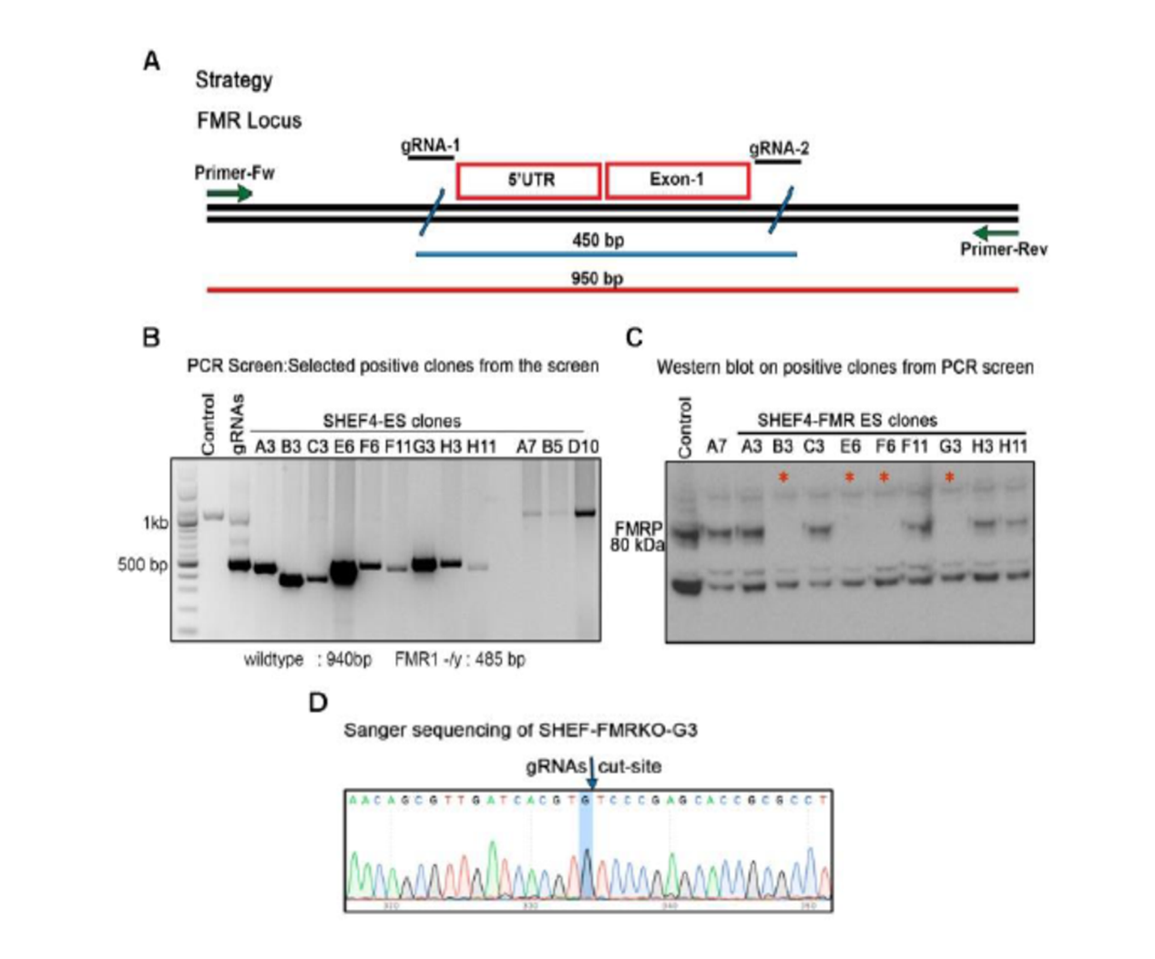

Appendix Figure 1: FMR1 null ES model system. A) The strategy for producing the FMR1 null ES with the position of the guide RNA for CRISPR/CAS9 mediated deletion. B) PCR screening of the clones. The positive clones have PCR amplicons of around 450bps. C) FMRP Western blot for screening the positive clones for absence of FMRP expression at protein level. The positive clones are marked by *. D) Representative Sanger sequence of the FMR1 null ES clone G3.

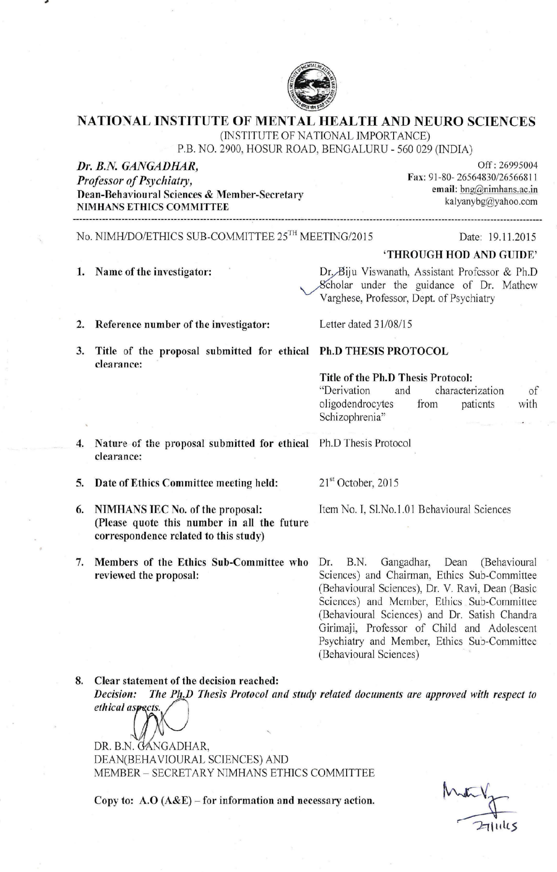**9.2. Ethical approvals**



